NPQLBC Conference
Participant Workbook
Name: ………………………………………………………………………………..
Session date: ………………………………………………………………………
INSERT DOCUMENT TITLE HERE
Welcome and setting norms
Our values
Agenda for today
Timings | Session
 | Welcome and setting norms | 20 mins
 | Leadership and your NPQLBC | 75 mins
 | How people learn | 45 mins
 | Experiencing a module pair | 90 mins
 | Experiencing a clinic | 60 mins
 | Close | 10 mins

Leadership and your NPQLBC
The importance of leading behaviour and culture
The disadvantage gap
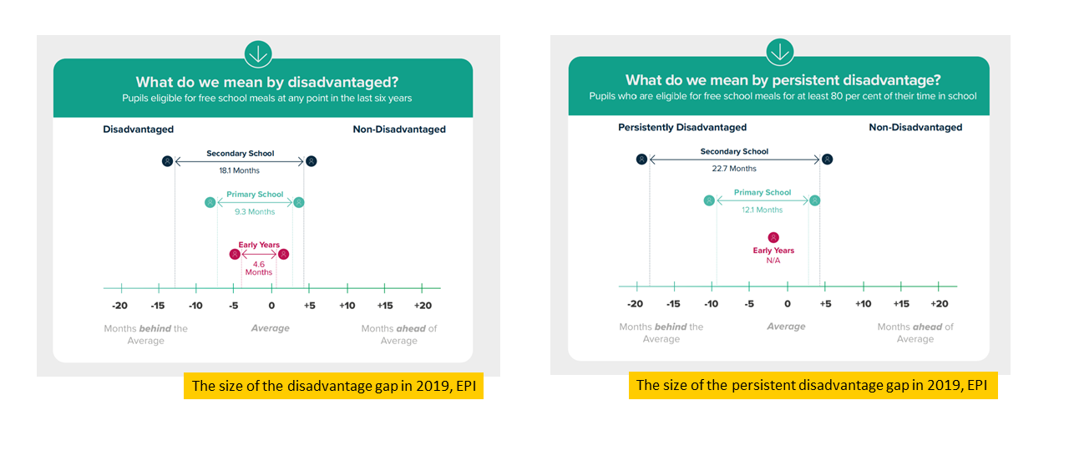
“Our vision is an education system where every child can thrive, no matter what their background.” (Ambition Institute, 2021)
The role of behaviour and culture
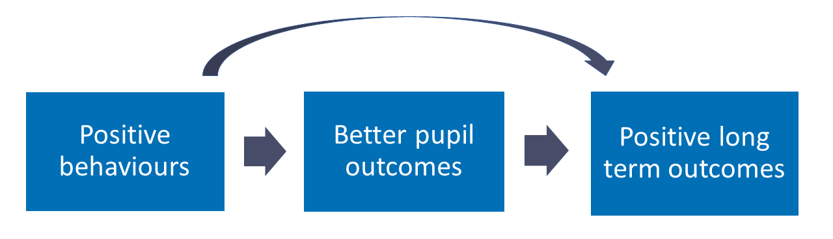
Reflection
- Why is it so important to close the attainment gap for disadvantaged pupils?
- Why are you seeking to develop your expertise in leading behavior and culture?
Notes

How do we develop expertise?
- Knowledge guides action which leads to impact
Reflection
- How can we develop expertise in your role?
- What impact will developing your expertise as a school leader have for you, your colleagues and your pupils?

Notes

Introduction to the NPQLBC
Programme principles
- Build knowledge: by the end of the programme, leaders will have built a deep educational knowledge about the persistent problems school leaders face. This will make them better decision makers.
- Be evidence informed: leaders will learn what the evidence suggests about these persistent problems (and what is unknown).
- Be sensitive to context: leaders will explore how their knowledge can be applied across different contexts. This will support them to consider how to apply their knowledge in their context.
- Apply strategically: leaders will be encourages to develop their expertise. They may choose to read more, review their current practice and when appropriate, apply what they have learned in their context.
- Keep getting better: leaders will be supported to continue to develop their expertise beyond the core content of the programme.
Programme overview
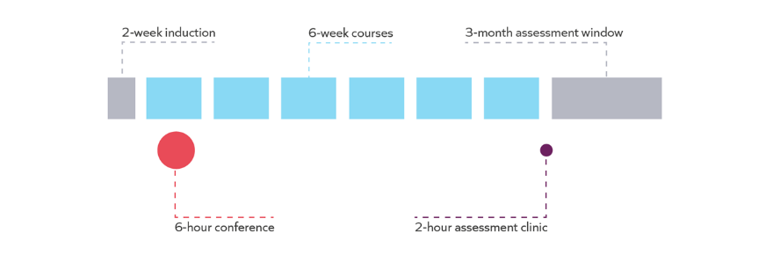
Courses
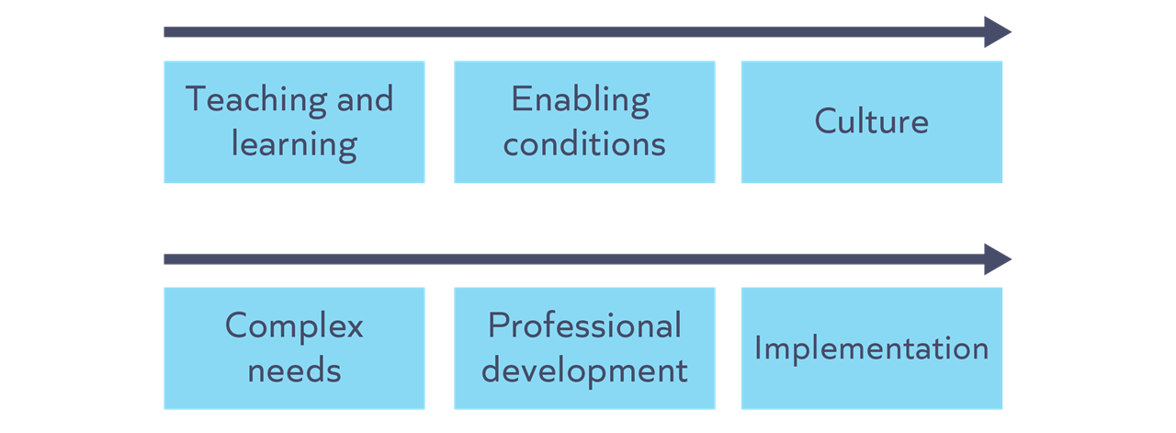

Course structure
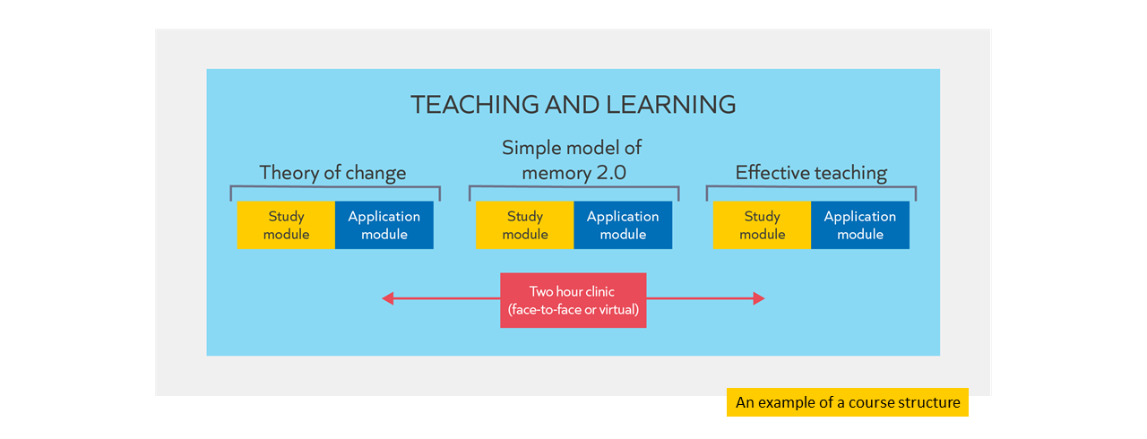
Assessment
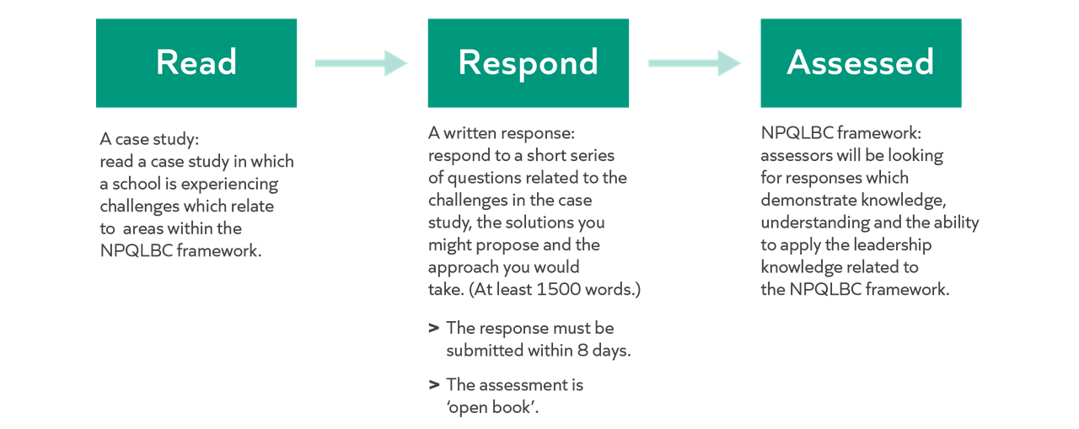
Support

Leadership knowledge | The programme is designed to build your knowledge of leadership, based on the NPQLBC framework. For example:  - Reading an evidence summary in each Insight module.  - Reading and analysing 2 examples that contextualise principles in each Insight module.  - Understand how to apply principles from a worked example of a scenario and leader’s response in each Clinic.  - Collaborate on a response to a scenario in each Clinic.
Assessment preparation | - A webinar before the assessment window.  - A live clinic before the assessment window.

Success on the programme
Attendance
- Attendance and engagement with all components of the programme are key to success.
- To enable you to submit for your end of programme assessment, the minimum expectation is that you engage with at least 90% of the programme.

Keep getting better
Developing formal knowledge: ​​
- Reading suggestions from NPQLBC
- Reading and listening more widely

Developing informal knowledge:​​
- Reflecting and distilling experiences
- Discussing with others

Developing self-regulation:​​
- Prioritising professional development, for example through attendance and engagement
- Prioritising wellbeing

Notes

Work with others

“peer support and learning is a fundamental ingredient of effective CPDL” (Cordingley et al, 2015)

“all collaborations are not equal… or equally productive” (Runfeldt, 2015)

Norm | What does this look like?
Be brave
Be kind
Be present
Apply strategically

Example…
- A pastoral leader reflects on their learning about effective responses to pupil behaviour
- They recognise that this is an area where they are not yet expert.
- They decide to follow up with the suggested reading and schedule to meet with several heads of year, heads of departments, lead practitioners and pupils and parents over the coming weeks to improve their understanding of the current approach to pupil behaviour in different departments across the school.
- They recognise there are areas which could be improved. However, when they review the school improvement plan they realise that it is not feasible to address these areas right now given the current priorities. They continue to read around the topic to develop their expertise in readiness for improvements at a more appropriate time.

Non-examples…
Too much | - An assistant headteacher in charge of behaviour reflects on their learning about how school leaders can address cyber bullying.  - They recognise that this is an area where they are not yet an expert.  - However, they see that another local school has made a positive start on this work and so they decide to implement staff training starting next term.
Too little | - A form tutor reflects on their learning about engaging parents and carers.  - They recognise that this is an area where they are not yet an expert.  - They assume that heads of year in the school probably have more expertise in this area so decide not to think about the topic further.

Notes

How people learn
Why do we need to know about learning?

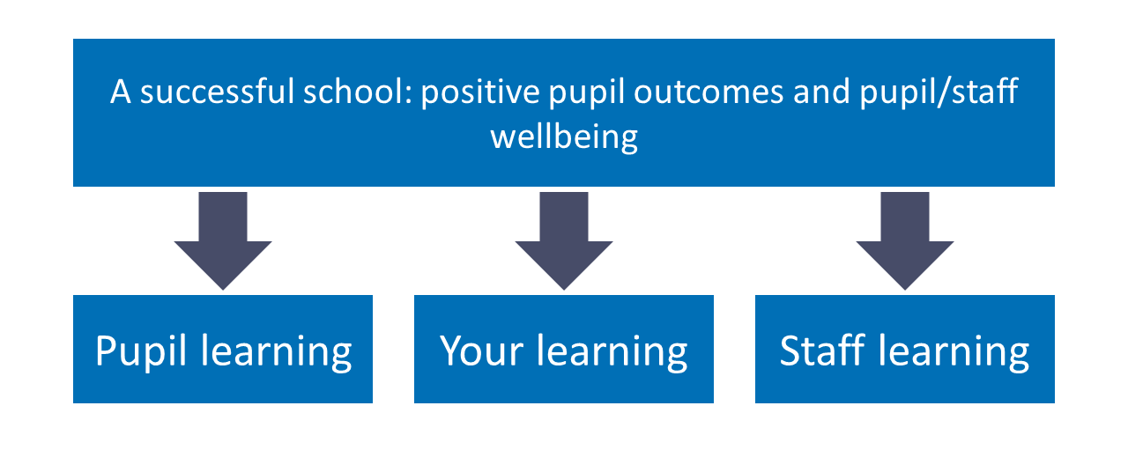
The importance of evidence
- Understanding the evidence enables leaders to make better decisions.
- Better decisions focus time and resources on more effective methods.

Notes

What is learning?

“Learning involves a lasting change in pupils’ capabilities or understanding.” (Department for Education, 2020).

Performance | Learning
Immediate change in capabilities or understanding that can be observed and measured. | Lasting change in capabilities and understanding, which happens over time and is hard to observe.

Lasting change: implications

Pupil learning | Staff learning | Your learning
When reviewing teacher impact, Ms Bibi knows she needs to triangulate data over time from a range of sources. She knows what she sees in a single lesson is pupil performance, not necessarily learning. | Ms Bibi, director of learning for year 8, asks her deputy to create a plan for the professional development of year 8 tutors. She gives feedback to ensure it includes times for staff to consolidate their skills and understanding over the long term, focusing on one thing at a time.. | After reading about a new topic in her NPQ insight module, Ms Bibi knows the value of revisiting these ideas in the application module and clinic to consolidate her understanding.

Reflection
- What are the implications of the definition of learning for you as a school leader?

Notes

How do we learn?

The simple model of memory
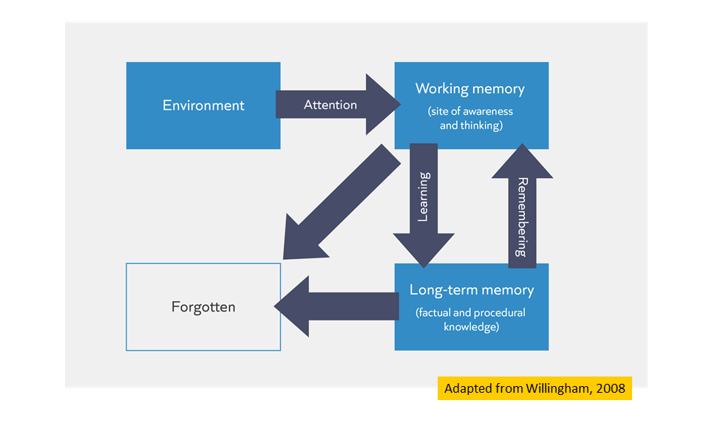
Ebbinghaus’ Forgetting Curve
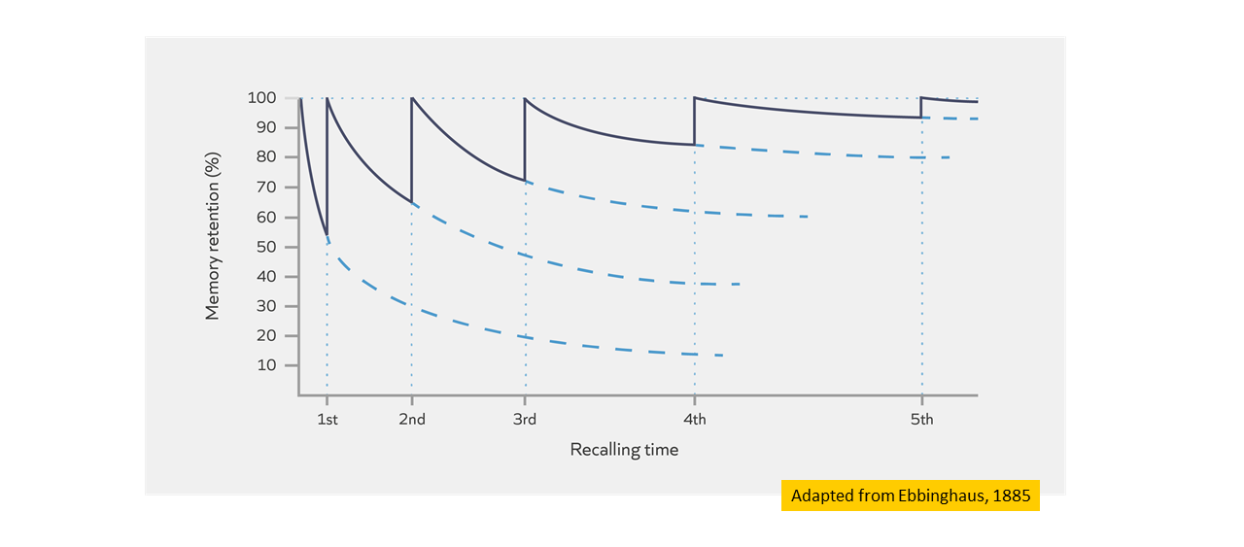

Notes

Check for understanding

Task: Which of these statements are TRUE?
- Learning is a lasting change in the learner's capabilities or understanding.
- Building knowledge in long-term memory is important because the better our prior knowledge, the more easily we can make sense of new information.
- Learners will struggle to build knowledge in long-term memory if they are cognitively overloaded.
- Retrieving, practising and thinking hard are all ways to guarantee the learner will become overloaded.

Notes

Learning and remembering: implications

Pupil learning | Staff learning | Your learning
Ms Amo, head of department, supports class teachers to build opportunities into lessons to retrieve and practice behaviour routines such as lining up or putting books in the box at the end of the lesson. | Mr Carter, deputy head, helps his teaching and learning lead break down a new behaviour strategy into steps so he can model it to teachers when training staff on it. | Ms James explains what she has found out about in her NPQ module to other colleagues so she can retrieve the knowledge and think hard about the underlying principles.

Notes

Mental Models

Mental models: The knowledge you have about a particular topic and how that knowledge is organised.

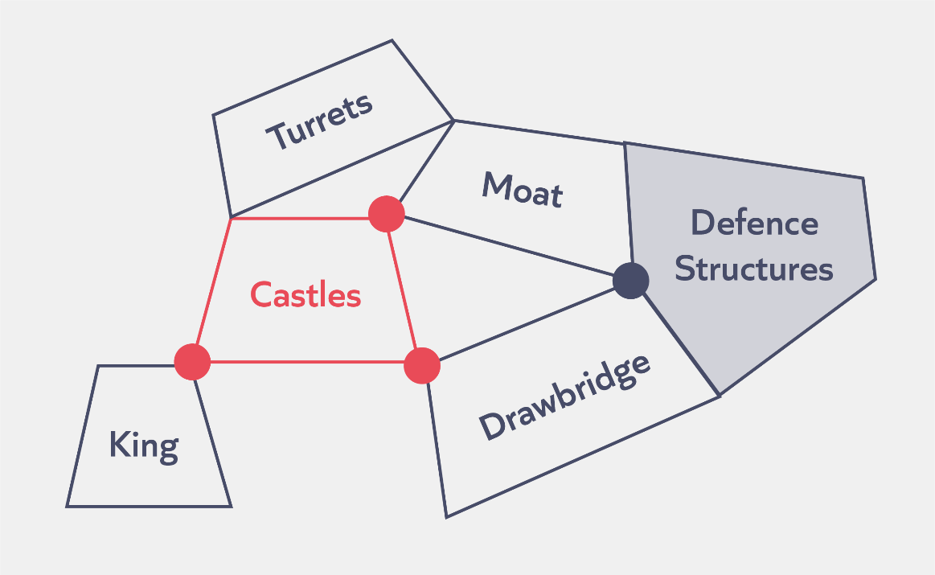

Check for understanding

Task: Which of these statements are TRUE?
- A leader’s mental model is all they know about school leadership.
- The more knowledge we have already learnt, the more successfully we can learn new knowledge in the future.
- Retrieval and practice helps to prevent knowledge being forgotten from our working memory.
Notes

Reflection
Scenario:
Kristy is a new headteacher. She has been approached by a senior leader wanting to use professional development time to encouraging pupil motivation. Last month the school introduced a new intervention policy for pupils with complex behavioural needs.

- How does understanding the science of learning help Kristy make a decision about whether/how to introduce the senior leader's changes?

Notes

Experiencing a module pair
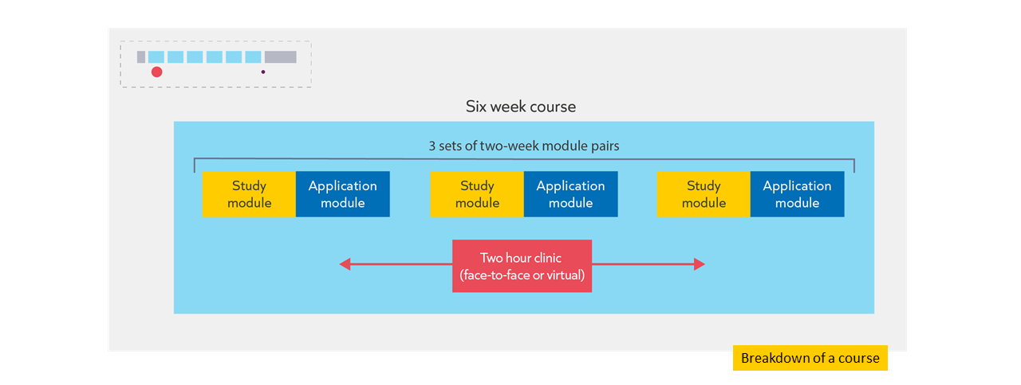

Study module

Read
Introduction
Understanding how people learn is vital for all teachers and school leaders. High quality teaching and learning is what makes the difference to pupils’ outcomes, especially pupils from disadvantaged backgrounds (Chetty et al., 2014; Hanushek, 1992).
Understanding how people learn is important for leaders of behaviour and culture. How pupils behave affects their ability to learn. Leaders need to understand how pupils learn in order to support pupils to behave in ways that are conducive to their success in learning, for example through teaching them learning behaviours or supporting other teachers to support learning effectively in the classroom.
Understanding how learning happens also equips leaders to better support teacher development. And as a participant yourself on a professional development programme, understanding how learning works will help you to maximise your own learning.
In this module, we are going to attend to the following:
- Principles of learning drawn from a simple model of memory
- Applications of the simple model of memory to pupil learning, leadership and for you personally
Guiding questions
Before you continue, consider:
- What do you already know about how pupils learn?
- How do these principles impact upon behaviour of students and staff and the wider culture of the school?
Optional pre-reading
This module assumes you understand the following ideas. If you wish to understand these in more depth before jumping in, then we recommend you read the following:
- Early Career Framework: Instruction Module 1

References
Chetty, R., Friedman, J. N., Rockoff, J. E. (2014). Measuring the Impacts of Teachers II: Teacher Value-Added and Pupil Outcomes in Adulthood. American Economic Review, 104(9), 2633–2679. https://www.aeaweb.org/articles?id=10.1257/aer.104.9.2633859–887. https://hanushek.stanford.edu/sites/default/files/publications/Hanushek%201992%20JPE%20100(1).pdf

Hanushek, E. (1992). The Trade-off between Child Quantity and Quality. Journal of Political Economy, 100(4), 859–887. https://hanushek.stanford.edu/sites/default/files/publications/Hanushek%201992%20JPE%20100(1).pdf

Evidence summary
Khalid is a pastoral leader within a teaching school hub. He has noticed disruption in a range of teachers’ lessons. He speaks to some of the pupils who were disrupting learning to find out more, and they explain that they often don’t understand the content being taught. These feelings of confusion and frustration seem to lead to disruption, which makes it even more difficult for effective teaching and learning to take place. In an attempt to improve behaviour in these classrooms, Khalid introduced a new behaviour strategy in a training session. However, he doesn’t see teachers applying this strategy in classrooms and the situation doesn’t seem to have improved.
How might Khalid be able to improve behaviour and culture more effectively by improving his understanding of how people learn?
What is learning?
Learning can be described as “a lasting change in pupils’ capabilities or understanding” (Department for Education, 2019, p.10). Learning involves both a process (thinking), as well as a product (the acquisition and organisation of new knowledge) (Mccrea 2019). Therefore, Khalid needs to encourage learning conditions that promote both process and product. For example, Khalid knows from experience that pupils will find it hard to engage in the process of learning (thinking hard about a problem or question) if classrooms are chaotic, unpredictable and disruptive. He’s also noticed that pupils and teachers alike need information to be broken down into smaller chunks for them to acquire new knowledge, the product.
Simple model of memory
The work of Daniel Willingham (2010) explaining cognitive processes and memory is very useful for educators. It provides models explaining key mechanisms and principles of learning. Learning is an incredibly complex process and occurs in a variety of ways, but this model helps us to understand some of the effects researchers have found through studying learning. These ideas can be applied to all learners, not just pupils.
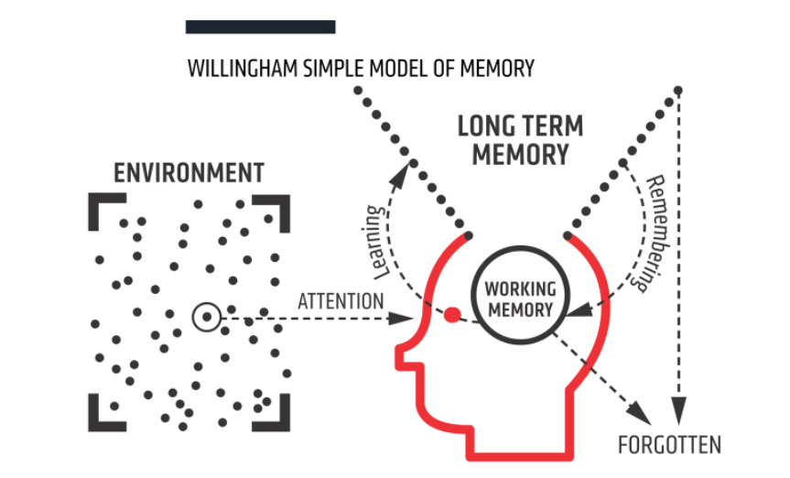
Figure 1: Willingham’s ‘simple model of memory’.
As the diagram above shows, Willingham’s simple model of memory splits memory into two parts: working memory and long-term memory. Working memory is the site of thinking (the process). It has a limited capacity for new knowledge and information. For us to learn something, it needs to be embedded in our long-term memory (‘be a lasting change’).
We take in new information from our environment, the world around us, using our working memory. This is where information that is actively being processed is held. Working memory is very limited (to about 3-4 items). This means we can only pay attention to a small number of new things at once. If working memory is overloaded, new information is forgotten instead of leading to a lasting change in long-term memory.
Fortunately, our long-term memory appears to be essentially unlimited. Long-term memory consists of everything we know and know how to do. We learn new information by combining and making sense of it in our working memory with knowledge already stored in our long-term memory (which we refer to as prior knowledge). The way we organise and store information in our long-term memory is called a 'mental model' or 'schema' (Sweller et al., 1998, Education Endowment Foundation, 2021). Recalling information from our long-term memory can help strengthen memories and reduce the risk of things being forgotten; you will return to this idea in course 1.
Implications for teaching
The more we know, the easier it is to build on that prior knowledge. This means that where new content is introduced, to either pupils in the classroom or teachers in a professional development session, attention should be paid to both how that information is presented and how much information is presented at any one time.
- Reduce and remove distractions
We learn what we think about, and what we think about is determined by what we attend to (Schweppe & Rummer, 2013). There are lots of stimuli in our environment that compete for our attention, but because working memory is limited, we can only choose to think about a handful of these at a time.
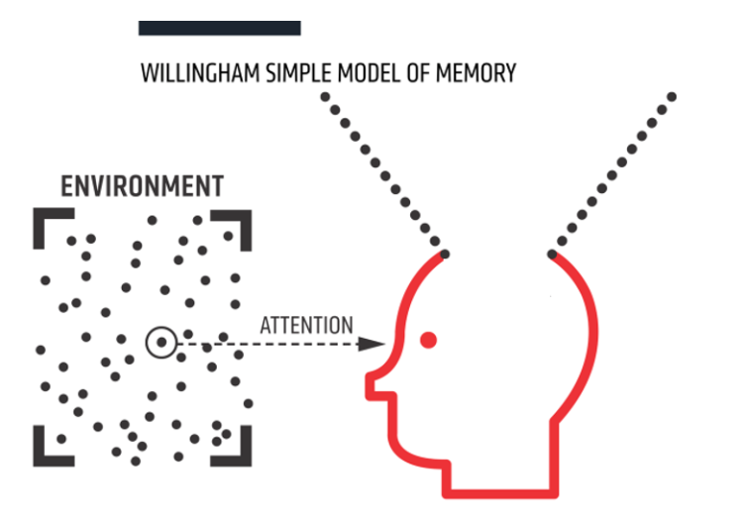
This means that attention is the gatekeeper of learning. Khalid is familiar with this idea; a large part of his job as a teacher and as a leader is to harness and direct attention. He knows that this involves motivating pupils and teachers as well as drawing their attention to the key concepts and ideas he wants them to learn.
Where possible, educators at all levels should aim to eliminate redundant information and reduce distractions in the environment. These distractions can be social (for example, peers or other adults), environmental (for example display boards or clocks), activity-based (for example irrelevant images or tasks), or internal (for example performance anxiety, mind wandering). This does not mean removing all displays, or always having pupils work silently; but might mean putting displays or clocks at the back of the class and thinking about whether pupil talk is likely to help or hinder the current task.
Khalid recognises that there were lots of distractions from learning in many of the classrooms he observed. He reflects that school-wide systems could reduce potential distractions caused by, for example, pupils arriving late or other interruptions.
Khalid also realises that it is just as important to think about redundant information and distractions when working with adults, such as when planning a meeting or designing a training session.
- Utilise limited working memory wisely
Working memory is where information that is being actively processed is held, but its capacity is limited and can be overloaded. Educators must ensure learners focus on a few ideas, processes or pieces of information at a time. For example, Khalid might support teachers who are struggling with behaviour in their classroom by encouraging them to reduce the number of instructions they give at one time and to say these instructions in fewer words.
Focusing learners’ attention on just a few pieces of information at a time is more difficult when brand new content is being introduced or where the learners are complete novices. This is because we use our existing knowledge, skills and understanding to make sense of new ideas. Thinking becomes more difficult if we have limited relevant knowledge held in long-term memory to think with. Thinking works best when we attend to no more than two or three interacting pieces of information at once (Sweller et al., 2011).
Introducing new content in small steps and building on prior knowledge are familiar ideas to Khalid when working with his own pupils. However he now recognises that sharing these approaches with other teachers might support them to better facilitate pupils’ learning. He also realises that he needs to put these ideas into practice when working with teachers too.
As well as using information from long-term memory to help us process new ideas, we can manage the strain on working memory by considering the format of information. Information can be represented in various modes (for example, speech, text, diagrams or images). How educators present information can help or hinder learning.
We can attempt to reduce cognitive load through how we present information by avoiding the ‘split attention effect’. The split attention effect can hinder learning by causing learners to process two or more sources of information simultaneously (Centre for Education Statistics and Evaluation [CESE], 2018). For example, if a learner needs to look at a diagram and separately read information to understand it, this could cause ‘split attention’. Or if a learner is reading information at the same time as listening to an explanation, this could cause ‘split attention’. Presenting the information in the same place at the same time (for example, on the diagram) reduces cognitive load. This is sometimes referred to as ‘dual coding’.
Split attention Dual coded
Khalid reflects on the disrupted lessons he observed and realises that teachers were often causing cognitive overload by splitting pupils’ attention. He is keen to support teachers to improve, but wary of suggesting a ‘quick fix’ that might lead to teachers misunderstanding how pupils learn.
The “modality effect” is another way to reduce cognitive load by providing visual and verbal information simultaneously (CESE, 2017). This works because working memory can be thought of as being split into visual and auditory (verbal) streams. An example of this would be narrating an explanation whilst displaying a diagram or image. Khalid thinks that this is likely to work especially well for explaining a complex concept, and the teachers he observed would be better able to facilitate learning if they adopted this approach. He realises they will need support to adjust their practice; he might need to script and practise their explanations with them so that they remember to break the information down into short sentences. He might also help them plan to point to appropriate parts of the diagram as they speak.
Pause. Reflect. Respond.
- How might understanding how to use limited working memory wisely help teachers in your school to better facilitate learning?
- How does understanding how to use limited working memory wisely help you to increase your impact as a leader of behaviour and culture?

Guiding yourself as a learner
Having considered the simple model of memory and some ideas about cognitive load from Khalid’s own perspective as a leader of behaviour and culture, let’s consider how you might use these ideas in your own learning.
As a learner yourself, you will need to consider:
- How will you fully attend to the content without distraction?
- What strategies do you need to put in place to think hard about this content without succumbing to cognitive overload?
- How will you self-regulate your learning?
- How will you know when it is appropriate to move from developing your own understanding of foundational concepts, to the application of the concepts in your professional development design and delivery?
The more you know about an idea or topic, the easier it is for you to learn yet more. This is as true for us as leaders as it is for the teachers and pupils we work with. One way to benefit from this is to seek out opportunities to add to your knowledge base. We can also strengthen our mental models through conversations with our peers, as this helps to consolidate understanding and form connections between pieces of knowledge.
Pause. Reflect. Respond.
- Consider the questions above. What actions will you take as you move through the rest of this module? The rest of the programme?
Summary
Khalid’s key takeaways therefore are:
- How pupils learn affects how they behave, and how they behave affects how they learn. Therefore, all leaders and teachers need to understand how to best support pupil learning.
- Learning can be thought of as a lasting change in capabilities or understanding.
- Working memory has a limited capacity. Therefore you should focus your attention on the thing to be learnt, avoiding distraction wherever possible to reduce cognitive overload.
- Principles of cognition and learning can be applied to learning opportunities for both pupils, teachers and ourselves.

Nuances and caveats
The simple model of memory is a model. Although the simple model of memory is effective at explaining some of the effects we see when studying learning, it is a model. Consequently, it will not explain everything we observe about memory or learning. This is similar to how scientific models such as Bohr’s model of the atom work – they represent and help us think about content, they are not an exact replica. The simple model of memory does not provide a precise formula for learning; it does provide us with useful guidelines.
The role of motivation. The capacity of the working memory does not always equate to the working memory an individual actually allocates to learning (Shell et al, 2010). In other words, just because there is the capacity to focus working memory for new learning, it doesn’t mean that we will. Motivation is a key factor in determining how much of working memory is put to best use.
Behaviour and learning are complex. As well as motivation, there are many influences and processes at play when we consider behaviour and learning. Although the simple model of memory helps teachers and leaders to understand how learning works and can help them maximise learning for the majority of pupils, it is important to recognise that individual pupils will have specific needs. Teachers and leaders should strive to understand pupil’s needs and adapt provision accordingly (Institute of Education Science, 2008).
Further reading
Mccrea, P. (2019). Learning: What is it, and how might we catalyse it? Ambition Institute. https://s3.eu-west-2.amazonaws.com/ambition-institute/documents/Learning_what_is_it_and_how_might_we_catalyse_it_v1.4.pdf
Willingham, D. T. (2017). A mental model of the learner: Teaching the basic science of educational psychology to future teachers. Mind, Brain, and Education, 11(4), 166-175
Willingham, D. T. (2009). Why don't students like school?: A cognitive scientist answers questions about how the mind works and what it means for the classroom. John Wiley & Sons.
References
Centre for Education Statistics and Evaluation (2017). Cognitive load theory: Research that teachers really need to understand. Accessible from: https://www.cese.nsw.gov.au/publications-filter/cognitive-load-theory-research-that-teachers-really-need-to-understand
Centre for Education Statistics and Evaluation (2018). Cognitive load theory in practice: Examples for the classroom. Accessible from: https://www.cese.nsw.gov.au/publications-filter/cognitive-load-theory-research-that-teachers-really-need-to-understand
Clark, R. C., Nguyen, F., & Sweller, J. (2011). Efficiency in learning: Evidence-based guidelines to manage cognitive load. John Wiley & Sons.
Department for Education [DfE] (2019). Early Career Framework. https://www.gov.uk/government/publications/early-career-framework
Education Endowment Foundation [EEF] (2021). Cognitive science approaches in the classroom: a review of the evidence. https://educationendowmentfoundation.org.uk/public/files/Publications/Cognitive_science_approaches_in_the_classroom_-_A_review_of_the_evidence.pdf
Institute of Education Sciences (2008). Reducing Behavior Problems in the Elementary School Classroom. https://ies.ed.gov/ncee/wwc/Docs/PracticeGuide/behavior_pg_092308.pdf
Mccrea, P. (2019). Learning: What is it, and how might we catalyse it? Ambition Institute. https://s3.eu-west-2.amazonaws.com/ambition-institute/documents/Learning_what_is_it_and_how_might_we_catalyse_it_v1.4.pdf
Schweppe, J., & Rummer, R. (2014). Attention, working memory, and long-term memory in multimedia learning: An integrated perspective based on process models of working memory. Educational Psychology Review, 26(2), 285-306.
Shell, D. F., Brooks, D. W., Trainin, G., Wilson, K. M., Kauffman, D. F., & Herr, L. M. (2010). The unified learning model. In The Unified Learning Model (pp. 1-4). Springer, Dordrecht.
Sweller, J. (2011). Cognitive load theory. In Psychology of learning and motivation (Vol. 55, pp. 37-76). Academic Press.
Sweller, J., Van Merrienboer, J. J., & Paas, F. G. (1998). Cognitive architecture and instructional design. Educational psychology review, 10(3), 251-296.Willingham, D. T. (2009). Why don't students like school?: A cognitive scientist answers questions about how the mind works and what it means for the classroom. John Wiley & Sons.

Reflection
- What is helpful about the Study section?
- How will the Study section help to build your mental models?
- Do you have any questions?

Notes

Quiz
Task: Answer the following questions.
- When presenting new or complex information, educators should ensure learners focus on a few ideas, processes or pieces of information at a time because:
  - Working memory has limited capacity
  - Long-term memory has limited capacity
  - Long-term memory is essentially unlimited

- Knowledge is organised:
- In the long-term memory as mental models
- In the working memory as mental models
- In the long-term memory but there is limited capacity

- The ideas about working memory and long-term memory apply to:
  - Only pupils
  - All learners including adults and children
  - Only pupils and inexperienced teachers

Reflection
- What do you need to do to make the most of the Quiz section?
- How will the Quiz section help to build your mental models?
- Do you have any questions?

Notes

Read
Task: Read Example 1 and answer the analysis questions.
Introduction
My name is Rachel and I’ve been headteacher at a primary for the last four years. Over the last two years we have invested in ensuring our practice is informed by a secure understanding of how people learn. Teachers have become better equipped to support pupils to learn effectively in classrooms and assemblies. Our pupils are more engaged, more knowledgeable, more confident, and ultimately, better equipped to succeed in life. An understanding of how staff learn underpins our leadership practice, enabling myself and other leaders to work more effectively with teachers and support staff to make our visions a reality.
In this next section we will be focusing on how leaders of behaviour and culture might utilise an understanding of how people learn in their practice. We can focus our thinking around the following four principles:
- Learners are learners: The implications of the simple model of memory can be applied to pupils, teachers, leaders and self.
- Guide attention: Limit distractions, direct attention and carefully consider the design of activities
- Break it down: Working memory is limited. Break knowledge down and plan for it to be introduced and practised in small steps. This can help teachers and pupils to gradually build mental models of increasing complexity
- Pupils as individuals: Recognise that individual pupils have unique needs and influences and may require tailored support

Example 1
I am a head of year in a Manchester secondary school. Over this term I have been working Matt, who is finding that behaviour in lessons is disrupting learning.
Earlier this term, I helped Matt to get pupils’ attention using a countdown. Matt uses this effectively to ensure pupils are listening while he gives instructions. However, pupils struggle to follow these instructions and therefore independent learning tasks break down quickly as pupils abandon the work, become distracted and in some cases disruptive. As a result, Matt’s energy during learning activities is focused on responding to off-task behaviour using the school’s behaviour policy, rather than supporting or assessing learning.
Using my knowledge of the simple model of memory, I was able to further analyse the situation. I noticed that:
- When giving instructions, Matt is moving around the room, handing out pens and paper resources to the pupils. This is potentially causing cognitive overload because pupils’ attention is overwhelmed, unsure whether to focus on Matt’s actions or instructions.
- Many pupils were trying to read the screen or the worksheet, taking in additional and different information at the same time as listening to Matt’s instructions. This is likely causing the split attention effect.
- Matt’s instructions are very long-winded – he explains what pupils have to do in several different ways. Again, this is likely to cause cognitive overload as pupils are processing lots of different pieces of information.
Pupils’ behaviour becomes challenging during the independent tasks due to this cognitive overload. Because they haven’t been able to process his instructions, they struggle to hold both the task instructions and think hard about the lesson content. This was apparent when several pupils asked Matt questions about what they were expected to do and many pupils gave only partial or incorrect answers to the questions in the task.
Before I meet with Matt for our coaching conversation, I need to choose an action step. I choose a single bite-sized improvement based on my understanding of the simple model of memory: the limited capacity of our working memory means we need to direct teacher’s attention to a focused area of practice so that they do not become cognitively overloaded. For example, if I give Matt three targets at a time, he may find it difficult to process the information. I also need to present this action step in a broken-down way which builds on his prior knowledge. For example, rather than just suggesting Matt ‘give clearer instructions’, I give him a bullet-pointed success criteria that breaks down what he needs to do.
Behaviour and culture is complex: I know there are a variety of factors which are influencing pupils’ behaviour in the classroom, not least that Matt hasn’t yet built trusting relationships with these pupils. However, I know that pupils are more likely to develop these relationships with Matt if he can help them feel successful in their learning. I also know that enabling more pupils to start the independent task successfully will give Matt scope to support individual pupils with their learning.
Matt’s action step is:
- Direct pupil attention while giving instructions so that you avoid split attention and reduce cognitive load by:
  - Ensuring that all pupils are listening before you give instructions.
  - Standing still at highly visible spot in the classroom.
  - Preparing succinct step-by-step instructions that include ‘what’, ‘how’ and ‘for how long’.
  - Using your lesson slide to display these succinct instructions as bullet points.

Conclusion
Throughout this scenario, I was able to plan and conduct a coaching conversation by focusing on the following module principles:
- Learners as learners
- Guide attention
- Break it down
- Pupils as individuals

Artefact
Script of a section of the coaching conversation
Coach (me): I’m going to show you an alternative way of delivering your instructions now. I want you to think about how this is different and what the impact is likely to be for pupils.
[In role as teacher. Stands still and points to bullet point instructions on slide]
When I say go, I want you to read the information in the grey box at the top of your worksheet and answer questions 1-5 in your exercise book. We’re going to be learning independently for this task, so the noise level should be quiet. You have 10 minutes. Okay, go.
[Instructions displayed on slide]:
Task:
- Read the information in the grey box at the top of your worksheet.
- Answer questions 1-5 in full sentences in your exercise book.
Noise level: Quiet for independent learning
Time: 10 minutes

What do you notice is the difference between how I delivered the instructions and how you did?
Matt: You weren’t giving out papers. And this meant you could point to the instructions on the screen. It took you a lot less time to give the instructions than it takes me!
Coach: Some really good points. Let’s focus on standing still first. What impact do you think this would have for pupils?
Matt:. I guess by not moving around it would allow pupils to focus better on your words.
Coach: If we think back to our training on the simple model of memory, you’ll remember that pupils, like all learners, including you and me, process information in their working memory. The working memory has a limited capacity: it can only hold 3-4 pieces of information at a time. If you are moving around the classroom, handing out resources, what do you think this means for pupils’ working memory?
Matt: They’ll be focusing attention on what I say, but also on what I’m doing. And when they get the resources, they’ll probably be curious and want to have a look at them, so then that’s another stimuli that competing for their attention. So ultimately, their attention will be split and they’ll be cognitively overloaded.
Coach: And what does this mean for pupils when they come to start the task?
Matt: Well they won’t have processed the instructions, so they won’t really know what to do. I find myself having to repeat my instructions so many times while pupils are working, and I think this could help with that.
Coach: Definitely. Let’s pick up on the other difference you spotted. Why did it take less time for me to give the instructions?
Matt: You just said what was written on the screen. So I guess you’d scripted the instructions when you made the slide and that meant you could deliver them really clearly. Also, you’ve broken them down into two steps. All the redundant words are cut out.
Coach: What impact would this have on pupils’ working memory?
Matt: Oh yes, it’s the same thing. More concise instructions means they pupils do not have to try to process loads of information I’m telling them. They can just process the 3 or 4 things in the box on the slide. And the visual matches what you’re saying so it’s not splitting their attention.
Coach: What would this mean for pupil learning?
Matt: Well if they aren’t overloaded by the instructions, it’s much more likely that they can get started and access the learning. There might still be some pupils that are confused or need my help, but if I more of them can get started, and I can focus on supporting the pupils that really need me during independent tasks.

Reflect
- How did the leader apply the principle of ‘guide attention’ in this example?
- How did the leader apply the principle of ‘learners as learners’ in this example?
- How did the leader apply the principle of ‘pupils as individuals’ in this example?

Reflection
- What is helpful about the Explore section?
- How will the Explore section help to build your mental models?
- Do you have any questions?

Notes

Reflection
- How does the Study Module help to build your mental model?
- Do you have any questions about the Study Module?
- How can you make the most of the Study Module?

Notes

Application Module
Re-analyse
Task: Discuss the Analyse questions from the Insight Module with your partner. Strive to:
  - Be brave: ask questions, share insights and experiences
  - Be kind: respectful, supportive, active listening
  - Be present: be fully engaged, keep to time

Reflection
- What is helpful about the Re-analyse section?
- How will the Re-analyse section help to build your mental models?
- Do you have any questions?

Notes

Select
Task: Select the most appropriate and useful application task for you and your context.
Module principle | Application tasks
Guide attention: Limit distractions, direct attention and carefully consider the design of activities | READ: Watch this video to learn more about how we can guide attention in the classroom: https://www.edutopia.org/video/optimizing-working-memory-classroom  REVIEW: Reflect on a lesson you recently taught or observed. Consider how effectively pupils attention was guided to the learning and what impacts this had on both learning and behaviour.  DO: Script an explanation of the importance of limiting distractions and directing attention for a teacher or group of teachers you are working with.  ADAPT ONE OF THE TASKS
Break it down: Break knowledge down and plan for it to be introduced and practised in small steps so teachers and pupils gradually build mental models of increasing complexity. | READ: Read principle 2 from: Rosenshine, B. (2012). Principles of Instruction.  Why might teaching new material overwhelm learners?  How might you mitigate for this?  REVIEW: Review a plan (for a lesson, assembly or professional development). Is knowledge broken down and planned to be introduced and practised in small steps?  DO: Script an explanation of the importance of breaking down knowledge into small, manageable chunks (such as stepped instructions for pupils, or action steps for teachers) for a teacher or group of teachers you are working with.  ADAPT ONE OF THE TASKS
Pupils as individuals: Recognise that individual pupils have unique needs and influences and may require tailored support. | READ: Read more about supporting individual pupils with learning in the classroom from: Gathercole, S. (2008) Working memory in the classroom. Consider:  - What are the implications of this article for supporting pupils in your school?  REVIEW: Reflect on a lesson you have recently taught or observed. Consider which pupils with additional or special educational needs may have benefitted from more effectively breaking it down or guiding attention.  DO: Script an explanation of the importance of being aware of individual pupils’ needs when they are giving instructions for a teacher or group of teachers you are working with.  ADAPT ONE OF THE TASKS

Discuss
- Which of these principles are most relevant to your context/role? Which did you choose and why?
- What do you plan to do next? How do you hope this will enhance your expertise and impact?

Plan

Example | Non-example
- Script an explanation of the importance of breaking down knowledge (Friday AM)  - To review the script with vice principal in our weekly line management meeting | - - Break things down more when delivering training to teachers

Notes

Reflection
- How does the Application Module help to build your mental model?
- Do you have any questions about the Application Module?
- How can you make the most of the Application Module?

Notes

Experiencing a clinic

Study consolidation

Module principles
Learners as learners: | The implications of the simple model of memory can be applied to pupils, teachers, leaders and self.
Break it down: | Break knowledge down and plan for it to be introduced and practised in small steps so teachers and pupils gradually build mental models of increasing complexity. .
Guide attention: | Limit distractions, direct attention and carefully consider the design of activities
Pupils as individuals: | Recognise that individual pupils have unique needs and influences and may require tailored support.

I do
Task: Read the scenario.

Scenario
A head of year is keen to support pupils to develop their independent study skills so that they can more effectively revise for upcoming assessments. She decides to utilise her fortnightly 15-minute assemblies over the half term to introduce key concepts and strategies to pupils.
The head of year wants pupils to enter these assemblies in a prompt and calm manner so that they can attend to what she wants them to learn. She has already established clear expectations and routines with teachers and pupils for assemblies. Pupils know that they enter and exit quietly in single-file lines. She also wants them to attend to the learning during the assembly without distraction, so she has taught pupils what it looks like to actively listen during the assembly. The head of year has worked with her form tutors to ensure they know how to reinforce expectations during assembly. To avoid distractions caused by latecomers, the head of year has established a system for managing lateness and consistently issues consequences. After several weeks of applying this approach, all pupils are on time for assembly.
The head of year has also worked with the special educational needs co-ordinator to ensure individual pupils get the support they need to attend to the learning in the assembly. For example, a pupil with a hearing impairment has a seat in the front row that enables them to access the assembly, and staff know strategies they can use to support individual pupils who find it more difficult to sit still and listen for extended periods, such as using non-verbal prompts and movement breaks.
When preparing to deliver each assembly, the head of year thinks carefully about how her visual resources can support what she is saying, rather than providing additional or contradictory information. For example, whenever the head of year shows a diagram, she pauses for pupils to take in the image before talking them through it. She also ensures that whenever she shares any text on the screen, she reads it aloud before expanding on what it means.
The first assembly begins with a diagram of the simple model of memory. The head of year quickly explains how learning takes place. As she is explaining the simple model of memory, she sees some pupils looking confused, and becomes aware that she is introducing pupils to complicated concepts using unfamiliar vocabulary. She then shares some examples of things that might be competing for pupils’ attention when they sit down to revise, such as notifications on a phone, music with prominent lyrics, a friend chatting, a hungry stomach and other documents on the desk. Next the head of year explains that research suggests our brain can only process 3-4 pieces of information at a time. She asks pupils to think about the topics they need to revise and how they can break it down into small chunks, like the 4 steps for solving quadratic equations or the 4 quotes that prove Macbeth appears heroic. She then asks two sixth form pupils she has invited to attend assembly to each share how they revise. One pupil discusses how they created a quiet distraction-free workspace, while the other talks about the type of revision activities she uses and how she created a revision schedule. The head of year emphasises that pupils will all have different circumstances and need to make this strategy work for them. She asks pupils to discuss with the person next to them what their key takeaways are from this assembly.
As the head of year listens in to pupils’ conversations, she hears a range of answers. Some pupils talk about putting their phone away when they are revising, others explain how they want to use past papers and some discuss their revision schedule. She also hears some pupils talking about how loud music actually helps them to concentrate and how they prefer to revise with a group of friends in the library so they feel more motivated. Other pupils begin to have off-topic conversations. The head of year realises that pupils have not learnt what she wanted them to from this assembly and she wonders why.

Question: Taking into account what you have learnt on this course -
a) What might be effective about this headteacher’s decision making?
b) What suggestions do you have to help them potentially make more effective decisions next time?
Refer to the relevant module principles in your answers.

Notes

Task: Make notes while the facilitator models how to respond to the question.

Module principle | Response/advice
Guide attention
Pupils as individuals
Learners as learners
Break it down

Reflection
- How will the ‘I do’ section help to build your mental models?
- What do you need to do to make the most of the ‘I do’ section?
- Do you have any questions?

Notes

We do
Task: Read the scenario.

Scenario
The assistant headteacher with responsibility for behaviour, culture and pastoral care at a primary school wants to support teachers to adopt a consistent approach to getting pupils’ attention. The need for teachers to improve their ability to get pupils’ attention has been identified as a priority based on the school’s self-evaluation cycle. Unless teachers can get all pupils’ attention, they cannot ensure all pupils are learning. At present, time is lost in lessons while teachers try to get pupils’ attention. Additionally, teachers often proceed with giving instructions or introducing content without all pupils’ attention and, consequently, they need to repeat themselves. The assistant headteacher has decided to introduce a call-and-response which will cue students to stop what they are doing and direct their attention to the teacher.
The teachers in the school have varying levels of experience and expertise: some members of staff have been teaching for more than 10 years, and some are early career teachers. The assistant headteacher knows that he needs to carefully plan his training sessions to ensure that all teachers can gradually build their mental model around this strategy so he thinks about how to break knowledge down and introduce it in small chunks with opportunities for practice.
The assistant headteacher decides to begin the training with an overview of the need for a call-and-response strategy. He explains the importance of attention for learning using the simple model of memory. Teachers are already familiar with the simple model of memory from previous training. The assistant headteacher displays a diagram of the simple model of memory, with several bullet points alongside which explain the key ideas from the model. While this slide is displayed, he gives an explanation of the simple model of memory including elaboration. As he is explaining, he notices that some members of staff are reading from the screen rather than listening to him.
Next, the assistant headteacher models the call-and-response strategy. He asks teachers to take notes on what he does while modelling the strategy. Most members of staff choose to take notes on their laptops. The assistant headteacher then asks staff to share their observations with their partner. During this discussion, an all staff email about a change to the duties rota is sent by the deputy headteacher. The assistant headteacher notices that several teachers start discussing the duty rota instead of the call-and-response model.
The assistant headteacher uses the call-and-response to get staff’s attention. He then shares a step-by-step success criteria which outlines how to implement the call-and-response strategy. He then plays a video of a non-example from a mathematics lesson. In the video, pupils are engaged in pair talk and the teacher tries (unsuccessfully) to get their attention, and then moves on to explain a new concept. This leads into an opportunity for teachers to discuss how the teacher could improve their practice. The contributions to the discussion vary: some staff focus on how the teacher could improve, while others talk about how the teacher is unable to see all pupils in the room during pair talk and some comment on the accuracy of the teacher’s explanation of the new concept. The assistant headteacher takes feedback from several teachers on the video, including those which are not focused on the way the mathematics teacher got pupils’ attention.
Finally, the assistant headteacher introduces the final activity in the professional development session: deliberate practice. Teachers work in pairs to practice using the call-and-response strategy and give each other feedback using the step-by-step success criteria.
At the end of the session, the assistant headteacher is confident that staff have understood how and why to use the call-and-response strategy. However, the assistant headteacher knows that one training session is unlikely to be sufficient to embed this strategy, so they plan follow-up sessions which will enable teachers to add nuance to the strategy later in the term. In particular, he plans for future sessions to explore how the strategy needs to be adapted by teachers and teaching assistants in order to support pupils with additional needs. Before the next session, they visit a range of teachers’ lessons to see the strategy in action. He is surprised to find that the strategy is being used inconsistently. Some teachers are using it but others aren’t, and suggest that it doesn’t seem relevant or necessary for pupils in their classroom.

Task: Respond to the following question independently, then discuss with your partner.

Question: Taking into account what you have learnt on this course -
a) What might be effective about this headteacher’s decision making?
b) What suggestions do you have to help them potentially make more effective decisions next time?
Refer to the relevant module principles in your answers.

Module principle | Response/advice
Learners as learners
Break it down
Guide attention
Pupils as individuals

Reflection
- How will the ‘We do’ section help to build your mental models?
- What do you need to do to make the most of the ‘We do’ section?
- Do you have any questions?

Notes

Reflection
- How does the clinic help to build your mental model?
- Do you have any questions about the clinic?
- How can you make the most of the clinic?

Notes

References
Chapman, R. L., Buckley, L., & Sheehan, M. (2013). School-Based Programs for Increasing Connectedness and Reducing Risk Behavior: A Systematic Review. Educational Psychology Review, 25(1), 95–114. https://www.ncbi.nlm.nih.gov/books/NBK127172/
Chetty, R., Friedman, J. N., Rockoff, J. E. (2014). Measuring the Impacts of Teachers II: Teacher Value-Added and Pupil Outcomes in Adulthood. American Economic Review, 104(9), 2633–2679. https://www.aeaweb.org/articles?id=10.1257/aer.104.9.2633
Education Endowment Foundation (2019) Improving Behaviour in Schools. https://educationendowmentfoundation.org.uk/public/files/Publications/Behaviour/EEF_Improving_behaviour_in_schools_Report.pdf
Education Policy Institute [EPI], 2020, Education in England: Annual Report 2020. https://epi.org.uk/publications-and-research/education-in-england-annual-report-2020
Furst, E., 2018. Learning in the brain. https://sites.google.com/view/efratfurst/learning-in-the-brain
Gutman, L. & Schoon, L. (2013). The impact of non-cognitive skills on the outcomes of young people. https://educationendowmentfoundation.org.uk/public/files/Presentations/Publications/Non-cognitive_skills_literature_review_1.pdf
Gutman and Vorhaus (2012) The impact of pupil behaviour and wellbieng on educational outcomes. https://www.basw.co.uk/system/files/resources/basw_22531-3_0.pdf
McCrae, P. (2018). Expert teaching: What is it, and how might we develop it. Institute for Teaching.
https://www.ambition.org.uk/research-and-insight/what-is-expert-teaching/
OECD (2015). Do teacher-pupil relations affect pupils' well-being at school? PISA in Focus, 50, https://www.oecd.org/pisa/pisaproducts/pisainfocus/PIF-50-(eng)-FINAL.pdf
Rose, N, (2018) The role of forgetting as we learn. Ambition Institute. https://www.ambition.org.uk/blog/why-forget/
Willingham, D., 2009. Why Don’t Students Like School? A Cognitive Scientist Answers Questions About How the Mind Works and What It Means for the Classroom. Jossey-Bas 2nd edition.

