NPQH Conference 1
Participant Workbook
Name: ………………………………………………………………………………..
Session date: ………………………………………………………………………
INSERT DOCUMENT TITLE HERE
Welcome and setting norms
Our values
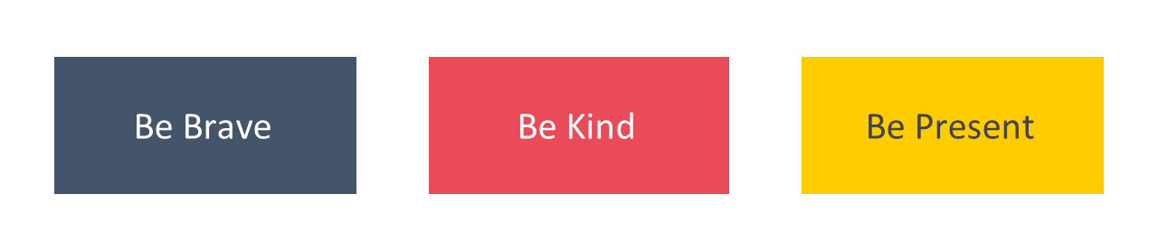
Agenda for today
Timings | Session
 | Welcome and setting norms | 20 mins
 | Leadership and your NPQH | 75 mins
 | How people learn | 45 mins
 | Experiencing a module pair | 90 mins
 | Experiencing a clinic | 60 mins
 | Close | 10 mins

Leadership and your NPQH
Introduction to school leadership
The importance of expert school leaders
The disadvantage gap
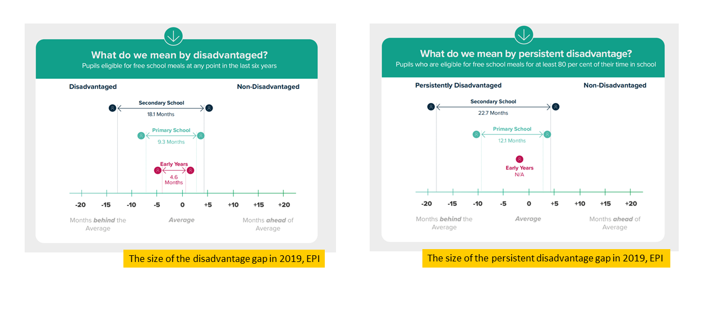
“Our vision is an education system where every child can thrive, no matter what their background.” (Ambition Institute, 2021)

The impact of expert school leaders
“We estimate that the impact of replacing a below-average elementary school principal (i.e., one at the 25th percentile of effectiveness) with an above-average principal (i.e., at the 75th percentile) would result in an additional 2.9 months of math learning and 2.7 months of reading learning each year for students in that school. Effects of this replacement in math would be larger than more than two-thirds of educational interventions compiled in a recent review, and the effects in reading would be larger than about half of interventions.” (Grimson, Egalite and Lindsay, 2021)
Expert school leaders have also been shown to impact:
- Pupil outcomes (Leithwood, 2008)
- Teacher turnover (Hanushek, 2013)
- Teacher satisfaction (Sims, 2019)

Reflection
- Why is it so important to close the attainment gap?
- Why are you seeking to develop your expertise as a school leader?
Notes

Developing expertise as a school leader
The challenge of school leadership
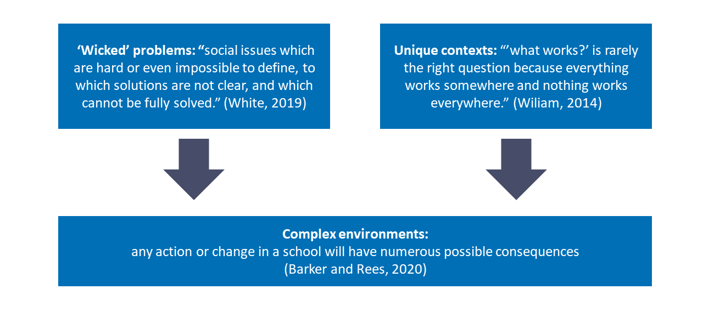
Notes

What is school leadership?
Viviane Robinson (2017) suggests effective leaders must have 3 key capabilities:
- Using deep educational knowledge...
- To solve complex educational problems...
- While building relational trust.

Persistent problems
Problem: A problem is a goal that needs to be achieved and a series of constraints that prevent that goal from being achieved.
Persistent problems are:
- Universal
- Controllable
- Causal
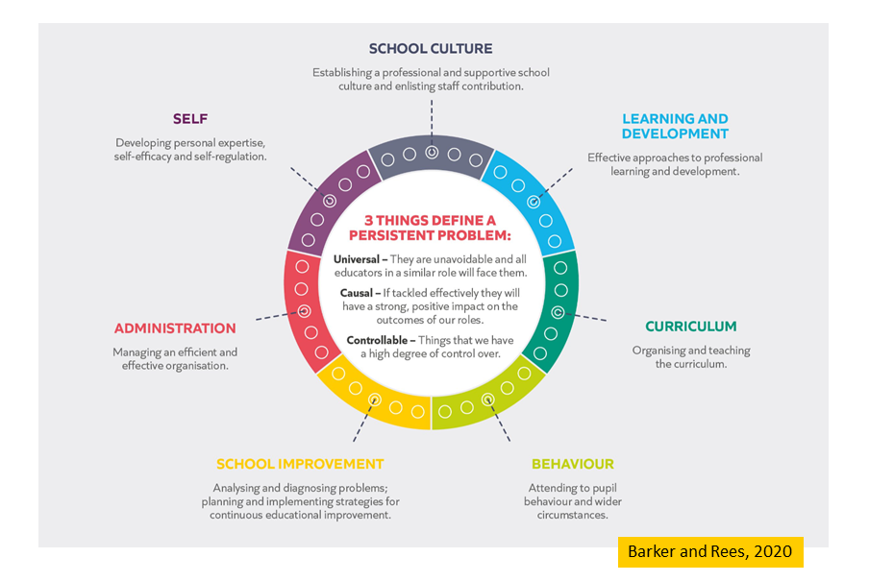

How do we develop expertise?

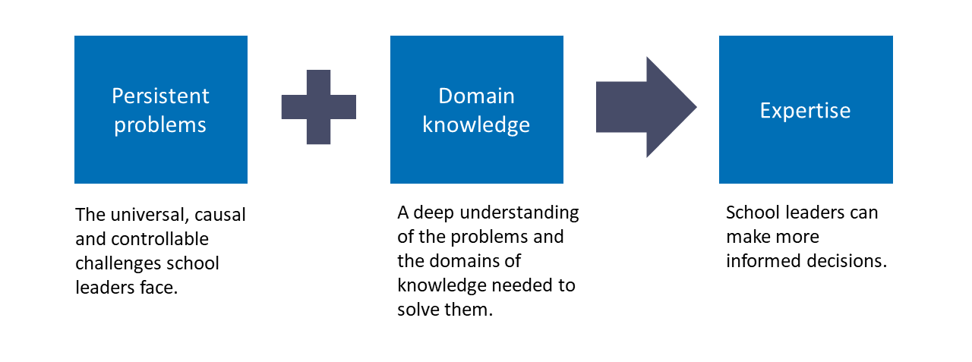
Notes

Reflection
- How can we develop expertise as school leaders? Use the words ‘problems’ and ‘knowledge’ in your answer.
- What impact will developing your expertise as a school leader have for you, your colleagues and your pupils? Developing my expertise will enable me to…

Notes

Introduction to the NPQEL
Programme principles
- Build knowledge: by the end of the programme, leaders will have built a deep educational knowledge about the persistent problems school leaders face. This will make them better decision makers.
- Be evidence informed: leaders will learn what the evidence suggests about these persistent problems (and what is unknown).
- Be sensitive to context: leaders will explore how their knowledge can be applied across different contexts. This will support them to consider how to apply their knowledge in their context.
- Apply strategically: leaders will be encourages to develop their expertise. They may choose to read more, review their current practice and when appropriate, apply what they have learned in their context.
- Keep getting better: leaders will be supported to continue to develop their expertise beyond the core content of the programme.

Notes

Programme overview
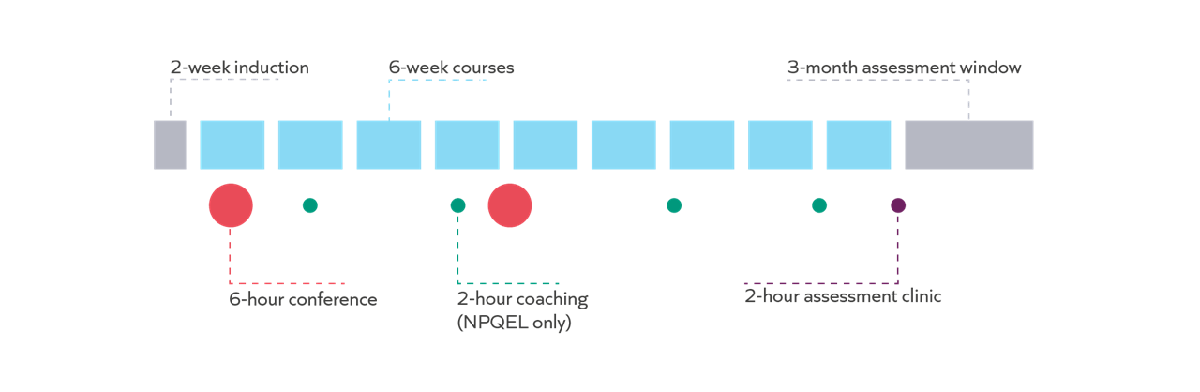
Communities sessions
- Communities sessions: problem solving with peers.

Additional support offer
- For new headteachers in their first two years of headship who are completing/have completed the NPQH.
- Support with diagnosing and tackling a problem of practice on a termly basis for 1 year.
- Support includes: coaching, pre and post coaching activities, shadowing opportunities (similar to school visits) and access to peer communities.

Programme journey

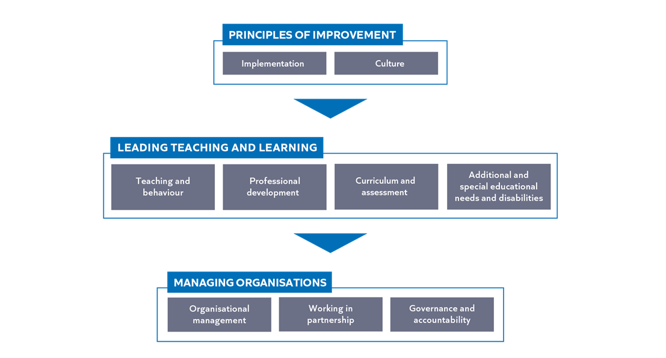

Course structure
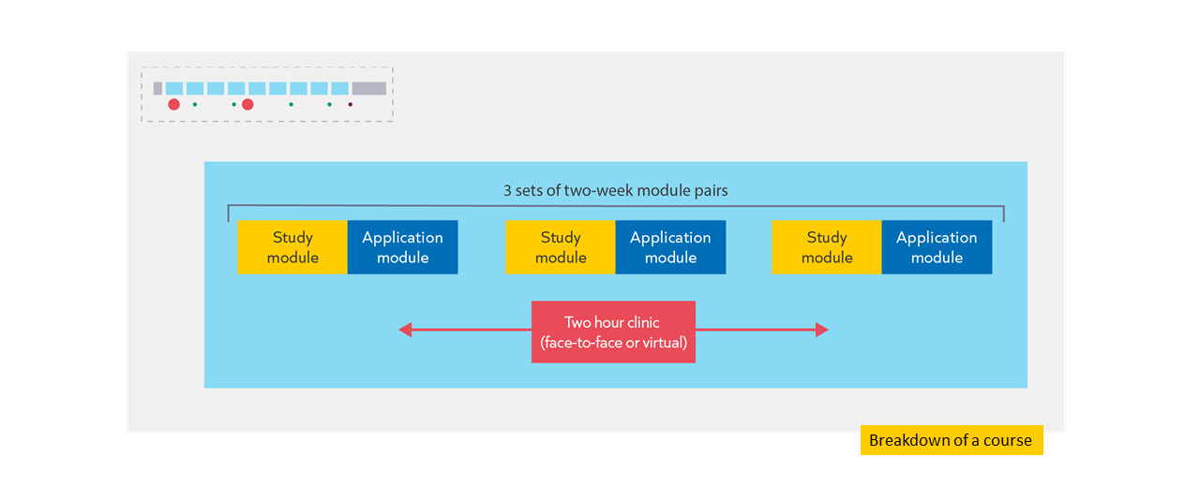

Assessment

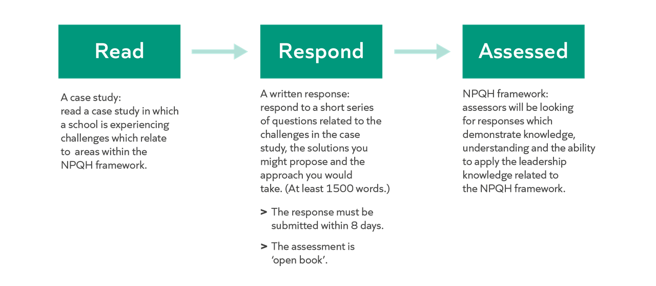
Support
Leadership knowledge | The programme is designed to build your knowledge of leadership, based on the NPQH framework. For example:  - Reading an evidence summary in each study module.  - Reading and analysing 2 examples that contextualise principles in each study module.  - Understand how to apply principles from a worked example of a scenario and leader’s response in each Clinic.  - Collaborate on a response to a scenario in each Clinic.
- A webinar before the assessment window.
- A live clinic before the assessment window.

Notes

Success on the programme
Attendance
- Attendance and engagement with all components of the programme are key to success.
- In pass your NQT you need to engage with at least 90% of the programme, across all components, and pass a summative assessment.

Types of knowledge
- Formal knowledge
- Informal knowledge
- Self-regulatory knowledge

Notes

Reflection:
Which activity could you do more of to keep getting better during and beyond the NPQEL?
- Developing formal knowledge: access suggestions from the NPQEL reading and listening more widely.
- Developing informal knowledge: reflecting and distilling experiences, and discussing with others.
- Developing self-regulation: prioritising professional development, for example through attendance and engagement, and prioritising wellbeing.

Notes

Work with others

“peer support and learning is a fundamental ingredient of effective CPDL” (Cordingley et al, 2015)

“all collaborations are not equal… or equally productive” (Runfeldt, 2015)

Norm | What does this look like?
Be brave
Be kind
Be present

Apply strategically

Example…
- A leader reflects on the knowledge they have acquired about leading literacy.
- They recognise that this is an area where they are not yet expert.
- They decide to follow up with the suggested reading and schedule to meet with the special educational needs co-ordinator, librarian and head of English over the coming weeks to improve their understanding of the current approach to literacy.
- They recognise there are areas which could be improved. However, when they review the School Improvement Plan they realise that its not feasible to address these areas right now given the current priorities. They continue to read around the topic to develop their expertise in readiness for improvements at a more appropriate time.

Non-examples…
Too much | - A leader reflects on the knowledge they have acquired about instructional coaching as a mechanism for delivering professional development.  - They recognise that this is an area where they are not yet an expert.  - However, they see that there is a strong evidence base so they decide to implement it starting next term.
Too little | - A leader reflects on the knowledge they have acquired about engaging parents and carers.  - They recognise that this is an area where they are not yet an expert.  - They assume that pastoral leaders in the school probably have more expertise in this area  so decide not to think about the topic further.

Notes

How people learn
Why do headteachers need to know about learning?

The role of the headteacher
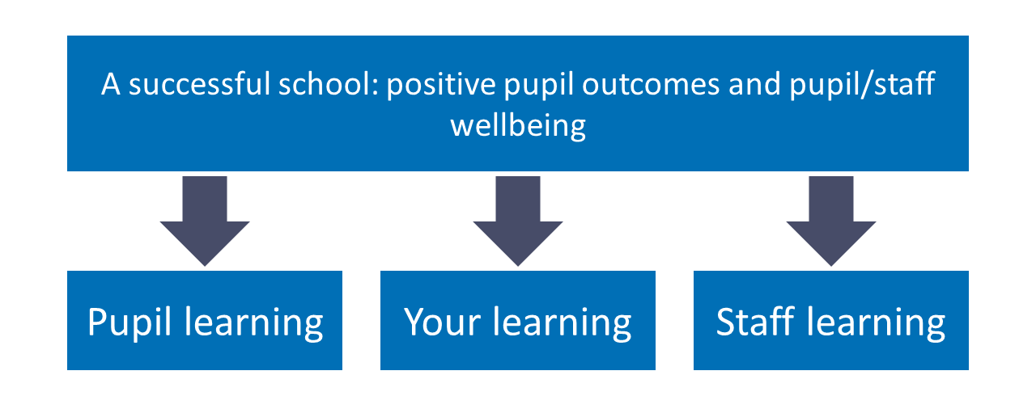

The importance of evidence
- Understanding the evidence enables leaders to make better decisions.
- Better decisions focus time and resources on more effective methods.

Notes

What is learning?

“Learning involves a lasting change in pupils’ capabilities or understanding.” (Department for Education, 2020).

Performance | Learning
Immediate change in behaviour or knowledge that can be observed and measured. | Lasting change in capabilities and understanding, which happens over time and is hard to observe.

Lasting change: implications

Pupil learning | Staff learning | Your learning
Mr Cobb knows that their pupils success in a end of lesson quiz today does not mean they have truly learnt this knowledge.  When reviewing teacher impact, Ms Gray knows she needs to look at learning  over time, not just in a single lesson. | Ms Gray plans for staff professional development over the long term, focussing on one thing at a time, rather than in disconnected episodes. | Ms Gray plans for staff professional development over the long term, focussing on one thing at a time, rather than in disconnected episodes.

Reflection
- What are the implications of the definition of learning for you as a school leader?
- What are the implications of the definition of learning for you as a school leader?

How do we learn?
Simple model of memory
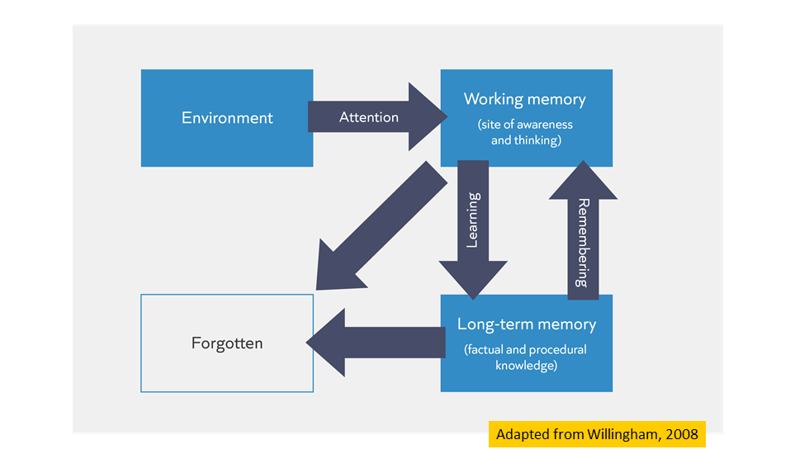

Learning and remembering
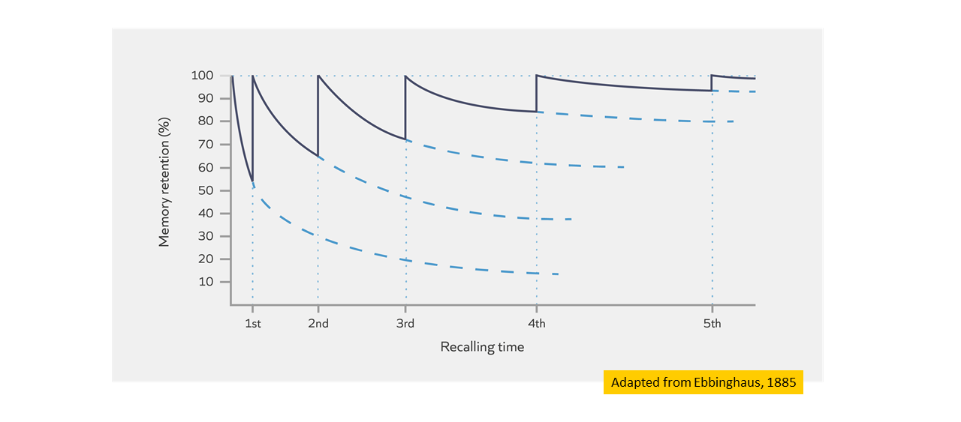
Notes

Check for understanding

Task: Which of these statements are TRUE?
- Learning is a lasting change in the learner's capabilities or understanding.
- Building knowledge in long-term memory is important because the better our prior knowledge, the more easily we can make sense of new information.
- Learners will struggle to build knowledge in long-term memory if they are cognitively overloaded.
- Retrieving, practising and thinking hard are all ways to guarantee the learner will become overloaded.
Notes

Learning and remembering: implications

Pupil learning | Staff learning | Your learning
Mr Smith designs questions that make sure pupils think hard about important information she has taught them.  Ms Amo supports subject leaders to build opportunities into curriculum plans to retrieve and practise taught content | Ms Carter breaks down a new teaching strategy into steps and models it to her teachers when training staff on it. She ensures they practise the same strategy many times over a term. | Ms James retrieves and explains what she has found out about in her NPQH module to other colleagues so she can revisit the knowledge and think hard about the underlying principles.

Notes

Mental Models

- Mental models: the knowledge you have about a particular topic and how that knowledge is organised.

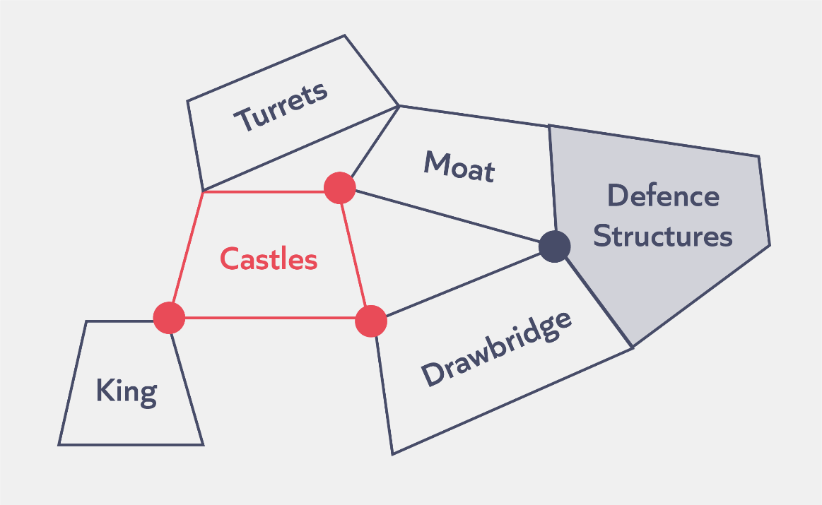
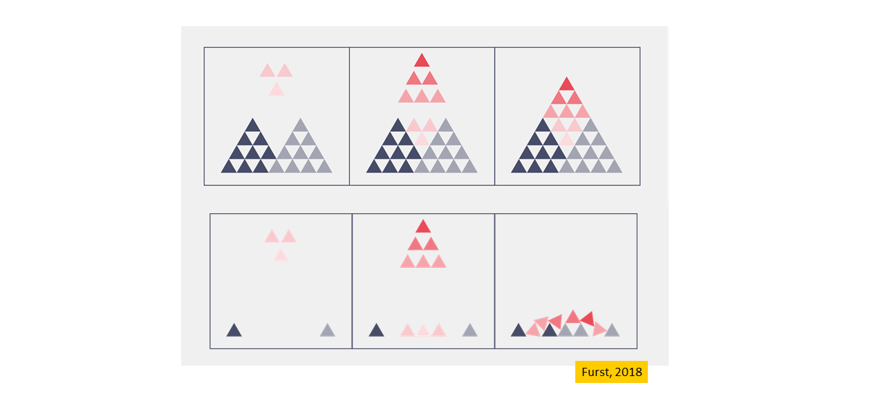

Check for understanding

Task: Which of these statements are TRUE?
- A leader’s mental model is all they know about school leadership.
- The more knowledge we have already learnt, the more successfully we can learn new knowledge in the future.
- Retrieval and practice helps to prevent knowledge being forgotten from our working memory.

Notes

Reflection
- Scenario: Kristy is a new headteacher. She has been approached by two senior leaders wanting to use professional development time to introduce changes to the way teaches plan lessons. Last month the school introduced a new marking policy.
- How does understanding the science of learning help Kristy make the best decisions when supporting this headteacher?
Notes

Experiencing a module pair
Programme journey
Course structure

Study module
Overview: study
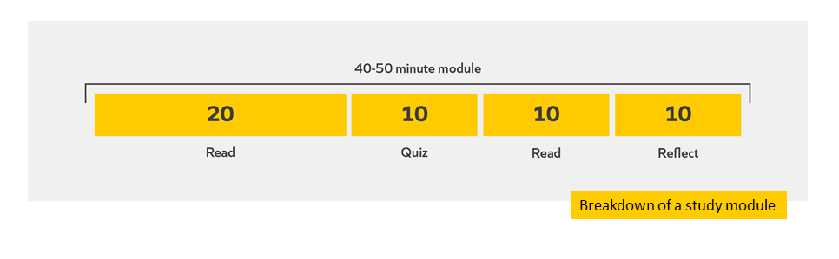
Notes

Evidence summary
Introduction
School leaders are responsible for making numerous decisions. How can they ensure that they make the best ones? Many school improvement strategies introduced to help pupils – from whole-school catch-up interventions, to giving each pupil a personal device like a laptop – simply do not work (Coe, 2013). Some of these strategies may not be based on secure evidence, others may be inappropriate in certain settings. Even when a strategy passes both these tests it can still be misunderstood, misshapen and misapplied. Meanwhile, new strategies exert a toll on teachers: they ask them to alter their routines, sometimes beliefs, and to invest in them time, energy and enthusiasm (Robinson, 2018). Many strategies, introduced to help pupils, do not work and increase the demands on teachers.
But other strategies do work, pupils reap the benefits, and the efforts of the teachers involved are rewarded. Why does this happen – some strategies fail and some succeed – and how might we shift the odds in our favour? There is no straightforward answer: strategies fail for a whole host of reasons, some of which are hard to predict (Coe, 2013). For example, some fail due to a lack of capacity or the right resources to implement, and some fail because the strategy is not implemented as intended. But taking a deliberate and structured approach to how a strategy is applied – what we’ll call from now on ‘implementation’ – is a best bet for leaders (Education Endowment Foundation, 2019a).
Implementation is not a single event that leaders can tick off and move on from, it is something that begins before a strategy has been introduced and continues until the strategy has been fully embedded into school life (EEF, 2019a).
Because implementation happens over a long time, and involves a range of specific implementation activities, it makes sense to break it down into stages. The Explore stage is where leaders identify what they want to do, while the Prepare stage is where leaders begin to create the conditions needed for it to be done well. The Delivery stage is when leaders focus on supporting colleagues to bring the strategy to life, and the final stage, Sustain, is the point at which leaders need to decide whether to stick or twist, scale up or try something else.
That’s what this course is about: how to use insights about implementation, across these four stages, to improve the odds that a school improvement strategy, introduced to help pupils, will work.
In this first module we will cover:
- Why we should focus on implementation
- The module principles of effective implementation
- The structure of this course

Guiding questions
Before you read on:
- Consider a time when you have been able to implement an effective school improvement strategy.
- What made this implementation effective?

References
Coe, R. (2013). Improving Education: A triumph of hope over experience. Centre for Evaluation and Monitoring. http://eachandeverydog.net/wp-content/uploads/2015/05/ImprovingEducation2013.pdf
Robinson, V. (2018). Reduce Change to Increase Improvement. Corwin.
Education Endowment Foundation (2019a). Putting evidence to work: a school’s guide to implementation. https://educationendowmentfoundation.org.uk/public/files/Publications/Implementation/EEF_Implementation_Guidance_Report_2019.pdf

Scenario
Nadia is the headteacher of a small, rural secondary school. She feels that the pupils in her school get too few opportunities in lessons to individually practise. She wants this to change. She likes the sound of a strategy a school in the next borough is running, which insists that pupils practise applying what they have just learnt for at least 10 minutes each lesson. Why should she pause to think about the implementation of this strategy before going ahead with it?
Why we should focus on implementation
“One of the characteristics that distinguishes effective and less-effective schools, in addition to what they implement, is how they put those new approaches into practice.” (EEF, 2019, p.3)

Many promising school improvement strategies introduced to help pupils are unsuccessful, at least in part due to ineffective implementation, such as teachers not utilising the strategy in the intended way (see for example: EEF, 2018; EEF, 2019b; EEF, 2019c). Getting implementation right therefore matters. But implementation is not an event, it is a process that will evolve over time in different ways depending on the context. It is also complex and rarely follows a simple trajectory. Getting implementation right is hard, but there is a structured process that Nadia can follow, made up of four stages, to guide her: Explore, Prepare, Deliver, Sustain. Each of these stages will be covered in more detail over the next few weeks, but for now here is a summary of each stage:
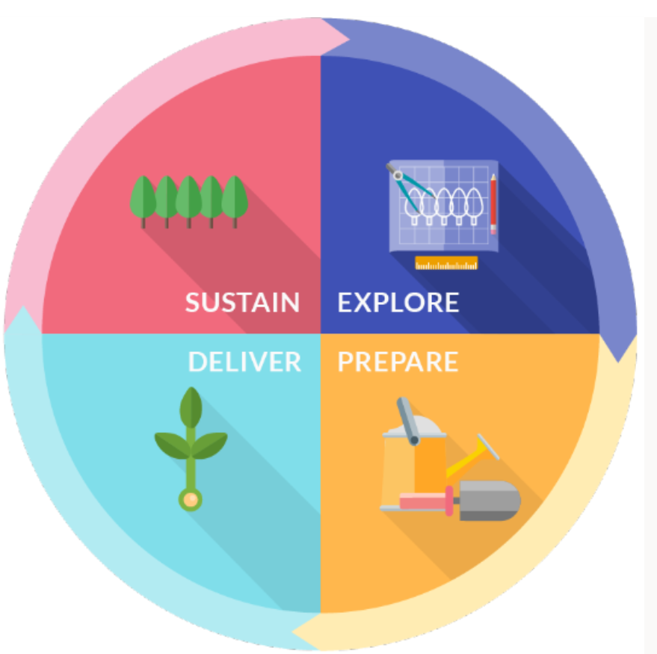
At the Explore stage leaders need to identify what problems exist that they can solve, what solutions exist to solve those problems, and work out the best fits for their context. Identifying the right problem and solution is critical: no amount of attention to the stages that follow can make an ineffective strategy effective or solve an unsolvable problem. By the end of this stage Nadia needs to know what she is doing and why she is doing it, if she wants to do anything at all.
At the Prepare stage leaders need to create the conditions that mean that colleagues can transform the idea on paper into something effective in practice. It is critical that leaders prepare as Robinson explains here: “Change is an extremely disruptive and costly process, in both a material and psychological sense… we do need to reduce the number of failed change efforts by being more thoughtful, before changes are adopted, about their likelihood of success and about the conditions required to ensure improvement.” (Robinson, 2018, pp.5-6) By the end of this stage Nadia needs to have plotted a journey from start to finish – one that has identified what training and resources will be needed along the way, when and how the strategy will be evaluated – and this will need to have been communicated with colleagues.
At the Deliver stage leaders need to make sure that colleagues are putting into practice what they planned on paper. School improvement strategies are rarely plug-and-play, and even those with a strong evidence base can be done well or done badly (Coe in Rose & Eriksson-Lee, 2017). Although every project tends to adapt slightly over time – sometimes for the better – the more faithful the delivery is to the principles that make the strategy effective (its ‘Active Ingredients’) the better (EEF, 2019a). By the end of this stage Nadia needs to have done what she can to make the strategy a success: now comes the decision on what to do next.
At the Sustain stage leaders have a decision to make: to scale up or scale back. It is at this stage where poor implementation can come back to bite: a leader who cannot tell if an unsuccessful strategy failed to take off because the core idea was not sound (intervention failure) or if it could have worked under the right conditions (implementation failure) cannot reliably know if he is right to stop it or if she is dumping a perfectly reasonable strategy unnecessarily (Proctor et al., 2011). Whatever Nadia decides to do when she reaches this stage, providing that she has carefully managed the previous three stages she can be confident in her decision.
Module principles
One of the key aims of each course is to help participants focus on the key underlying ideas, or ‘deep structures’, instead of surface level features. This is intended to help participants transfer and apply their knowledge in their own context.
Take this example from the classroom. Here are two mathematics problems with very different surface level features but a common ‘deep structure’:
- Sarah and Nick have 20 sweets between them. Sarah has three times as many sweets as Nick. How many sweets does Sarah have?
- A T-shirt normally costs £18 but has 25% off in a sale. How much does the T-shirt cost in the sale?
Here, an understanding the deep structure of these problems would allow someone with more expertise to see that both problems can be solved in the same way (by finding three-quarters of the total amount).
As ‘deep structures’ is a general term, we will call the ‘deep structures’ for each module the ‘module principles’. This next section will introduce the module principles for the module on effective implementation.
The module principles of effective implementation
Nadia has now been introduced to the four stages of implementation. But before she goes any further with her plan to introduce more individual practise opportunities, she wants to know a bit more about what principles sit behind effective implementation. Below are nine principles she will need to consider. Some are specific to a stage within implementation, whilst others she will need to bear in mind throughout. These principles will appear across all the modules in the Implementation course and are called ‘module principles’:
Patient: Keep in mind that implementation is a process, not a one-time event. While all changes within a school will run to different schedules – from smaller tactical changes to larger strategic ones – it is not uncommon for the implementation process to last for in excess of two years, from start to finish, on a change project (Nadeem et al., 2018). While this will represent challenges for schools, leaders who invest time and resource before adoption, and move deliberately and carefully during delivery, are more likely to reap the rewards (EEF, 2019a). Nadia needs to make sure that in her haste to make her school better she does not rush introducing a change, and in doing so reduce its overall impact.
Prudent: Make as few changes as possible whilst maintaining an effective and improving school. We tend to underestimate how long projects will take to deliver (Kahneman & Tversky, 1979). This phenomenon is known as the ‘planning fallacy’ and is the underlying reason for why good implementation starts from a foundation of prioritisation: pick fewer strategic changes, but approach them diligently. Leaders need to recognise that managing multiple school improvements at once is complex and may even damage the chances of success. Both reviewing and stopping existing strategies, as well as prioritising only the most promising new strategies, mean that leaders can focus on doing less better. Nadia needs to make sure that she creates the time and resources her staff need in order to do the job well.
Context-specific: Consider the fit and feasibility of any change given the context within which it would need to be delivered. Leaders must avoid conflating ‘what has worked’ with ‘what will work’. Very few interventions could be considered ‘plug-and-play’. Some interventions may work more or less well in one context compared to another. They might be more effective at one time compared to another (for example, if staff capacity or motivation for change is higher in a given year compared to another). And some strategies will rub up against a school’s vision, mission and values, whilst for other schools it might slot neatly into place. Nadia needs to ensure that any changes she makes are consistent with what her school wants to and plausibly can achieve.
Needs-based: Start by understanding the problem before looking for the solution. Although Nadia may believe that more individual practice for pupils might be a good thing, is she sure that this is a strategy that is worth investing significant time, resource and energy into? Problems with attendance in Year 9 or retaining early-career staff might be more pressing and solving them might yield better results. Nadia cannot resolve every issue within her school immediately, so she needs to identify what the biggest issue is right now.
Evidence-informed: Make changes based on the best available evidence and knowledge of the context. Some strategies are more effective than others, and some strategies will be more effective in certain contexts than other contexts. Nadia has heard good things about the practice strategy being delivered in the school near her, but she knows far less about how effective it really is, anecdotal evidence aside, and whether that same strategy would work in her context. She needs to be sure that it is the right strategy to deliver before she focuses on how to deliver it.
Prepared: Invest time and resource into the planning stage. When it comes to delivering a large-scale change “[t]he better you ‘till the soil’, the more likely it will be for roots to take hold” (EEF, 2019a, p.8). Nadia needs to have clarity on why she wants to make a change, what will be involved both in making it happen and how that will be resourced, and how she will know if things are working or not. Without sufficient investment at this stage, she will run into trouble further down the line (for example, she may struggle to communicate her idea to her colleagues who will be responsible for delivering it).
Proactive: Reduce the barriers and increase the facilitators for effective implementation from the beginning and throughout. For the implementation of any change to be given a chance to succeed, the school needs to have the right enabling conditions or an ‘implementation-friendly climate’ (EEF, 2019a). For example, if Nadia wants her staff to introduce a new strategy into their lessons, she needs to have created a culture where all staff feel trusted to try, and even make mistakes, safe in the knowledge that they will be supported through encouragement and, if necessary, training. Nadia might lead on this, but this does not solely rest on her. Implementation benefits from leaders at all levels setting out a clear and positive vision for colleagues to buy into, and receiving feedback from colleagues on what is and is not working throughout. Only once Nadia and her team have created the enabling conditions in her school – staff trust, buy-in, capacity – and prepared a clear plan for delivery will she be ready to put her change into action.
Intentional: Follow a carefully planned and responsive process to delivering the improvement. Delivery is an ongoing process that must adapt to context over time, and is made up of specific implementation activities. An intentional approach is about moving away from random acts which may lead to random success, to being purposeful and deliberate. Nadia’s role in monitoring what is happening and who needs support, modelling what she wants to see, motivating colleagues to persist and modifying her strategy based on observation and feedback will be crucial to its overall success.
Secure: Make informed decisions on scaling-up or scaling-back. Leaders need to collect and analyse data that can tell them whether or not a change has proven a success. If it has, then they may wish to begin preparing for its scaling up or for it to become further embedded. But sometimes a strategy a leader has invested their time and energy into will fail to work. While this can be disappointing it is important to acknowledge it, because knowing this allows leaders to invest in something else, perhaps something that will work. Afterall, “[i]t is not unreasonable that we grapple with problems. Our responsibility is to do what we can, learn what we can, improve the solutions and pass them on” (Feynman, 1955, p.15). Provided that Nadia has stuck closely to the previous eight principles, she should be well-placed to make a decision on what to do next.
The process of implementation
“Implementation can be described as a series of stages with activities relating to thinking about, preparing for, delivering, and sustaining change.” (EEF, 2019, p.8)

Nadia knows that she needs to learn more about implementation before she takes her proposal any further. What should she focus on?
Over the next few weeks on this course, you will focus on four phases of the Education Endowment Foundation’s Implementation framework:
- Explore: how to pick the right problem, select the right solution and assess the fit for your context.
- Prepare: how to prepare for delivery, prepare for evaluation, and prepare your context for change.
- Deliver and Sustain: how to deliver change, decide on what to do next, and sustain change.
Summary
Overall, Nadia has three key takeaways:
- Implementation is a process, with stages and activities carried out over time. It is not a one-off event.
- The process of implementation can be broken down into the stages Explore, Prepare, Deliver and Sustain
- Effective implementation requires leaders to be patient, prudent, context-specific, needs-based, evidence-informed, prepared, proactive, intentional and secure.
Caveat
The series of stages, as depicted in the Education Endowment Foundation’s guidance, should not be interpreted as saying that implementation is a linear process. Implementation in the real-world is a messy process. Whilst some activities should always precede others – for example, exploring credible solutions will always precede training staff on how to use those solutions – other activities will be ongoing – for example, asking for and receiving staff feedback.
Further reading
If you enjoyed this module, and you would like to discover more, we recommend reading the following:
- Education Endowment Foundation (2019a). Putting evidence to work: a school’s guide to implementation. https://educationendowmentfoundation.org.uk/public/files/Publications/Implementation/EEF_Implementation_Guidance_Report_2019.pdf
References
Banerjee, A. (2007). Inside the machine. https://economics.mit.edu/files/5850
Coe, R. (2013). Improving Education: A triumph of hope over experience. Centre for Evaluation and Monitoring. http://eachandeverydog.net/wp-content/uploads/2015/05/ImprovingEducation2013.pdf
Feynman, R. P. (1955). The value of science. Engineering and Science, 19, 13–15. https://calteches.library.caltech.edu/1575/1/Science.pdf
Education Endowment Foundation. (2018). Good behaviour game: Evaluation report and executive summary. https://educationendowmentfoundation.org.uk/public/files/GBG_evaluation_report.pdf
Education Endowment Foundation. (2019a). Putting evidence to work: a school’s guide to implementation. https://educationendowmentfoundation.org.uk/public/files/Publications/Implementation/EEF_Implementation_Guidance_Report_2019.pdf
Education Endowment Foundation. (2019b). Digital feedback in primary maths: Evaluation report. https://educationendowmentfoundation.org.uk/public/files/Projects/Evaluation_Reports/Digital_Feedback.pdf
Education Endowment Foundation. (2019c). The Rise Project: Evidence-Informed School Improvement. https://educationendowmentfoundation.org.uk/public/files/Projects/Evaluation_Reports/RISE_Report_final.pdf
Kahneman, D., & Tversky, A. (1979). Intuitive prediction: Biases and corrective procedures. TIMS Studies in Management Science, 12, 313-327 https://citeseerx.ist.psu.edu/viewdoc/download?doi=10.1.1.469.2095&rep=rep1&type=pdf
Nadeem, E., Saldana, L., Chapman, J. & Schaper, H. (2018). A Mixed Methods Study of the Stages of Implementation for an Evidence-Based Trauma Intervention in Schools. Behaviour Therapy. 49(4): pp. 509–524. https://doi.org/10.1016/j.beth.2017.12.004
Proctor, E., Silmere, H., Raghavan, R., Hovmand, P., Aarons, G., Bunger, A., Griffey, R. & Hensley, M. (2011). Outcomes for Implementation Research: Conceptual Distinctions, Measurement Challenges, and Research Agenda. Administration and Policy in Mental Health and Mental Health Services Research, 38(2) p65–76. https://www.ncbi.nlm.nih.gov/pmc/articles/PMC3068522/pdf/10488_2010_Article_319.pdf
Robinson, V. (2018). Reduce Change to Increase Improvement. Corwin.
Rose, N. & Eriksson-Lee, S. (2017). Putting evidence to work: How can we help new teachers use research evidence to inform their teaching?. Teach First. https://www.teachfirst.org.uk/sites/default/files/2019-08/Putting_Evidence_to_work_2017.pdf
Reflection
- What is helpful about the evidence summary section?
- How will the evidence summary section help to build your mental models?
- Do you have any questions?

Quiz
Task: answer the following questions
- Effective implementation matters because:
  - It will ensure that new behaviours are adopted quickly
  - It will give a change the best chance of succeeding
  - It will ensure the intervention leads to positive outcomes

- What do leaders need to have created before beginning the implementation process?
  - A culture of high levels of trust
  - A culture of high-stakes accountability
  - A culture of high levels of autonomy

- Which of these stages involves picking the right problem to address before deciding what strategy to implement?
- Explore
- Prepare
- Deliver
- Sustain
Reflection
- What do you need to do to make the most of the quiz section?
- How will the Check section help to build your mental models?
- Do you have any questions?

Notes

Examples and reflection
Read example 1 and answer the reflection questions
Introduction
My name is Rachel and I’ve been headteacher at Marlstone Primary School for the last four years. We are part of a trust of schools who all share about 80% of the curriculum content that we teach. Two years ago, a new primary school joined our trust and quickly adopted our curriculum content. That experience has stuck with me because it did not go so well: we introduced the curriculum too fast before teachers felt ready to teach it, which led to a drop in their results and this relationship has been hard to rebuild. We realised that we never really asked ourselves if introducing a new curriculum, so soon after the school had joined, should have been our priority. It was a reminder that we can be quick to introduce new ideas that we are enthusiastic about, but occasionally too slow to ask if it is the right decision for that context at that time.
In this next section we will be focusing on how headteachers might approach the task of deciding whether or not an idea is worth pursuing, and how they can create the ideal conditions for success. We can focus our strategic thinking around the following three principles:
- Prudent: Make as few changes as possible whilst maintaining an effective and improving school.
- Needs-based: Start by understanding the problem before looking for the solution.
- Evidence-informed: Make changes based on the best available evidence and knowledge of the context.
Example 1
Scenario
I am a headteacher of a medium-sized secondary school on the outskirts of a large town. My senior leadership team – made up of vice principals for assessment and curriculum, behaviour and pastoral care and professional development – have all come to me with new strategies that they are proposing we implement. It is clear to me that managing all these strategies at once will be too complex and lead to worse outcomes across all three. We need to focus on just one. Here is how I came to my decision on what to do.
Narrative
Be prudent
In this case, the school’s senior leaders all believed that they had a sensible strategy to offer. The Vice Principal for Assessment and Curriculum wanted to introduce some of the principles from the science of learning into our current curricula where they were obviously absent. The Vice Principal for Behaviour and Pastoral Care wanted to introduce a new behaviour management system which included parents receiving text messages when pupils were given two warnings in a lesson. And the Vice Principal for Professional Development wanted to introduce a mentoring programme for senior leaders and middle leaders new to their role, including new heads of department and pastoral leads. All had potential benefits, but for any of them to work I needed to be prudent, which meant making as few changes as possible whilst maintaining an effective and improving school. I therefore decided that I would select just one of the strategies to pursue, if any at all.

Be needs-based
To make this decision I needed to be needs-based and start by understanding the problems in my school, rather than looking at the solutions I was being offered. The data from our internal systems suggested that behaviour was not a major issue within the school, in fact overall behaviour and attendance scores were improved from the previous year. The behaviour at our school was far from perfect, but it was not a problem that needed urgent attention. Mentoring for new middle and senior leaders was slightly more tricky. We had not collected any data on this issue, and so the initial meeting amounted to various anecdotes being shared about how leaders had expressed that they would like a mentor for a number of reasons. I asked the Vice Principal to produce a survey to establish how typical these views were. The responses suggested that this was indeed an offer new leaders wanted, and so it remained in contention. However, an investigation of our curriculum materials led me to believe that this was where we needed to invest our time in the short-term. In one department in particular, major concepts appeared to be introduced and then never returned to – it was as though pupils were expected to remember everything from Year 10 having only encountered these ideas once.
Be evidence-informed
Having narrowed down my options to introducing principles from the science of learning into our curricula materials – for example, ensuring that pupils returned to key ideas more than once – I finally needed to decide whether this was worth the investment, if it should be ignored in favour of something else that had not yet been suggested, or if we should just concentrate on doing what we were already doing better. This involved sitting down with the Vice Principal and discussing the research that sat behind it. Although we had both heard about the importance of the science of learning, we decided to invest in really understanding the principles behind the strategy because if we were going to successfully implement this strategy we knew that we needed to have expert knowledge, otherwise we would not be able to explain our rationale to colleagues. He shared summaries of papers he had read, and we talked about if and how they might work in our school. I decided to go ahead with the strategy because based on the best available evidence and knowledge of my context the strategy seemed to be reasonable, it fitted with our strategic direction to improve our results at Key Stage 4 and, if we got it right, would probably have a positive impact on pupils. We could have tried to implement this alongside the mentoring scheme, but we decided that it would be better – such was the potential benefit to pupils – that we focus on this one strategy diligently.
Next steps
Some of the teachers at our school knew a lot about the principles we were asking to be introduced into our curricula – spacing material out over time, giving pupils opportunities to retrieve prior knowledge and testing pupils on material using formative assessments. However, many other teachers were less familiar and so we decided to invest money and time for the Vice Principal to create some training materials which she would deliver to Middle Leaders who would, in turn, deliver to their departments with subject-specific examples. We also looked at where we could piggy-back on existing policies, strategies and routines, many of which our teachers had become used to. Where possible we are looking to repurpose existing processes and resources – for example, using existing meeting times used for training to introduce the principles – rather than creating a separate set of procedures. Time will tell how well it works.
Caveat
As Sharples and colleagues note: “There are legitimate barriers to implementing effectively in schools” (p.4). Schools may need to take action, and fast, even when they do not have all the information (for example, in response to the COVID-19 pandemic). This is unlikely to change any time soon. The purpose of this course is to develop a mental model for how to approach implementation even when the conditions are far from ideal.
Analyse
- How did the leader demonstrate the principle ‘prudent’?
- How did the leader demonstrate the principle ‘needs-based’?
- How did the leader demonstrate the principle ‘evidence-informed’?
Notes

Reflect
- What is helpful about the examples and reflection section?
- How will the examples and reflection section help to build your mental models?
- Do you have any questions?

Reflection
- How does the study module help to build your mental model?
- Do you have any questions about the study module?
- How can you make the most of the study module?

Notes

Application Module
Overview: application module
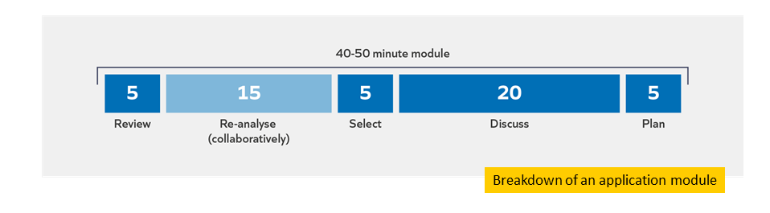
Re-analyse
Task: Discuss the reflection questions from the study module with your partner. Strive to:
- Be brave: ask questions, share insights and experiences
- Be kind: respectful, supportive, active listening
- Be present: be fully engaged, keep to time

Reflection
- What is helpful about the re-analyse section?
- How will the re-analyse section help to build your mental models?
- Do you have any questions?

Notes

Select
Task: Select the most appropriate and useful application task for you and your context.
Module principle | Application task
Proactive: Reduce the barriers and increase the facilitators for effective implementation from the beginning and throughout. | Read: Read pages 8-11 of the Education Endowment Foundation’s ‘Putting Evidence to Work: A School’s Guide to Implementation’  - How do the authors suggest that leaders can create an ‘implementation-friendly climate’?  - What is the role of leadership in implementation?
 | Review: Review your school’s current approach to creating an implementation-friendly climate.
 | Do: Identify the key barriers to implementation in your school right now – use page 18 of The Health Foundation’s report ‘What’s getting in the way?: Barriers to improvement in the NHS’ to help.
Prudent: Make as few changes as possible whilst maintaining an effective and improving school. | Read: Read a summary of ‘People systematically overlook subtractive changes’  - What might you be able to stop doing which might have no adverse effect or improve your effectiveness?
 | Review: Review the number of school improvement activities that you are currently managing and compare them against your strategic aims.
 | Do: Conduct a ‘sludge audit’ in which you identify some not especially helpful activities that could be removed to give you and your colleagues more time to do better things in the future.

Discuss
- Which of these principles are most relevant to your context/role? Which did you choose and why?
- What do you plan to do next? How do you hope this will enhance your expertise and impact?

Plan

Example | Non-example
- To conduct the sludge audit (Wednesday period 4)  - To review the sludge audit with each vice principal in our weekly line management meeting  - To read Education Endowment Foundation Guide to Implementation (next Thursday AM) | - Be more prudent in future implementation planning

Task: Plan your next steps.

Reflection
- How does the Application Module help to build your mental model?
- Do you have any questions about the Application Module?
- How can you make the most of the Application Module?

Notes

Experiencing a clinic

Clinic overview
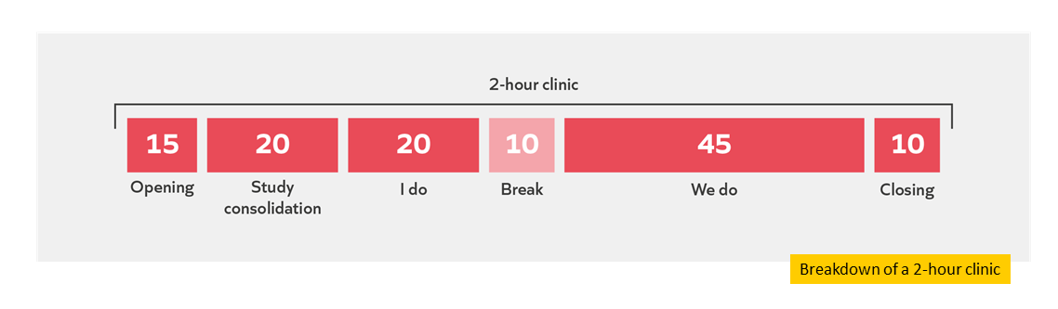

Study consolidation

Module principles
Needs-based | Start by understanding the problem before looking for the solution.
Evidence-informed | Make changes based on the best available evidence and knowledge of the context
Proactive | Reduce the barriers and increase the facilitators for effective implementation from the beginning and throughout.
I do
Task: Read the scenario.

Scenario
A headteacher was recently appointed to a school where reading data from pupils in Early Years had shown a steady decline in recent years. Multiple reading-related projects and programmes were running in the centre and had been for a while. These included a project where teachers worked with parents, a volunteer reading programme and early language interventions to support communication. However, many of the children were still not making expected progress in their reading: they struggled with decoding words and their comprehension skills were weak.
The headteacher and the lead teacher for literacy conducted a robust diagnosis process focusing on the problem (reading attainment). They triangulated relevant data: they spoke to teachers, observed lessons and analysed reading data for the different classes and groups of pupils. They identified that teaching was inconsistent: some teachers taught using whole language approaches, others used phonics. Having identified a problem that needed resolving, one that was in-line with the aims of the centre and its strategic direction, the headteacher set about finding a solution.
The headteacher tasked the lead teacher for literacy to look at the available research-informed guidance on whole language vs. phonics approaches. His lead teacher for literacy informed him that the evidence base suggested phonics would support pupils to decode words. He stressed that it was not a silver bullet: teachers still needed to read to pupils, model how to use vocabulary etc. but phonics has a strong evidence base for supporting pupils with decoding. The headteacher therefore decided to keep the other projects and programmes running as he suspected they might support the pupils’ comprehension. After combing through a number of programmes, evaluating the evidence behind each one, they settled on one that seemed to have the strongest evidence base.
The headteacher knew that implementation is a process not a single event, so he and his lead teacher for literacy would need to plan and prepare before delivering the change. With the lead teacher for literacy, he drafted the following plan which outlined a long-term approach:
Why do we need to make a change? | What are we going to do about it? | How will we measure the impact?
- Too few pupils are making expected progress in reading, which is partially the result of inconsistent and sometimes ineffective teaching strategies.  - If not resolved, this will lead to long-term disadvantages for these pupils. | - We are going to introduce systematic synthetic phonics to every EYFS teacher. They will then teach reading using these techniques with all pupils from half term 4.  - Teachers will have an initial professional development session.  - They will use 30 mins of their weekly professional development time to tackle issues with teaching phonics.  - Supportive learning walks will be used to pick up on successes and common areas for improvement to inform future training sessions. | - We will compare how this cohort performs on reading assessments compared to a previous, similarly-matched cohort.  - We will continue trialling this next year to see if pupils who receive a full year’s worth of teaching this way benefit compared to this year’s pupils who will receive it for less than half a year.
When everyone returned after the Christmas break, the lead teacher for literacy delivered the initial training session. Here she introduced staff to the evidence base and rationale for the change in line with the strategic direction of the centre. She demonstrated how to use phonics and set out the long-term training plan.
A month later, the headteacher decided to observe some reading lessons. He noticed inconsistencies creeping in again: some teachers were trying to use phonics and not doing it very well, and others were not using it at all.
He asked the teachers why they were not using phonics as they had been trained. One comment seemed to sum up the rest:
“I found the training useful and want to use phonics but between coordinating the volunteers and parents, interventions and my other planning, I found it really hard to do that as well.”
Question: Taking into account what you have learnt on this course -
a) What might be effective about this headteacher’s decision making?
b) What suggestions do you have to help them potentially make more effective decisions next time?
Refer to the relevant module principles in your answers.

Task: Make notes while the facilitator models how to respond to the question.

Notes

Module principle | Response/advice
Needs based
Evidence informed
Proactive
Reflect
- How will the ‘I do’ section help to build your mental models?
- What do you need to do to make the most of the ‘I do’ section?
- Do you have any questions?

Notes

We do
Task: Read the scenario.

Scenario
A headteacher has just returned from a visit to an Ofsted-rated ‘Outstanding’ school several hours away from her own. Her school is quite different: it is rated as ‘Requires Improvement’. When she was escorted around the school she visited, she noticed how motivated and engaged all the pupils there were. The teachers had pupils working in pairs and groups for parts of the lesson, usually once pupils had been taught some material and shown a good grasp of it. In contrast, she felt many of the pupils seem to lack motivation. This, she reasoned, is leading to poor behaviour in class. Her school had up to 40 pupils in detention after school each day. Teacher morale was also low, with many claiming pupils were too chatty and interrupted them constantly to the point where they could not finish their expositions.
Back at her own school, she shared with her own senior leadership team how motivated the pupils were and how she noticed in each lesson there was a real emphasis on group and paired activities. This was something she wanted her staff to use. To this end, her teaching and learning lead sent the Education Endowment Foundation’s (2018) paper on ‘Collaborative learning’, research-based guidance on how paired and group work can be used effectively in schools to senior leaders and led a discussion group on best practice principles. They fed back that, in line with the guidance, teachers would need training on how to plan carefully for group or paired work in lessons, would need support with devising routines for group work and teachers would need to model explicitly the behaviours they needed to see from pupils. The headteacher tasked her teaching and learning lead with developing training and gauging willingness from the staff to use paired and group activities. As well as doing whole-staff training, she was pleased that her teaching and learning lead was repurposing existing resources: the school had a well-established coaching programme for teachers and coaches could be trained to focus some of their observations and feedback on supporting teachers to use paired and group work effectively. Staff also seemed willing to give the approach a go.
After viewing the teaching and learning lead’s training plan, the headteacher realised it was not enough to have robust training and support: they needed to create capacity for teachers by reviewing and stopping any ineffective practices first. The headteacher decided to phase out work with an external provider on literacy since this took up a significant portion of professional development time and a recent review from the literacy lead in school indicated teachers felt they had got what they needed from the programme.
However, after a term of training, there were still just as many, if not more, pupils in detention. The teaching and learning lead reported that group and paired discussions were being planned purposefully and teachers were modelling the behaviours and routines they needed to see, but low-level disruption continued and was often harder for teachers to manage during group activities. The teaching and learning lead felt they might have been wrong to insist teachers use group and paired work.

Task: Respond to the following question independently, then discuss with your partner.
Question: Taking into account what you have learnt on this course -
a) What might be effective about this headteacher’s decision making?
b) What suggestions do you have to help them potentially make more effective decisions next time?
Refer to the relevant module principles in your answers.

Module principle | Response/advice
Needs based
Evidence informed
Proactive

Reflect
- How will the ‘We do’ section help to build your mental models?
- What do you need to do to make the most of the ‘We do’ section?
- Do you have any questions?

Notes

Reflection
- How does the clinic help to build your mental model?
- Do you have any questions about the clinic?
- How can you make the most of the clinic?

Notes

References
Barker, J. & Rees, T., (2020) Complexity, Purpose and Problems in School Leadership. Ambition Institute. https://www.ambition.org.uk/blog/complexity-purpose-and-problems-school-leadership/
Bereiter, C., & Scardamalia, M. (1993). Surpassing ourselves: An inquiry into the nature and implications of expertise. Chicago, IL: Open Court.
Cordingley, P., Higgins, S., Greany, T., Buckler, N., Coles-Jordan, D., Crisp, B., Saunders, L., Coe, R. (2015) Developing Great Teaching: Lessons from the international reviews into effective professional development. Teacher Development Trust.
Education Policy Institute [EPI], 2020, Education in England: Annual Report 2020. https://epi.org.uk/publications-and-research/education-in-england-annual-report-2020

Furst, E., 2018. Learning in the brain. https://sites.google.com/view/efratfurst/learning-in-the-brain
Grissom, J., Egalite, A., Lindsay, C., (2021) What Great Principals Really Do. ASCD. https://www.ascd.org/el/articles/what-great-principals-really-do
McCrae, P. (2018). Expert teaching: What is it, and how might we develop it. Institute for Teaching.
https://www.ambition.org.uk/research-and-insight/what-is-expert-teaching/
Robinson, V. (2017). Capabilities required for leading improvement: Challenges for researchers and developers. ACERsSearch https://research.acer.edu.au/cgi/viewcontent.cgi?article=1306&context=research_conference.
Rose, N, (2018) The role of forgetting as we learn. Ambition Institute. https://www.ambition.org.uk/blog/why-forget/
White, B., 2019. ‘The Wicked Problem of school improvement’ on Walden Education. https://benjamindwhite.wordpress.com/2019/07/25/the-wicked-problem-of-school-improvement/
Wiliam, D., 2014. Spoken Presentation. Research ED: http://www.dylanwiliam.org/Dylan_Wiliams_website/Presentations_files/2014-09-06%20ResearchED.pptx
Willingham, D., 2009. Why Don’t Students Like School? A Cognitive Scientist Answers Questions About How the Mind Works and What It Means for the Classroom. Jossey-Bas 2nd edition.

