NPQLTD Conference
Participant Workbook
Name: ………………………………………………………………………………..
Session date: ………………………………………………………………………
INSERT DOCUMENT TITLE HERE
Welcome and setting norms
Our values
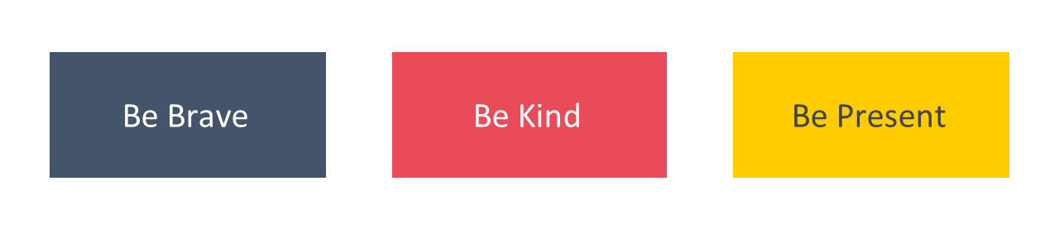
Agenda for today
Timings | Session
 | Welcome and setting norms | 20 mins
 | Leadership and your NPQLTD | 75 mins
 | How people learn | 45 mins
 | Experiencing a module pair | 90 mins
 | Experiencing a clinic | 60 mins
 | Close | 10 mins

Leadership and your NPQLTD
Introduction to school leadership
The importance of expert school leaders
The disadvantage gap
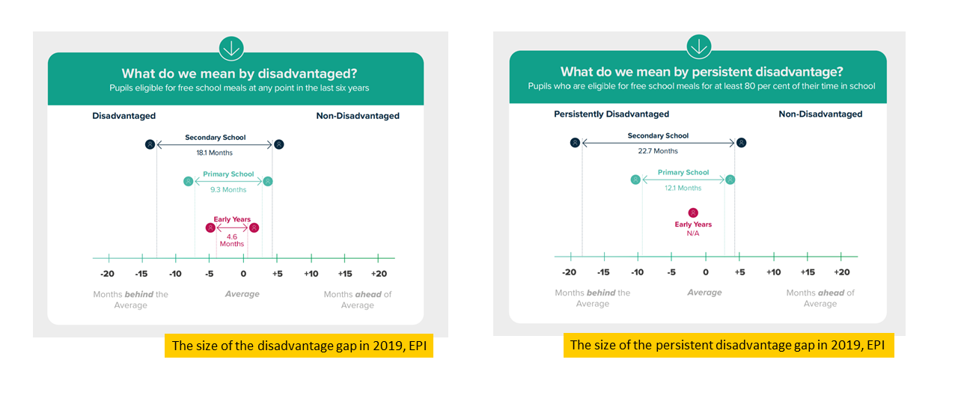
“Our vision is an education system where every child can thrive, no matter what their background.” (Ambition Institute, 2021)
The importance of quality teaching
The most rigorous academic papers find consistent and significant results: having a very effective, rather than an average teacher raises each pupil’s attainment by a third of a GCSE grade...The effect of having a very effective teacher as opposed to an average teacher is the same as the effect of reducing class size by ten students in Year 5 (ages 9-10) and thirteen or more students in Year 6 (ages 10-11)...The effects of high-quality teaching are especially large for pupils from disadvantaged backgrounds, who gain an extra year’s worth of learning under very effective teachers compared to poorly performing teachers. (Sutton Trust, 2011)
The impact of high-quality teacher development
High-quality teacher development has been shown to impact:
- Pupil outcomes (Leithwood, 2008)
- Teacher turnover (Hanushek, 2013)
- Teacher satisfaction (Sims, 2019)
Pupil outcomes
Reflection
- Why can a focus on teacher professional development help close the attainment gap?
- Why are you seeking to develop your expertise in teacher development?

What is teacher expertise?
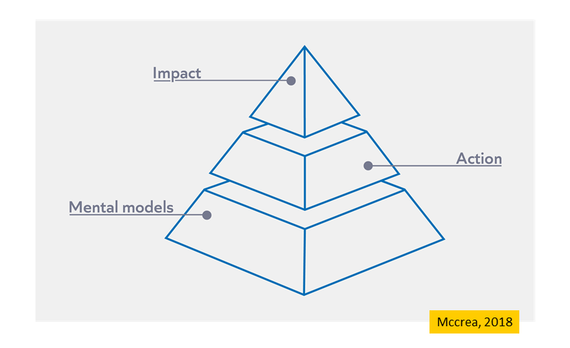
Notes

Experts can…
- Make better decisions
- Exert less effort to make effective decisions
- See underlying issues
Notes

Reflection
- What are mental models and how do experts apply them?
- Why might it be important to focus on developing the mental models of teachers, rather than just giving them strategies to try out in their classroom?
- To what extent has professional development you have experienced been designed to build your expertise? Refer to the ‘best bets’ to support your answer.
Notes

Introduction to the NPQLTD
Programme principles
- Build knowledge: by the end of the programme, leaders will have built a deep educational knowledge about the persistent problems school leaders face. This will make them better decision makers.
- Be evidence informed: leaders will learn what the evidence suggests about these persistent problems (and what is unknown).
- Be sensitive to context: leaders will explore how their knowledge can be applied across different contexts. This will support them to consider how to apply their knowledge in their context.
- Apply strategically: leaders will be encourages to develop their expertise. They may choose to read more, review their current practice and when appropriate, apply what they have learned in their context.
- Keep getting better: leaders will be supported to continue to develop their expertise beyond the core content of the programme.
Notes

Programme overview
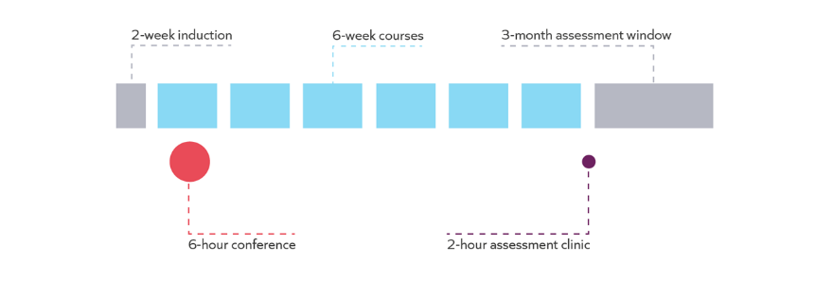
Courses (overview)
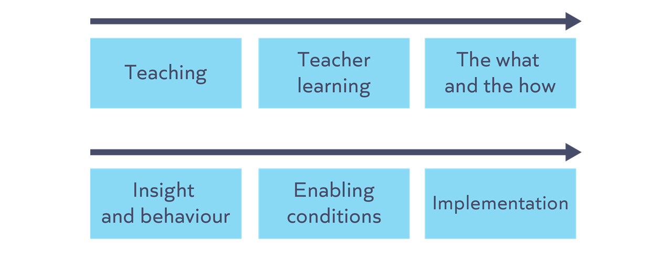
These course titles may change subject to feedback from the DfE/EEF.
Course structure
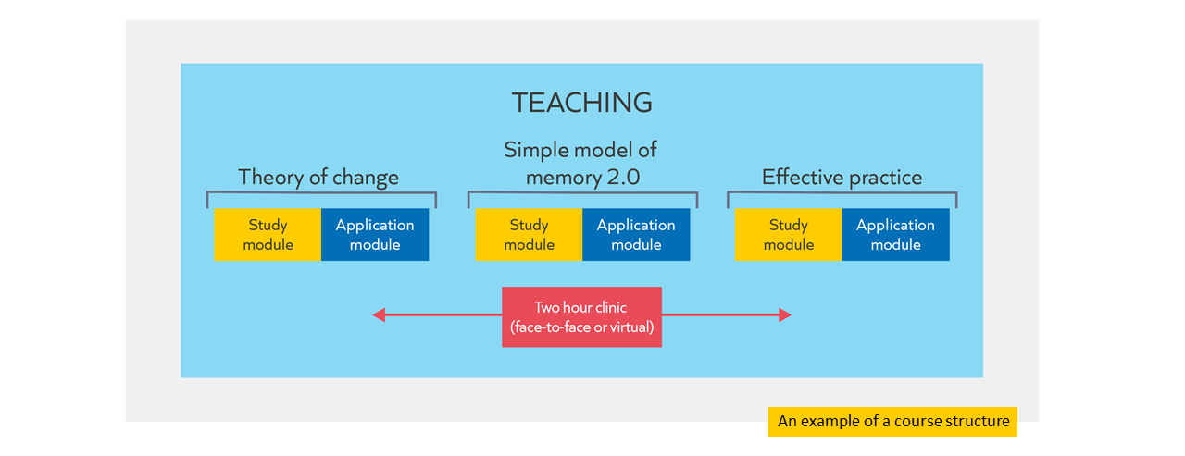
Courses (module details)
Course | Module
- Teaching | Theory of change
- Teaching | Simple model of memory 2.0
- Teaching | Effective practice (teaching)
- Teacher learning | Teacher expertise development
- Teacher learning | Habits & behaviour change
- Teacher learning | Teacher motivation
- The what and the how | Identifying learning content
- The what and the how | Sequencing learning
- The what and the how | Appropriate development approaches
- Insight and behaviour | Building & balancing insights
- Insight and behaviour | Assessment & evaluation
- Insight and behaviour | Systems & coherence
- Enabling conditions | Enabling conditions
- Enabling conditions | Professional climate
- Enabling conditions | School culture
- Implementation | Explore
- Implementation | Prepare
- Implementation | Deliver & sustain
Please note that these course and module titles are subject to change following feedback from the DfE and EEF.
Notes

Assessment
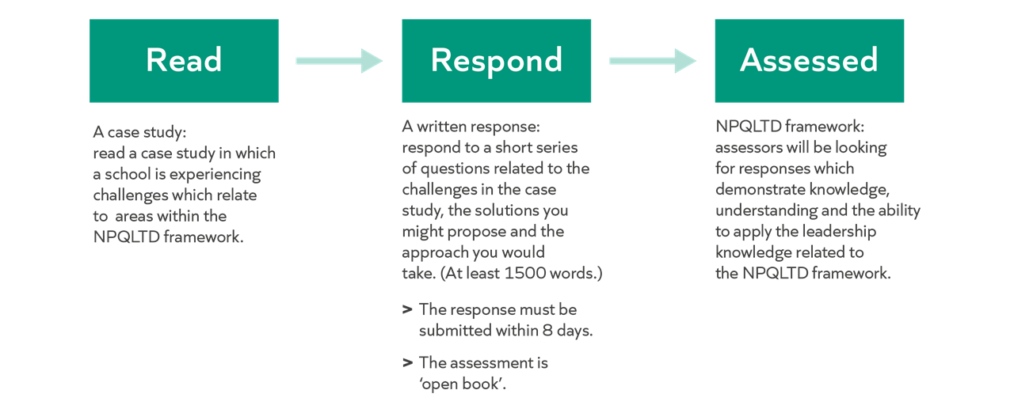
Support
Knowledge | The programme is designed to build your knowledge of teacher development, based on the NPQLTD framework. For example:  - Reading an evidence summary in each study module.  - Reading and analysing 2 examples that contextualise principles in each study module.  - Learning from a worked example of a scenario and leader’s response in each clinic.  - Collaborating on a response to a scenario in each clinic.
Assessment preparation | - Two short asynchronous webinars before the assessment window.  - A live clinic before the assessment window.

Notes

Success on the programme
Attendance
- Attendance and engagement with all components of the programme are key to success.
- To enable you to submit for your end of programme assessment, the minimum expectation is that you engage with 90% of the programme inputs.

Keep getting better
Developing formal knowledge: ​​
- Reading suggestions from NPQLT Reading and listening more widely
Developing informal knowledge:​​
- Reflecting and distilling experiences
- Discussing with others
Developing self-regulation:​​
- Prioritising professional development, for example through attendance and engagement
- Prioritising wellbeing

Notes

Work with others
“peer support and learning is a fundamental ingredient of effective CPDL” (Cordingley et al, 2015)
“all collaborations are not equal… or equally productive” (Runfeldt, 2015)

Norm | What does this look like?
Be brave
Be kind
Be present
Apply strategically
Example…
- A leader reflects on their learning about leading literacy.
- They recognise that this is an area where they are not yet expert.
- They decide to follow up with the suggested reading and schedule to meet with the SENCo, librarian and Head of English over the coming weeks to improve their understanding of the current approach to literacy.
- They recognise there are areas which could be improved. However, when they review the school improvement plan, they realise that it is not feasible to address these areas right now given the current priorities. They continue to read around the topic to develop their expertise in readiness for improvements at a more appropriate time.

Non-examples…
Too much | - A leader reflects on the knowledge they have acquired about instructional coaching as a mechanism for delivering professional development.  - They recognise that this is an area where they are not yet an expert.  - However, they see that there is a strong evidence base so they decide to implement it starting next term.
Too little | - A leader reflects on their learning about the importance of routines.  - They recognise that this is an area where they are not yet an expert.  - They assume that pastoral leaders in the school probably have more expertise in this area, so they decide not to think about the topic further.
Implementation
The EEF implementation framework gives detailed guidance on how to make effective and sustainable change in schools: EEF Implementation framework.
Notes

How people learn
Why do we need to know about learning?

The role of the school leader
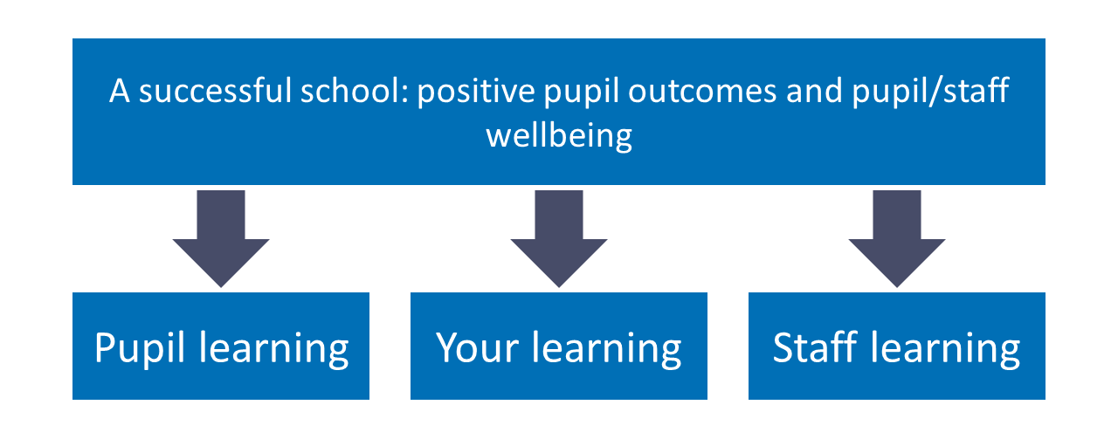
The importance of evidence

- Understanding the evidence enables leaders to make better decisions.
- Better decisions focus time and resources on more effective methods.
Notes

What is learning?

“Learning involves a lasting change in pupils’ capabilities or understanding.” (Department for Education, 2020).

“Effective teacher development is likely to involve a lasting change in teachers’ capabilities and understanding so that their teaching changes” (Department for Education, 2020).

Performance | Learning
Immediate change in behaviour or knowledge that can be observed and measured. | Lasting change in capabilities and understanding, which happens over time and is hard to observe.

Lasting change: implications

Pupil learning | Staff learning | Your learning
When reviewing teacher impact, Ms Gray knows she needs to triangulate data over time from a range of sources. She knows what she sees in a single lesson is pupil performance, not necessarily learning. | Ms Gray creates a plan for staff professional development. She ensures it plans for staff to consolidate their skills and understanding over the long term, focusing on one thing at a time, rather than disconnected episodes. | After reading about a new topic in her NPQ insight module, Ms Gray knows the value of revisiting these ideas in the application module and clinic to consolidate her understanding.

Reflection
- Through professional development, how can you support teachers to ‘learn’ and not just to ‘perform’ temporarily?
Notes

How do we learn?

Simple model of memory
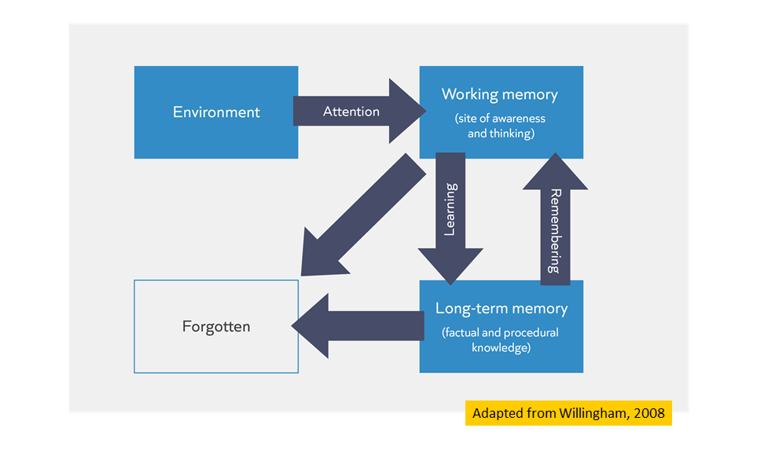

Ebbinghaus’ Forgetting Curve
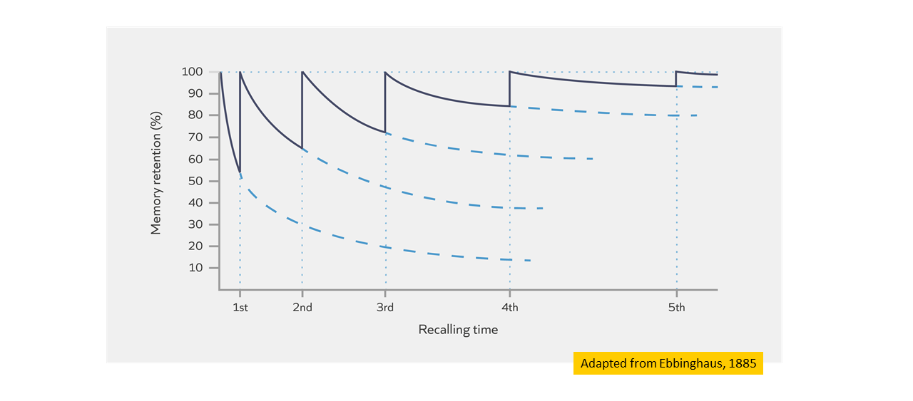
Notes

Check for understanding

Task: Which of these statements are TRUE?
- Learning is a lasting change in the learner's capabilities or understanding.
- Building knowledge in long-term memory is important because the better our prior knowledge, the more easily we can make sense of new information.
- Learners will struggle to build knowledge in long-term memory if they are cognitively overloaded.
- Recalling knowledge, practising and thinking hard are all ways to guarantee the learner will become overloaded.

Reflection
- To what extent are these ideas from the science of learning new to you? How do you use these ideas in your teaching?
- What implications do the limitations of working memory have on the way we plan and delivery teacher professional development?

Notes

Learning and remembering: implications

Pupil learning | Staff learning | Your learning
Mr Amo supports subject leaders to build opportunities into curriculum plans to retrieve and practise taught content. | Ms Carter breaks down a new teaching strategy into steps and models it to her teachers when training staff on it. She ensures they practise the same strategy many times over a term. | Mr James retrieves and explains what he has found out about in his NPQLTD module to other colleagues so he can revisit the knowledge and think hard about the underlying principles.

Notes

Mental Models

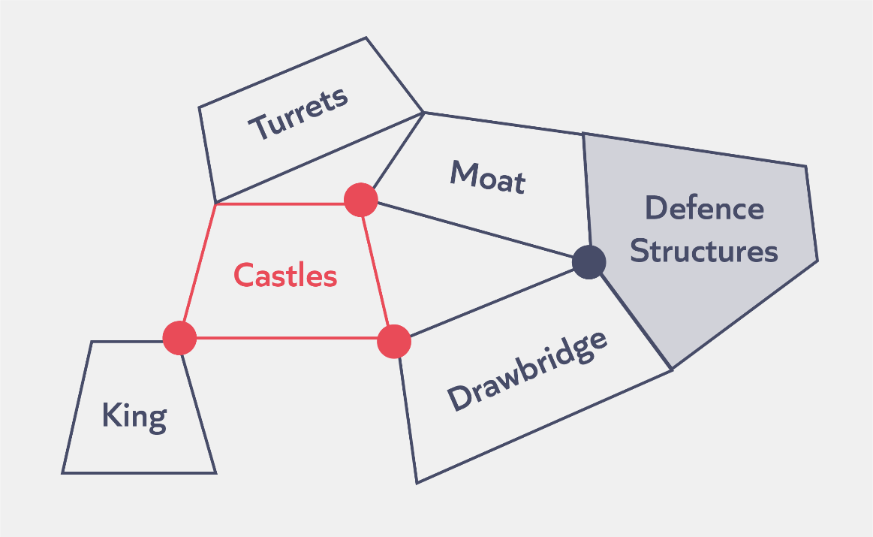
Mental models: The knowledge you have about a particular topic and how that knowledge is organised.

Check for understanding

Task: Which of these statements are TRUE?
- A teacher’s mental model is all they know about teaching.
- The more knowledge we have already learnt, the more successfully we can learn new knowledge in the future.
- Recalling and practising helps to prevent knowledge being forgotten from our working memory.
Notes

Reflection
Scenario:
Kristy is a new school-centred initial teacher training (SCITT) lead. She has been approached by a mentor who wants to add additional one-to-one sessions in with her mentee to improve their understanding of assessment. However, the current whole school staff development focus is on tackling misconceptions. The mentee also attends those sessions.

- How does understanding the science of learning help Kristy make a decision about whether agree to the proposed changes?

Notes

Experiencing a module pair
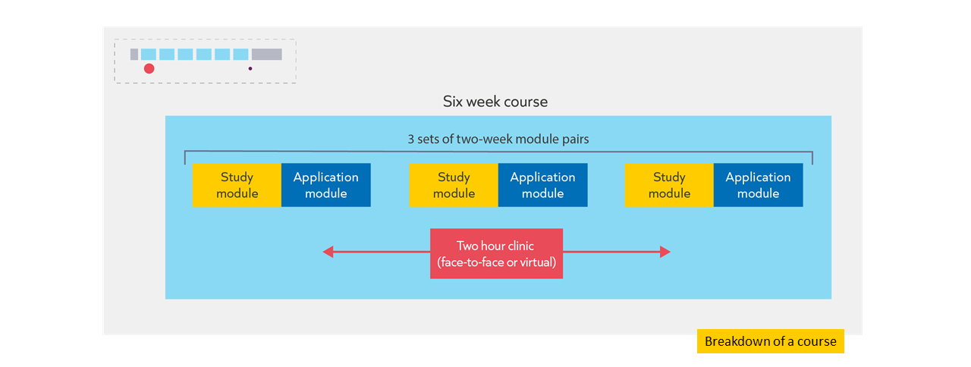
Study module
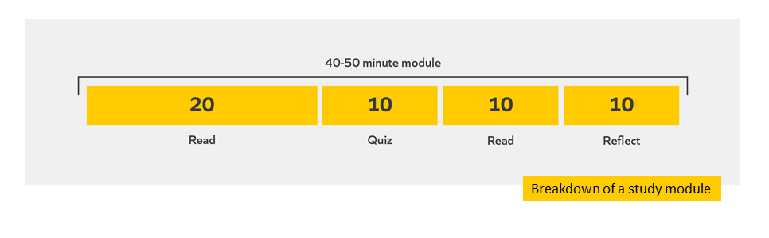
Introduction
Learning involves a lasting change in learners’ capabilities or understanding. This is true for the pupils in our classrooms, the teachers we support and ourselves when we are participants in professional development. Effective professional development is likely to involve a lasting change in teachers' capabilities or understanding so that their teaching changes. The more we know about learning and how it works, the more likely we will be able to make it happen (Willingham, 2018).
It is therefore imperative that we have clarity over how we can make this lasting change happen. To do so, we’ll utilise a model of memory to help us understand memory a bit more and help us to make better decisions in: developing our teachers; helping our teachers to make learning more likely for their pupils; and in guiding yourself as a learner on this course.
In this module, we are going to attend to the following:

- Principles of learning and cognition utilising a simple model of memory
- Applications of the simple model of memory to pupil learning, teacher education and for you personally as a learner

Guiding questions
Before you continue, consider:
- What do you already know about how pupils learn?
- What professional development have teachers in your school or organisation received in this area, if any?
- What principles do you currently apply to organise teacher learning in your professional development offer?
Optional pre-reading
This module assumes you understand the following ideas. If you wish to understand these in more depth before jumping in, then we recommend you read the following:

- Standard 2: How pupils learn from the Early Career Framework (2019)
- Early Career Framework module ECF Module I1

References

Willingham, D. T. (2017). A mental model of the learner: Teaching the basic science of educational psychology to future teachers. Mind, Brain, and Education, 11(4), 166-175.

Evidence summary
Problem
Khalid is a professional mentor and ITT lead within a teaching school hub. Khalid has reviewed the content and sequence of learning planned to support early career teachers (ECTs). He has reflected that it would be useful to introduce more about how pupils learn from cognitive science. Khalid knows that understanding the simple model of memory, and the functions of working memory and long-term memory is important for all teachers. Khalid wants to support early career teachers to understand the practical implications of this for their planning and teaching. Khalid is also aware that early career teachers are novices, they are just beginning to acquire and organise their own knowledge about effective teaching and learning. Khalid thinks that he will need to frame this differently when working with ECTs than with their mentors; he knows he needs to consider the implications of the simple model of memory for the learning of early career teachers, as well as pupils in the classroom.
What is learning?
Learning can be described as “a lasting change in pupils’ capabilities or understanding” (Department for Education, 2019, p.10). Learning is both a process involving thinking, as well as a product involving the acquisition and organisation of new knowledge (Mccrea, 2019). Therefore, Khalid needs to create a learning environment for ECTs that highlights the importance of being responsive to the conditions that promote both process and product as a classroom teacher. He also needs to be mindful of the learning environment he creates for his teachers as a teacher educator for the same purpose. Khalid can utilise well-established models of thinking and models for acquiring and organising new knowledge. Although there are some benefits in separating learning into the two parts listed above, it must also be recognised that they are intertwined, and therefore influence each other.

Simple model of memory
The work of Daniel Willingham (2009) explaining cognitive processes and memory is very useful for teacher educators and teachers. This is because it provides models explaining key mechanisms and principles of learning. Just as importantly, these ideas can be applied to all learners, not just pupils.
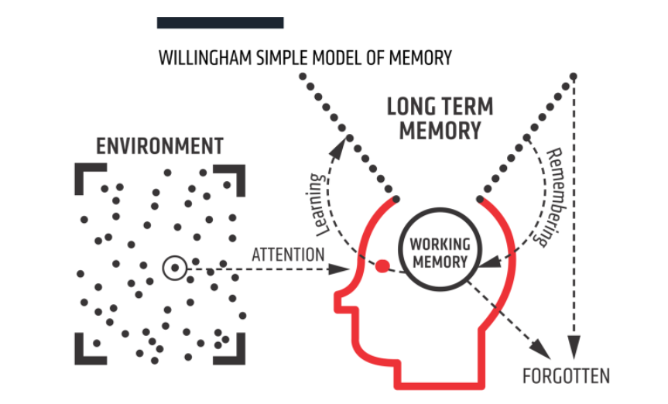
Figure 1: Willingham’s ‘simple model of memory’.
As the diagram above shows, his simple model of memory splits memory into two parts, working memory and long-term memory. Working memory can be thought of as the site of thinking and has a limited capacity for new knowledge and information. For us to learn something, it needs to be embedded in our long-term memory (‘be a lasting change’).
We take in new information from our environment - the world around us - using our working memory. This is where information that is actively being processed is held. Working memory is very limited (to about 4-5 items). This means we can only pay attention to a small number of new things at once as working memory can easily become overloaded. If working memory is overloaded, new information is forgotten instead of leading to a lasting change in long-term memory.
Fortunately, our long-term memory appears to be essentially unlimited. Long-term memory consists of everything we know and know how to do (factual and procedural knowledge). We learn new information from our environment by combining and making sense of it in our working memory with knowledge already stored in our long-term memory (prior knowledge). The way we organise and store information in our long-term memory is called a 'mental model' or 'schema' (Sweller et al., 1998, Education Endowment Foundation, 2021). Recalling information from long-term memory can help strengthen memories and reduce the risk of things being forgotten; you will return to this idea in course 1.
Implications for teaching
The more we know, the easier it is to build on that prior knowledge. This means that where new content is introduced, to either pupils in the classroom or teachers in a professional development session, attention should be paid to both how that information is presented and how much information is presented at any one time.
- Reduce and remove distractions
We learn what we think about, and what we think about is determined by what we attend to (Schweppe & Rummer, 2013). There are lots of stimuli in our environment that compete for our attention, but because working memory is limited, we can only choose to think about a handful of these at a time.
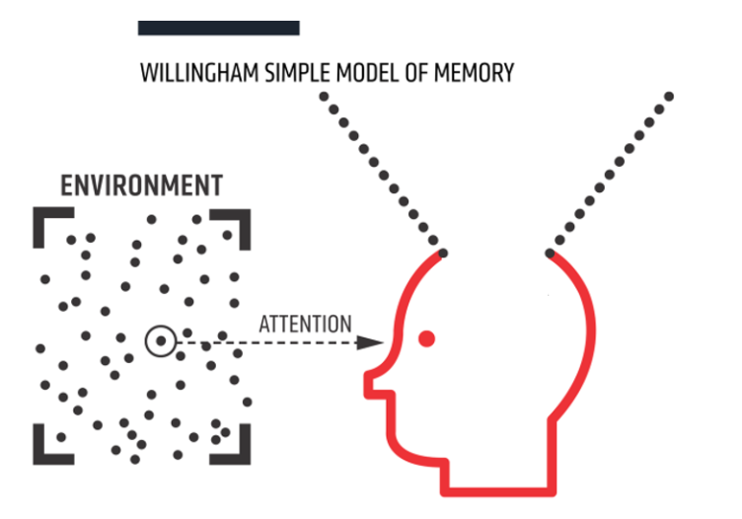
This means that attention is the gatekeeper of learning. Khalid is familiar with this idea; a large part of his job as a teacher and as a teacher educator is to harness and direct attention. He knows that this involves motivating pupils and teachers as well as drawing their attention to the key concepts and ideas he wants them to learn.
Where possible, educators at all levels should aim to eliminate redundant information and reduce distractions in the environment. These distractions can be social (for example, peers or other adults), environmental (for example display boards or clocks), activity-based (for example irrelevant images or tasks), or internal (for example performance anxiety, mind wandering). This does not mean removing all displays, or always having pupils work silently; but might mean putting displays or clocks at the back of the class and thinking about whether pupil talk is likely to help or hinder the current task. Khalid is used to thinking about redundant information and distractions when working with pupils but is aware that he sometimes forgets this when working with adults. He is likely to need to take into consideration the timing of professional development, the location and room setup of staff training, and how he envisages staff working together during sessions as well as the design and delivery of any slides he uses.
- Utilise limited working memory wisely
Working memory is where information that is being actively processed is held, but its capacity is limited and can be overloaded. Educators must ensure learners focus on a few ideas, processes or pieces of information at a time. This is more difficult if brand new content is being introduced or where the learners are complete novices. This is because we use our existing knowledge, skills and understanding to make sense of new ideas. Thinking becomes more difficult if we have limited relevant knowledge held in long-term memory to think with. Thinking works best when we attend to no more than two or three interacting pieces of information at once (Sweller et al., 2011). Again, introducing new content in small steps and building on prior knowledge are familiar ideas to Khalid when working with pupils, but he is aware he needs to put these ideas into practice when working with teachers too. Khalid knows he works with teachers with differing levels of expertise (as well as ECTs who are likely to be more novice); deciding how much to break down content is a major challenge of his role.
As well as using information from long-term memory to help us process new ideas, we can manage the strain or cognitive load on working memory by considering the format of information (e.g. Baddeley, 2003). Information can be represented in various modes (for example, speech, text, diagrams or images). These different modes influence how we are able to think about the information they carry. For example:
- We don’t have to hold text in our heads;
- Speech can also carry non-verbal information;
- Diagrams can be effective at exposing the connections between elements.
Using multiple modes of sharing information can help or hinder effective use of working memory. Khalid knows that this means he needs to think carefully about how he combines images, text and speech.
For example, we can attempt to reduce cognitive load by avoiding the “split attention effect”. The split attention effect can hinder learning by causing learners to split their attention through having to process two or more sources of information simultaneously (CESE, 2018). An example of this would be a diagram which can’t be understood without referring to separate explanatory text. The diagram below illustrates the split attention effect as readers have to move their attention from the diagram to the text and back again to make sense of the information.
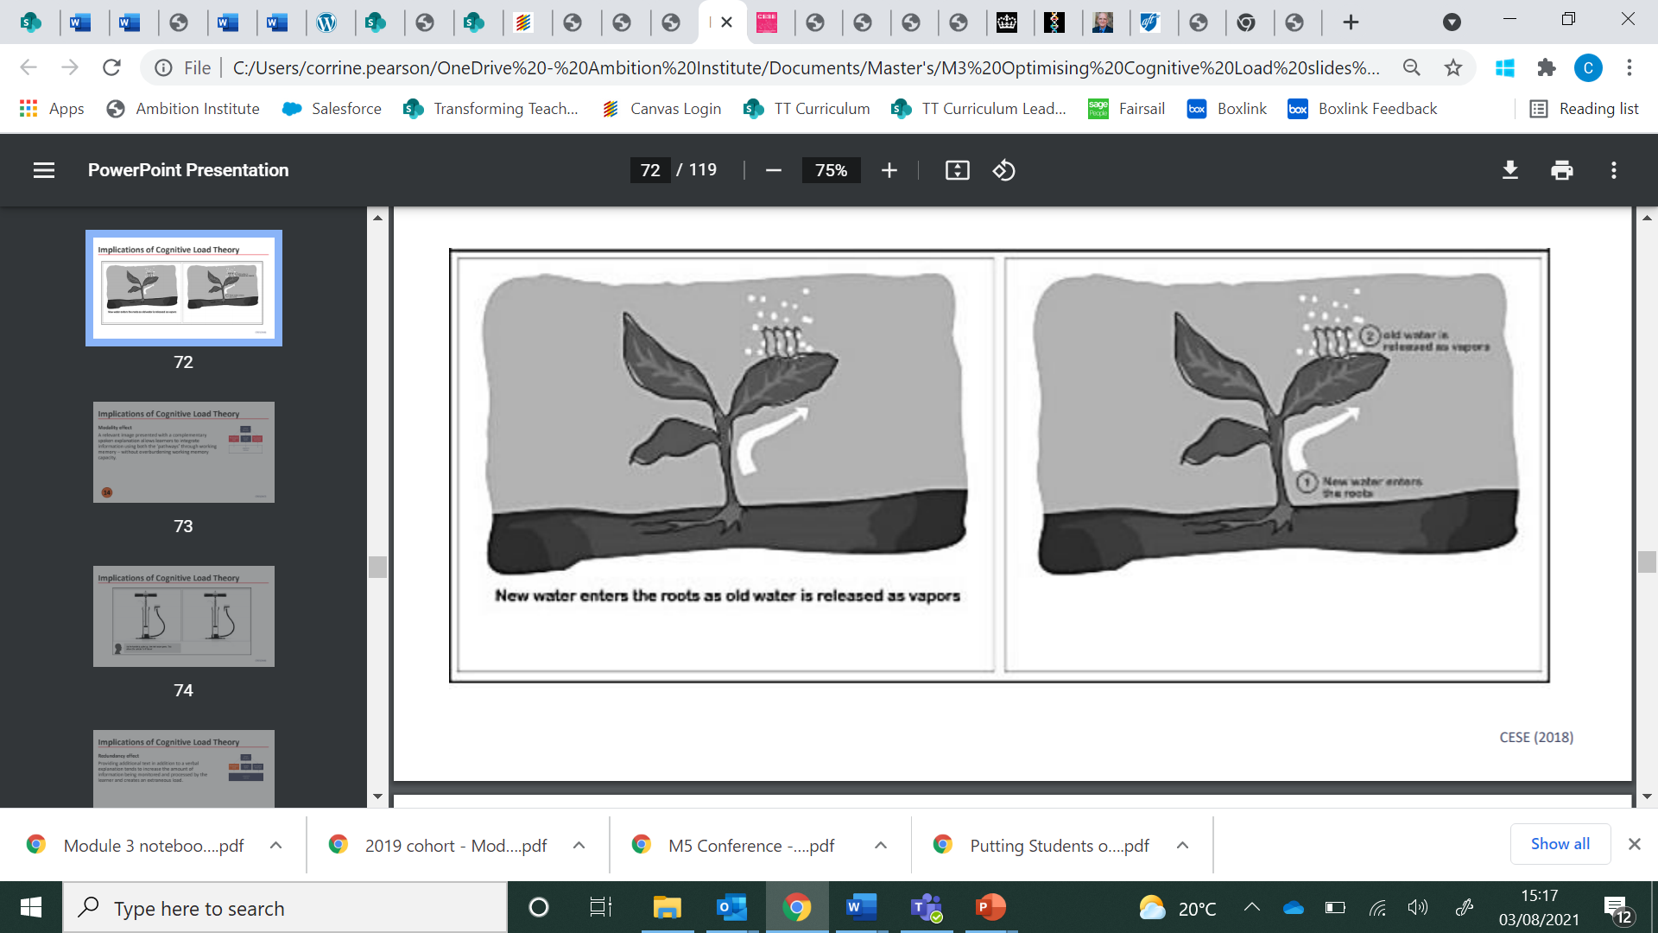
The split attention effect can be avoided by presenting information in the same place and at the same time. The diagram below provides an example of providing text on a diagram where it is needed to avoid the split attention effect and reduce cognitive load. This is sometimes referred to as ‘dual coding’.
Another example of the split-attention effect occurs when a teacher or teacher educator displays text on a slide and then reads the same text out loud. Khalid is used to avoiding this with pupils (for example by providing key bullet points and explaining them verbally), but when he reflects on his practice, he realises he doesn’t always apply this to his work with teachers.
Conversely, the “modality effect” allows us to reduce cognitive load by providing visual and verbal information simultaneously (CESE, 2017). This works because working memory can be thought of as being split into visual and auditory (verbal) streams. An example of this would be narrating an explanation whilst displaying a diagram or image. Khalid thinks that this is likely to work especially well for explaining a complex concept, such as the simple model of memory, to teachers. He realises he might need to script and practise his explanation so that he remembers to break the information down into short sentences. He might also plan how he could point to appropriate parts of the diagram as he speaks.
Khalid realises that the ideas around cognitive load and working memory are nuanced. There is a risk that teachers may over-simplify or misinterpret these ideas if they are not explained clearly or if there is not enough time to think about and discuss the ideas. For example, a review of research into applications of dual coding (EEF, 2021) in the classroom revealed that presenting additional visual information sometimes led to negative effects on learning. The review suggested that this might be caused by images which are decorative rather than informative; such images are likely to increase rather than decrease cognitive load.
Learning new or complex content is challenging (for pupils or teachers) because we learn by building on what we already know. By paying attention to how and how much information is presented we can reduce cognitive load. This makes it more likely that these new ideas or skills will become part of long-term memory and produce a lasting change in capability.
A lot of the ideas from the science of learning including the simply model of memory are familiar to Khalid from his work with pupils, despite this he knows he will have to think hard about applying them to his work with teachers.
Guiding yourself as a learner
Having considered the simple model of memory and some ideas about cognitive load from Khalid’s own perspective as a teacher educator, let’s consider how you might use these ideas in your own learning.
The same principles applied above to the teaching of pupils and through teacher education also apply to you as a learner on this programme. Particularly if this content on cognition and memory is new to you, as you work through the rest of the module you will need to consider:
- How will you fully attend to the content without distraction?
- What strategies do you need to put in place to think hard about this content without succumbing to cognitive overload?
- How will you self-regulate your learning?
- How will you know when it is appropriate to move from developing your own understanding of foundational concepts, to the application of the concepts in your professional development design and delivery?
Pause. Reflect. Respond.
- Consider the questions above. What actions will you take as you move through the rest of this module? The rest of the programme?
- How might you support teachers you are working with to reflect on their learning in the same way?
The more you know about an idea or topic, the easier it is for you to learn yet more. One way to benefit from this is to seek out opportunities to add to your knowledge base, creating more optimal conditions for thinking as your mental models develop. The more information our knowledge networks contain, the more we are able to think about. The amount of information they contain is determined by the number of meaningful connections they possess. The ease with which we can access and think with these elements is determined by how consolidated these connections are in our mind. Connection and consolidation are the two fundamental levers of learning. The more meaningful connections we forge, the more comprehensive and refined our understanding becomes. The greater our variation of experience, the more abstract and transferrable our knowledge becomes, and the more flexibly we can apply it across a range of situations (Lo, 2012). Sense- making can be supported by our peers, especially those coming from a similar starting point (or just ahead of us in the process).
A final aspect of self-regulation to consider is that some of the content of the NPQLTD programme is likely to be familiar to you. An important aspect of self-regulation will be to continue to think hard about such ideas, particularly how they connect together and can be applied to a variety of contexts.
Summary
Fully guided and explicit instruction is an effective strategy for introducing new and complex information where there is little background knowledge in the long-term memory to support thinking.
- Learning requires thinking about new content introduced into our working memory and is enhanced when new knowledge can interact with knowledge already stored in our long-term memory. Learning can be thought of as the persistent change in knowledge (Mccrea, 2019).
- Working memory has a limited capacity therefore you should focus your attention on the thing to be learnt avoiding distraction wherever possible to reduce cognitive overload.
- Learning new content where there is an underdeveloped mental model is more difficult as there is little to no prior knowledge to draw upon to help with thinking about the new knowledge
- Principles of cognition and learning can be applied to learning opportunities for both pupils and teachers and can impact resource design and delivery techniques
- Principles of cognition and learning can be applied to participants on this programme as learners, and considerations should be made about optimal learning conditions and self-regulation

Nuances and caveats
The simple model of memory is a model. Although the simple model of memory is effective at explaining some of the effects we see when studying learning, it is a model. It is not possible to identify the site of working or long-term memory in the brain. Consequently, it will not explain everything we observe about memory or learning. This is similar to how scientific models such as Bohr’s model of the atom work – they represent and help us think about content, they are not an exact replica. The simple model of memory does not provide a precise formula for exactly how to introduce and explain content; it does provide us with useful guidelines.
The role of motivation. Shell et al (2010) make an important point in their writing on motivation and cognition: the capacity of the “absolute” working memory does not always equate to the working memory an individual actually allocates to learning. In other words, just because there is the capacity to focus working memory on new learning, it doesn’t mean that focus and attention will materialise. Motivation is a key factor in determining how much of working memory is put to best use.
Further reading
Mccrea, P. (2019). Learning: What is it, and how might we catalyse it? Ambition Institute. https://s3.eu-west-2.amazonaws.com/ambition-institute/documents/Learning_what_is_it_and_how_might_we_catalyse_it_v1.4.pdf
Willingham, D. T. (2017). A mental model of the learner: Teaching the basic science of educational psychology to future teachers. Mind, Brain, and Education, 11(4), 166-175.
Willingham, D. T. (2009). Why don't students like school?: A cognitive scientist answers questions about how the mind works and what it means for the classroom. John Wiley & Sons.
References
Ambrose, S. A., Bridges, M. W., DiPietro, M., Lovett, M. C., & Norman, M. K. (2010). How learning works: Seven research-based principles for smart teaching. John Wiley & Sons.
Baddeley, A. (2003). Working memory: looking back and looking forward. Nature reviews neuroscience, 4(10), 829-839.
Centre for Education Statistics and Evaluation (2017). Cognitive load theory: Research that teachers really need to understand. Accessible from: https://www.cese.nsw.gov.au/publications-filter/cognitive-load-theory-research-that-teachers-really-need-to-understand
Centre for Education Statistics and Evaluation (2018). Cognitive load theory in practice: Examples for the classroom. Accessible from: https://www.cese.nsw.gov.au/publications-filter/cognitive-load-theory-research-that-teachers-really-need-to-understand
Clark, R. C., Nguyen, F., & Sweller, J. (2011). Efficiency in learning: Evidence-based guidelines to manage cognitive load. John Wiley & Sons.
Department for Education [DfE] (2019). Early Career Framework. https://www.gov.uk/government/publications/early-career-framework
Education Endowment Foundation [EEF] (2021). Cognitive science approaches in the classroom: a review of the evidence. [Online] Accessible from: https://educationendowmentfoundation.org.uk/public/files/Publications/Cognitive_science_approaches_in_the_classroom_-_A_review_of_the_evidence.pdf
Ling Lo, M. (2012). Variation theory and the improvement of teaching and learning. Göteborg: Acta Universitatis Gothoburgensis.
Mccrea, P. (2019). Learning: What is it, and how might we catalyse it? Ambition Institute. https://s3.eu-west-2.amazonaws.com/ambition-institute/documents/Learning_what_is_it_and_how_might_we_catalyse_it_v1.4.pdf
Schweppe, J., & Rummer, R. (2014). Attention, working memory, and long-term memory in multimedia learning: An integrated perspective based on process models of working memory. Educational Psychology Review, 26(2), 285-306.
Shell, D. F., Brooks, D. W., Trainin, G., Wilson, K. M., Kauffman, D. F., & Herr, L. M. (2010). The unified learning model. In The Unified Learning Model (pp. 1-4). Springer, Dordrecht.
Simonsmeier, B. A., Flaig, M., Deiglmayr, A., Schalk, L., & Well-being, S. (2018). Domain-Specific Prior Knowledge and Learning: A Meta-Analysis Prior Knowledge and Learning Domain-Specific Prior Knowledge and Learning : A Meta-Analysis Universität Trier, Germany PH Schwyz , Switzerland,
Sweller, J. (2011). Cognitive load theory. In Psychology of learning and motivation (Vol. 55, pp. 37-76). Academic Press.
Sweller, J., Van Merrienboer, J. J., & Paas, F. G. (1998). Cognitive architecture and instructional design. Educational psychology review, 10(3), 251-296.
Willingham, D. T. (2009). Why don't students like school?: A cognitive scientist answers questions about how the mind works and what it means for the classroom. John Wiley & Sons.
Reflection
- What is helpful about the Study section?
- How will the Study section help to build your mental models?
- Do you have any questions?

Notes

Quiz
Task: Answer the following questions.
- When presenting new or complex information, educators should ensure learners focus on a few ideas, processes or pieces of information at a time because:
  - Working memory has limited capacity
  - Long-term memory has limited capacity
  - Long-term memory is essentially unlimited

- Knowledge is organised:
- In the long-term memory as mental models
- In the working memory as mental models
- In the long-term memory but there is limited capacity

- The ideas about working memory and long-term memory apply to:
  - Only pupils
  - All learners including adults and children
  - Only pupils and inexperienced teachers
Reflection
- What do you need to do to make the most of the Quiz section?
- How will the Quiz section help to build your mental models?
- Do you have any questions?
Notes

Reflection
Task: Read Example 1 and answer the analysis questions.
Example 1
Scenario
I am an early career teacher (ECT) mentor in a large, urban primary school. Nancy, the early career teacher I am working with teaches Year 5. It is the Autumn term of the academic year, and we have been working on developing routines to support high expectations. There has been a whole school focus on incorporating methods influenced by cognitive science, so even staff new to the school have some familiarity with the simple model of memory and its implications for teaching.
This example is part of an instructional coaching conversation between a mentor and an ECT. The narrative contains a description of the conversation along with some of the decisions I made; the excerpt of the conversation itself is also provided. The example will focus on the following module principles:
- Learners are learners: the implications of science of learning apply to pupils, teachers, leaders and self.
- Guide attention: limit distractions, direct attention and carefully consider the design of activities
- Prior knowledge considered: professional development should start from what teachers know and can do, and be adapted to teachers’ developing expertise
- Break it down: Working memory is limited. Break knowledge down and plan for it to be introduced and practised in small steps. This can help teachers and pupils to gradually build mental models of increasing complexity.
The instructional coaching cycle involves brief, weekly lesson observations focused on a particular area of teaching; these are followed by a feedback session. The feedback session is built around identifying a bite-sized ‘action step’ which will help the teacher develop their skills in the area of focus. The mentor will model what the action step should look like in practice, and then support the teacher to do deliberate practice (a cycle of feedback and practice).
Narrative
In the lesson I’ve noticed that some of the pupils in Nancy’s class are finishing their work when she is talking. I know that this is likely to be a distraction. I could launch straight into setting an action step, but if I do this without helping Nancy build her mental model for behaviour first, then the new step is less likely to stick, and Nancy is less likely to be able to apply it appropriately to other situations.
In the lesson I’ve noticed that some of the pupils in Nancy’s class are finishing off their work when she is talking. I know that this is likely to be a distraction. I could launch straight into setting an action step, but if I do this without helping Nancy build her mental model for behaviour first then the new step is less likely to stick, and Nancy is less likely to be able to apply it appropriately to other situations.
During the coaching conversation below you will see that I:
- Ask Nancy what she thinks about pupils working while she is talking. This is because I need to figure out how well she is able to link what she knows about the simple model of memory and pupils’ behaviour.
- Ask her specifically about the simple model of memory, both to activate her prior knowledge, and also to judge where to start my explanation. Like when working with pupils, I want to break down the ideas so that they are easy to grasp but I don’t want to overload Nancy with detail.
- Talk Nancy through the importance of attention, and therefore behaviour, in terms of its impact on learning.
- Once I’m convinced that Nancy has made the connections and is bought into the idea, I share the action step that we are going to work on and provide a live model of what it looks like.
- Finally, I support Nancy to practise the step until she is ready to implement it into her classroom practice.
Artefact
We join the coaching session part-way through. The mentor and teacher have already discussed and praised the teacher’s progress and reviewed the previous action step.
Mentor: “In the lesson I noticed that some pupils were finishing off their work when you were speaking. What can you tell me about that?”
Nancy: “Yeah, that happens sometimes. I find it hard to get them to stop, and most of them seem to be listening when I ask them questions afterwards, so I don’t think it is that big a deal.”
Mentor: “How do you think pupils working when you are speaking will affect their learning?”
Nancy: “I don’t think it affects their learning much, as I said they still seem to be able to concentrate.”
Mentor: “I’m not sure I agree with you there, but before I explain why, tell me what you can remember about the simple model of memory.”
Nancy: “Erm, well I remember that memory can be thought of as being split into working memory and long-term memory, and that working memory is limited. And that long-term memory is where all your knowledge and skills are stored. If you have too many things in working memory, then it gets overloaded and you won’t remember. That’s why we have to break things down to teach them.”
Mentor: “Great explanation, you’ve remembered loads. There’s another thing that is important: it is our attention that controls what information goes into working memory. Because working memory is limited, we can’t pay attention to everything going on in the environment around us. Our attention decides what gets into working memory in the first place, and therefore what has a chance of getting into long-term memory.
Pupils finishing off their work is likely to be taking up some of their working memory. They might cope with this if what you are talking about is familiar and simple, but as soon as it gets a little bit harder, working memory can get overloaded. Remind me why that matters again?”
Nancy: “If information doesn’t get into working memory then we can’t think about it so it can’t become part of long-term memory.”
Mentor: “Exactly. Let me give you a non-teaching example to try and make it clearer. I know you cycle to school – how hard is it to think about something tricky whilst cycling? Perhaps planning your route to somewhere you’ve only been to once or twice whilst riding?”
Nancy: “Ah, yep now I understand! That’s really difficult, even though I find it easy if I’m not cycling. I guess if I’d been finishing an email whilst you were explaining that would have made things harder too.”
Mentor: “Excellent, now let’s have a look at an action step linked to this that we can practise.”
Conclusion
Throughout this scenario, I was able to structure my explanation by focusing on the following module principles:
- Learners are learners: the implications of the science of learning apply to pupils, teachers, leaders and self.
- Guide attention: limit distractions, direct attention and carefully consider the design of activities
- Prior knowledge considered: professional development should start from what teachers know and can do, and be adapted to teachers’ developing expertise
- Break it down: Working memory is limited. Break knowledge down and plan for it to be introduced and practised in small steps. This can help teachers and pupils to gradually build mental models of increasing complexity.

Reflection
- How does the leader consider prior knowledge?
- How does the leader guide the teacher’s attention?
- What might the leader do differently if this were a non-example of learners are learners?

Reflection
- What is helpful about the Reflection section?
- How will the Reflection section help to build your mental models?
- Do you have any questions?
Notes

Reflection
- How does the Study Module help to build your mental model?
- Do you have any questions about the Study Module?
- How can you make the most of the Study Module?

Notes

Application Module
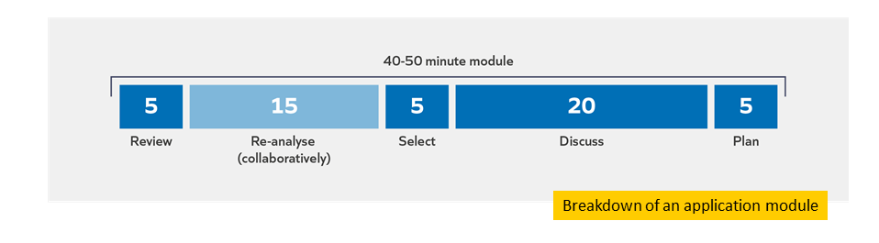
Re-analyse
Task: Discuss the Reflection questions from the Study Module with your partner. Strive to:
  - Be brave: ask questions, share insights and experiences
  - Be kind: respectful, supportive, active listening
  - Be present: be fully engaged, keep to time

Reflection
- What is helpful about the Re-analyse section?
- How will the Re-analyse section help to build your mental models?
- Do you have any questions?
Notes

Select
Task: Select the most appropriate and useful application task for you and your context.
Module principle | Application task
Break it down: Working memory is limited. Break knowledge down and plan for it to be introduced and practised in small steps | Read principle 2 from: Rosenshine, B. (2012). Principles of Instruction.  - Why might teaching new material overwhelm learners?  - How might you mitigate for this?
 | Review: Review a plan for professional development for an area you are responsible for. Is knowledge broken down and planned to be introduced and practised in small steps?
 | Do: Script an explanation of how you would explain the importance of breaking down knowledge and introducing and practising it in small steps in a lesson for a professional development session targeted at a group of teachers you work with.
Consider prior knowledge: professional development should start from what teachers know and can do, and be adapted to teachers’ developing expertise | Read: Read a section from the Early Career Framework.  - How does prior knowledge help us make sense of new material?
 | Review: Consider one objective from a professional development curriculum that you lead which you intend teachers to have learnt by the end of the curriculum. Track back across the curriculum and consider how this objective builds on previous curriculum content.
 | Do: Prepare an explanation of how knowledge in the curriculum builds for a mentor meeting with an Early Career Teacher.

Discuss
- Which of these principles are most relevant to your context/role? Which did you choose and why?
- What do you plan to do next? How do you hope this will enhance your expertise and impact?

Plan

Example | Non-example
- To review the whole school plan for literacy professional development with the head of English (Wednesday period 4)  - To script an explanation about the importance of breaking down prior knowledge (Tuesday, period 5)  - To read principle 2 from Rosenshine’s Principles of Instruction (next Thursday before school) | - Make sure I always break down knowledge in professional development sessions

Notes

Reflection
- How does the Application Module help to build your mental model?
- Do you have any questions about the Application Module?
- How can you make the most of the Application Module?

Notes

Experiencing a clinic
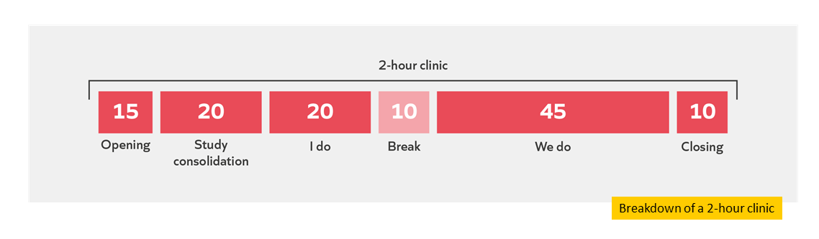
Study consolidation

Module | Module principles
Simple model of memory | Learners are learners: the implications of the science of learning apply to pupils, teachers, leaders and self
Simple model of memory | Prior knowledge considered: professional development should start from what teachers know and can do, and be adapted to teachers’ developing expertise
Simple model of memory | Break it down: Working memory is limited. Break knowledge down and plan for it to be introduced and practised in small steps. This can help teachers and pupils to gradually build mental models of increasing complexity.

I do
Task: Read the scenario.

Scenario 1
The induction lead at an all-through school has identified teacher modelling as a priority for the early career teachers (ECTs) they are responsible for. They have decided to supplement the school’s core Early Career Framework (ECF) provision with additional training on using the ‘I do-we do-you do’ strategy for modelling and scaffolding practice. ‘I do-we do-you do’ is a strategy for providing pupils with explicit modelling (I do), and then gradually reducing the scaffolded support (we do) to allow pupils to practise independently (you do). The ECTs in the school teach a range of ages (with pupils between 7 and 16 years old) and subjects and have undertaken a variety of training routes. Three of the ECTs are in their second year of teaching at the school, and one of these also completed their school-based initial teacher training (ITT) in the school. The remaining four ECTs are all in their first year of teaching but qualified from a mixture of school and university-based ITT routes.
The induction lead identifies modelling as a priority based on the school development plan.
As a result, the induction lead decides to begin the training with an overview of the ‘I do-we do-you do’ strategy. They explain the key features of the strategy as a whole. Having done this, they explain that the focus of this session is going to be on the ‘I do’ stage, but that they will return to the model over subsequent sessions. The lead then identifies some success criteria for this stage of the ‘I do-we do-you do’ strategy. They provide a model of how they would break down and then explain a process from a secondary mathematics lesson. Afterwards they support the ECTs to use the criteria to identify why it was successful. Some of the ECTs seem really confident in their responses and provide insightful criteria which they can link to their own subjects. However, some of the ECTs who have just joined the school focus on less important aspects of the model, such as the context of the mathematical problem.
After having modelled an example of the ‘I do’ stage, the lead plays a video non-example from a mathematics lesson. This allows them to lead a discussion with the ECTs on how the explanation could have been improved. In this case, the improvement focuses on the teacher breaking down the process and narrating their thought process as they demonstrated to the class. Again, the ECTs’ contributions to the discussion vary, with some less experienced ECTs suggesting that the content was already broken down enough for pupils.
After this guided practice, the induction lead checks for the ECTs’ understanding by using a multiple-choice question about the key features of an ‘I do’ explanation. They then ask the ECTs to practise scripting their explanations for an upcoming lesson, using the criteria identified earlier to help them. Finally, the ECTs practise delivering their explanations to a partner and receive feedback.
At the end of the session, the lead is confident that the ECTs have understood how and why to use the first stage of the ‘I do-we do-you do’ strategy. The ECTs are enthusiastic about trying it out in their lessons. However, they know that one training session is unlikely to be sufficient to embed this strategy, so they plan follow-up sessions on the ‘we do’ and ‘you do’ elements of the strategy later in the term. Before the next session, they visit all the ECTs’ lessons to see their modelling in action. They are surprised to find that the ‘I do’ explanations are inconsistent. Some teachers are using it but don’t appear to have linked it with their understanding of the simple model of memory; they are trying to cover large chunks of content in one go, often whilst talking over crowded PowerPoint slides. Other teachers don’t appear to be using the strategy and when asked, they say that they had tried it but that it didn’t work for their subject or year group.
Question:
Taking into account what you have learned on this course:
a) What might be effective about this leader’s decision making?
b) What suggestions do you have that might enable them to make more effective decisions next time?

Task: Make notes while the facilitator models how to respond to the question.
Module principle | Response/suggestion
Learners are learners
Prior knowledge considered
Break it down
Other notes:

Reflect
- How will the ‘I do’ section help to build your mental models?
- What do you need to do to make the most of the ‘I do’ section?
- Do you have any questions?

Notes

We do
Task: Read the scenario.
Scenario 2
The whole school professional development lead at a large inner-city secondary school has been working with the school’s pastoral leadership team to develop the expertise of the heads of year. Together, they have identified that providing pupils with clear and consistent messaging is a priority. The heads of year have identified that they want to improve the clarity of their communication in assemblies as they don’t feel that pupils are retaining the key messages. Assemblies in the school are only 15 minutes long which adds to the importance of clear communication. Due to the size of the school, year group assemblies are an important point of communication with pupils, but not all heads of year are confident in designing and delivering assemblies. This is partly due to their range of experience and expertise; some heads of year are new to their posts, while others have been doing the role for over 10 years.
Based on discussions with the pastoral team and observing assemblies, the professional development lead has identified that assemblies often contain too much information, with teachers speaking over complicated slides. In some year groups, pupils are also distracted, whispering to each other or turning around. The lead identifies that the problem of pupils retaining information can be explained using the simple model of memory; planning and delivering assemblies with this in mind should help address both the issues around clarity and around pupils’ attention.
The lead designs a programme of training to run over the course of a term. Some of this they will facilitate directly, and other elements will be led by members of the pastoral team. The training will link back to whole school training on the simple model of memory at the start of the year. The leader knows that the differences in expertise means that the emphasis of the professional development will need to be different for each head of year. The differences in experience will also influence the professional development lead’s approach to communication with different members of staff. They also know that, as with pupils, they will need to support heads of year to come back to the content over the course of the year so that it is not forgotten; they add reminders to do this to their diary.
The first professional development session begins with a brief quiz of the features of the simple model of memory and its implications for teaching. The professional development lead knows that, in general, the heads of year have considerable expertise so are likely to benefit from a less guided approach. In pairs, the heads of year then identify the key elements of an effective assembly, with a focus on communicating key messages. To scaffold this discussion more expert heads of year are paired with more novice members of the team.
In the whole group discussion, the professional development lead draws together some key points for delivering information clearly in assemblies:
- Only try to communicate the most important messages
- Give clear explanations and repeat them
- Make the messages memorable
The professional development lead also highlights the importance of strong routines to ensure that pupils are able to pay attention, as this wasn’t mentioned in the paired discussion.
The lead knows that what we know from the science of learning applies to teachers as well as pupils. As a result, they model an assembly where two key messages have been highlighted and are repeated at several points. The model uses clear, uncluttered slides and the lead has carefully scripted their explanation. Straight after this model, they provide teachers with time to practise. The heads of year are given the choice of practising designing their assemblies or practising entry routines for assemblies.
At the end of the session, the professional development lead supports the heads of year to reflect on where else they can use the principles from the simple model of memory; particularly in their year team staff meetings.
The heads of year are excited at putting the training into action and looking forward to the improved impact of their assemblies. A few weeks later the professional development lead is disappointed when they visit a range of assemblies; although most of the heads of year have implemented some of the strategies, they have done so inconsistently. Many of the assemblies visited attempt to make the messages memorable by including images or phrases which turn out to be distracting instead of linking to the message itself. Some of the more expert heads of year have successfully reduced the number of messages and increased their clarity However, less-expert heads of year, including some of the most experienced, are still sharing a large number of messages and repeating them all several times.
Task: Respond to the following question independently, then discuss with your partner.

Questions:
1. Taking into account what you have learned on this course:
a) What might be effective about this leader’s decision making?
b) What suggestions do you have that might enable them to make more effective decisions next time?
2. How have you used, or how do you anticipate using, one or more module principles in your decision making?
Module principle | Response/suggestion
Learners are learners
Prior knowledge considered
Break it down
Other

Reflect
- How will the ‘We do’ section help to build your mental models?
- What do you need to do to make the most of the ‘We do’ section?
- Do you have any questions?

Notes

Reflection

- How does the clinic help to build your mental model?
- Do you have any questions about the clinic?
- How can you make the most of the clinic?

Notes

References
Bereiter, C., & Scardamalia, M. (1993). Surpassing ourselves: An inquiry into the nature and implications of expertise. Chicago, IL: Open Court.
Berliner, D.C. (2004) Describing the Behavior and Documenting the Accomplishments of Expert Teachers. Bulletin of Science, Technology and Society, 24(3), p. 200–212.
Cordingley, P., Higgins, S., Greany, T., Buckler, N., Coles-Jordan, D., Crisp, B., Saunders, L., Coe, R. (2015) Developing Great Teaching: Lessons from the international reviews into effective professional development. Teacher Development Trust.
Education Policy Institute [EPI], 2020, Education in England: Annual Report 2020. https://epi.org.uk/publications-and-research/education-in-england-annual-report-2020

Sims, S., & Fletcher-Wood, H. (2021). Identifying the characteristics of effective teacher professional development: a critical review. School effectiveness and school improvement, 32(1), 47-63.
Fletcher-Wood, H., & Zuccollo, J. (2020). The effects of high-quality professional development on teachers and students: A rapid review and meta-analysis. Education Policy Institute. https://epi.org.uk/publications-and-research/effects-high-quality-professional-development/

Furst, E., 2018. Learning in the brain. https://sites.google.com/view/efratfurst/learning-in-the-brain
Kraft, M. A., Blazar, D., & Hogan, D. (2018). The effect of teacher coaching on instruction and achievement: A meta-analysis of the causal evidence. Review of educational research, 88(4), 547-588.
McCrae, P. (2018). Expert teaching: What is it, and how might we develop it. Institute for Teaching.
https://www.ambition.org.uk/research-and-insight/what-is-expert-teaching/
Robinson, V. (2017). Capabilities required for leading improvement: Challenges for researchers and developers. ACERsSearch https://research.acer.edu.au/cgi/viewcontent.cgi?article=1306&context=research_conference.
Rose, N, (2018) The role of forgetting as we learn. Ambition Institute. https://www.ambition.org.uk/blog/why-forget/
Sutton Trust (2011) Improving the impact of teachers on pupil achievement in the UK – interim findings. https://www.suttontrust.com/wp-content/uploads/2019/12/2teachers-impact-report-final-1.pdf
Wiliam, D., 2014. Spoken Presentation. Research ED: http://www.dylanwiliam.org/Dylan_Wiliams_website/Presentations_files/2014-09-06%20ResearchED.pptx
Willingham, D., 2009. Why Don’t Students Like School? A Cognitive Scientist Answers Questions About How the Mind Works and What It Means for the Classroom. Jossey-Bass 2nd edition.

