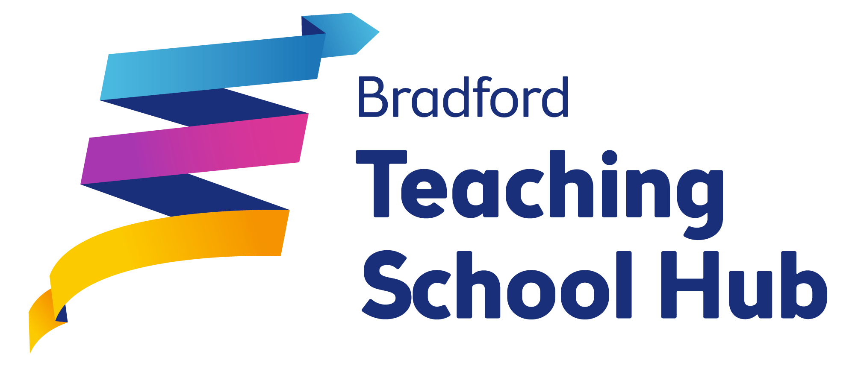
Impact of school-to-school support: Interim / Final Review
Supporting school/trust/organisation |  | Supported school
Name(s): |  | Name:
Role(s): |  | Role:
School/Trust/  Organisation: |  | School:
Type of report: | Interim / Final | Date of report:
Broad intended outcomes: |  |  |  | RAG rating
Summary of actions and progress towards achieving the agreed outcomes:
Evidence of impact to date:
Next steps:
Funding summary:
Opportunity Area funded school-to-school support
2019-20 grant allocation carry forward (if applicable)
- Total grant allocation: £
- Spend to date: £
- Committed spend: £
- Underspend: £
2020-21 grant allocation (if applicable)
- Total grant allocation: £
- Spend to date: £
- Committed spend: £
- Underspend: £
Notes (e.g. changes to plan)

