NPQLT Conference
Participant Workbook
Key takeaways:
Name: ………………………………………………………………………………..
Session date: ………………………………………………………………………
INSERT DOCUMENT TITLE HERE
Welcome and setting norms
Our values
Agenda for today
Timings | Session
 | Welcome and setting norms | 20 mins
 | Leadership and your NPQLT | 75 mins
 | How people learn | 45 mins
 | Experiencing a module pair | 90 mins
 | Experiencing a clinic | 60 mins
 | Close | 10 mins

Leadership and your NPQLT
The disadvantage gap
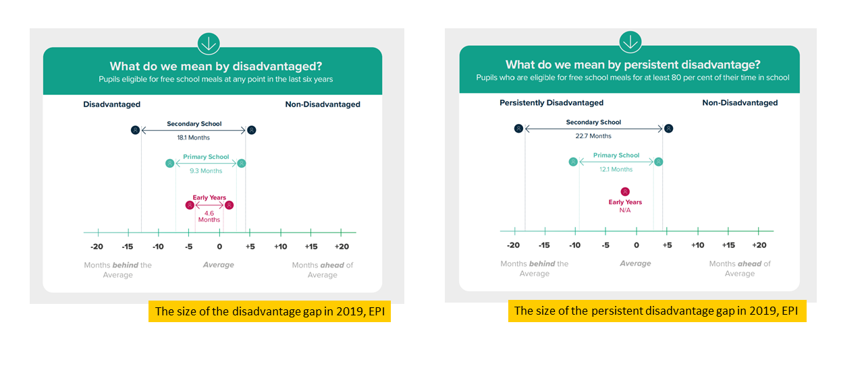
“Our vision is an education system where every child can thrive, no matter what their background.” (Ambition Institute, 2021)
The importance of quality teaching
The most rigorous academic papers find consistent and significant results: having a very effective, rather than an average teacher raises each pupil’s attainment by a third of a GCSE grade...The effect of having a very effective teacher as opposed to an average teacher is the same as the effect of reducing class size by ten students in Year 5 (ages 9-10) and thirteen or more students in Year 6(ages 10-11)...The effects of high-quality teaching are especially large for pupils from disadvantaged backgrounds, who gain an extra year’s worth of learning under very effective teachers compared to poorly performing teachers. (Sutton Trust 2011)
The impact of expert school leaders
Expert school leaders have also been shown to impact:
- Pupil outcomes (Leithwood, 2008)
- Teacher turnover (Hanushek, 2013)
- Teacher satisfaction (Sims, 2019)
Reflection
- As a leader of teaching, what impact are you hoping to have in your school?
- What steps have you already taken to develop your expertise as a school leader?

What is teacher expertise?
Notes

Expert leaders of teaching
Experts can…
- Make better decisions
- Exert less effort to make effective decisions
- See underlying issues
Notes

Reflection
- How can you develop expertise in your role?
- What impact will developing expertise have for you, your colleagues and your pupils?
Notes

Introduction to the NPQLT
Programme principles
- Build knowledge: by the end of the programme, leaders will have built a deep educational knowledge about the persistent problems school leaders face. This will make them better decision makers.
- Be evidence informed: leaders will learn what the evidence suggests about these persistent problems (and what is unknown).
- Be sensitive to context: leaders will explore how their knowledge can be applied across different contexts. This will support them to consider how to apply their knowledge in their context.
- Apply strategically: leaders will be encourages to develop their expertise. They may choose to read more, review their current practice and when appropriate, apply what they have learned in their context.
- Keep getting better: leaders will be supported to continue to develop their expertise beyond the core content of the programme.
Notes

Programme overview
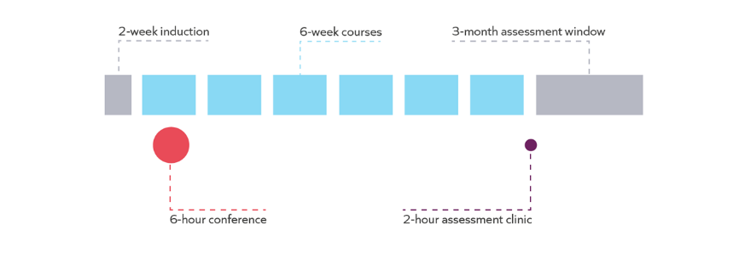
Courses
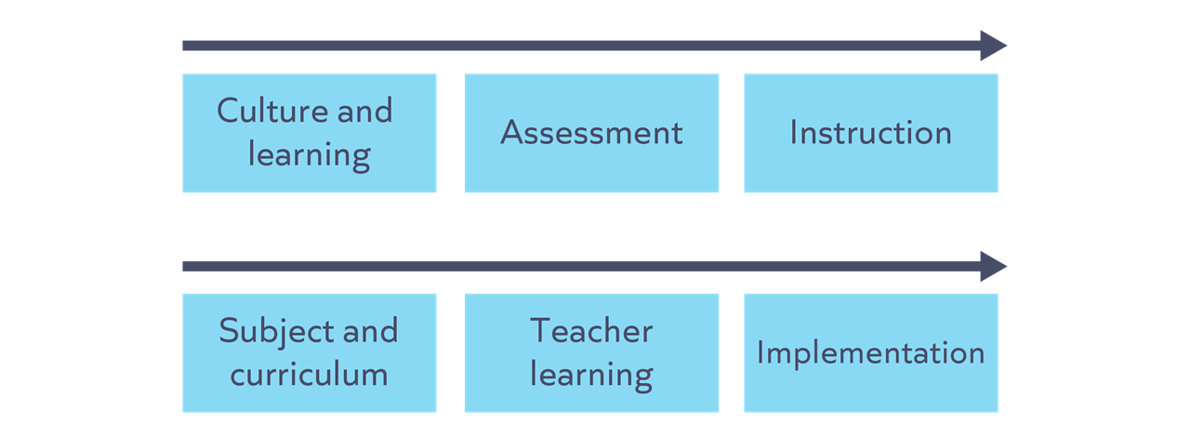
Course structure

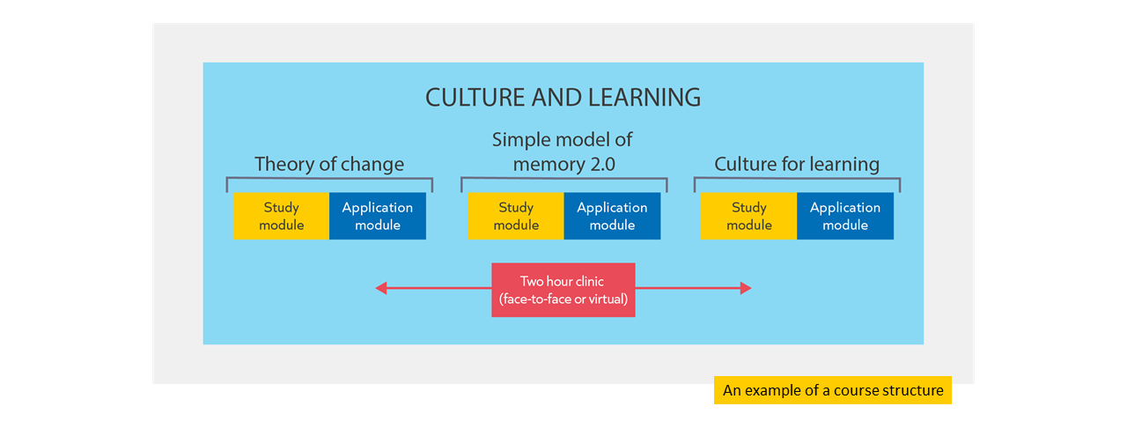

Communities session
Communities sessions are designed to give you and your peers a chance to talk about challenges you’re facing in your leadership role. You will follow a structured protocol to unpick the problem and discuss potential solutions. There will be one communities session per course but the focus of each session will depend on the challenges you’re currently facing in school rather than the content of the NPQLT programme.
Assessment
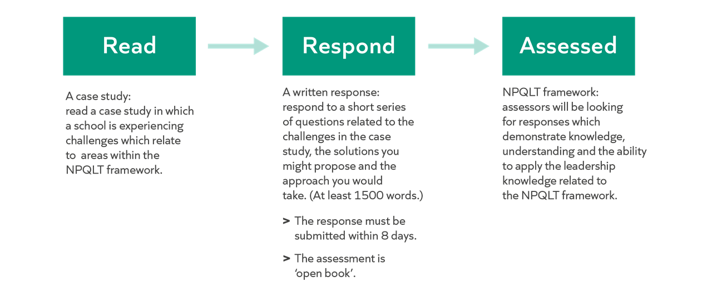
Support
Leadership knowledge | The programme is designed to build your knowledge of leadership, based on the NPQH framework. For example:  - Reading an evidence summary in each Study module.  - Reading and analysing 2 examples that contextualise principles in each Study module.  - Understand how to apply principles from a worked example of a scenario and leader’s response in each Clinic.  - Collaborate on a response to a scenario in each Clinic.
Assessment preparation | - A webinar before the assessment window.  - A live clinic before the assessment window.

Notes

Success on the programme
Attendance
- Attendance and engagement with all components of the programme are key to success.
- To enable you to submit for your end of programme assessment, the minimum expectation is that you engage with 90% of the programme inputs.

Keep getting better
Developing formal knowledge: ​​
- Reading suggestions from NPQLT Reading and listening more widely

Developing informal knowledge:​​
- Reflecting and distilling experiences
- Discussing with others

Developing self-regulation:​​
- Prioritising professional development, for example through attendance and engagement
- Prioritising wellbeing

Notes

Work with others

“peer support and learning is a fundamental ingredient of effective CPDL” (Cordingley et al, 2015)

“all collaborations are not equal… or equally productive” (Runfeldt, 2015)

Norm | What does this look like?
Be brave
Be kind
Be present
Apply strategically

Example…
- A leader reflects on the knowledge they have acquired about leading literacy.
- They recognise that this is an area where they are not yet expert.
- They decide to follow up with the suggested reading and schedule to meet with the special educational needs co-ordinator, librarian and head of English over the coming weeks to improve their understanding of the current approach to literacy.
- They recognise there are areas which could be improved. However, when they review the School Improvement Plan they realise that its not feasible to address these areas right now given the current priorities. They continue to read around the topic to develop their expertise in readiness for improvements at a more appropriate time.

Non-examples…
Too much | - A leader reflects on the knowledge they have acquired about instructional coaching as a mechanism for delivering professional development.  - They recognise that this is an area where they are not yet an expert.  - However, they see that there is a strong evidence base so they decide to implement it starting next term.
Too little | - A leader reflects on the knowledge they have acquired about engaging parents and carers.  - They recognise that this is an area where they are not yet an expert.  - They assume that pastoral leaders in the school probably have more expertise in this area  so decide not to think about the topic further.

Implementation
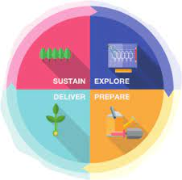
The EEF implementation framework gives detailed guidance on how to make effective and sustainable change in schools: EEF Implementation framework.

Notes

How people learn
Learning contexts
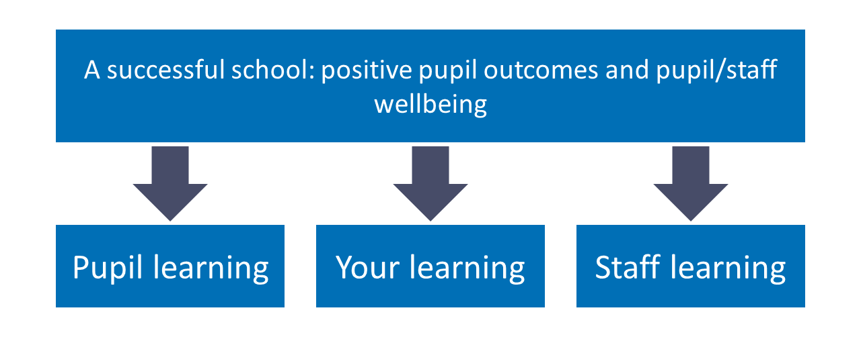
The importance of evidence
- Understanding the evidence enables leaders to make better decisions.
- Better decisions focus time and resources on more effective methods.

Notes

What is learning?

“Learning involves a lasting change in pupils’ capabilities or understanding.” (Department for Education, 2020).

Performance | Learning
Immediate change in behaviour or knowledge that can be observed and measured. | Lasting change in capabilities and understanding, which happens over time and is hard to observe.
Lasting change: implications

Pupil learning | Staff learning | Your learning
When reviewing teacher impact, Ms Gray knows she needs to look at data over time from a range of sources. She knows what she sees in a single lesson is pupil performance, not necessarily learning. | Ms. Gray asks the teaching and learning lead to create a plan for staff professional development. She gives feedback to ensure it plans for staff to consolidate their skills and understanding over the long term, focusing on one thing at a time, rather than disconnected episodes. | After reading about a new topic in her NPQLT Study module, Ms. Gray knows the value of revisiting these ideas in the application module and clinic to consolidate her understanding.

Reflection
- What are the implications of the definition of learning for you as a leader of teaching?
Notes

How do we learn?
Simple model of memory
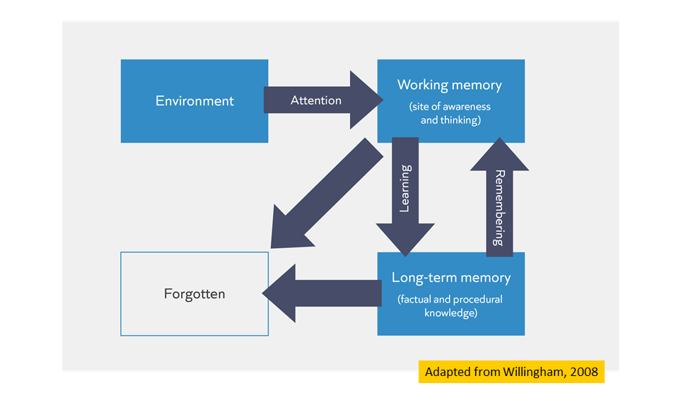
Learning and remembering
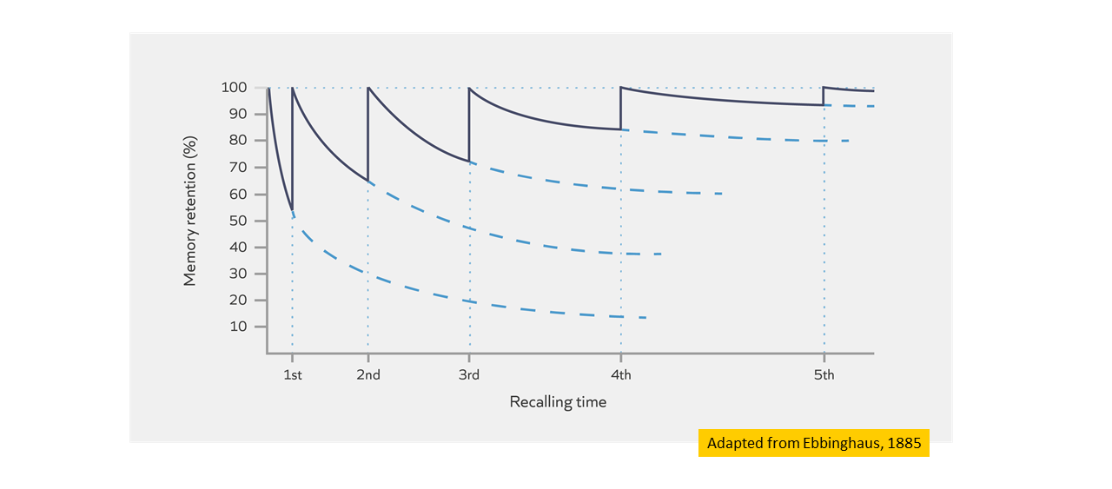
Notes

Check for understanding
Task: Which of these statements are TRUE?
- Learning is a lasting change in the learner's capabilities or understanding.
- Building knowledge in long-term memory is important because the better our prior knowledge, the more easily we can make sense of new information.
- Learners will struggle to build knowledge in long-term memory if they are cognitively overloaded.
- Retrieving, practising and thinking hard are all ways to guarantee the learner will become overloaded.
Notes

Learning and remembering: implications

Pupil learning | Staff learning | Your learning
Ms. Amo supports subject leaders to build opportunities in to curriculum plans to retrieve and practise taught content | Mr. Carter breaks down a new teaching strategy into steps and models it to his teachers when training staff on it. He ensures they practise the same strategy multiple times. | Ms. James retrieves and explains what she has found out about in her NPQLT module to other colleagues so she can revisit the knowledge and think hard about the underlying principles.

Notes

Mental Models

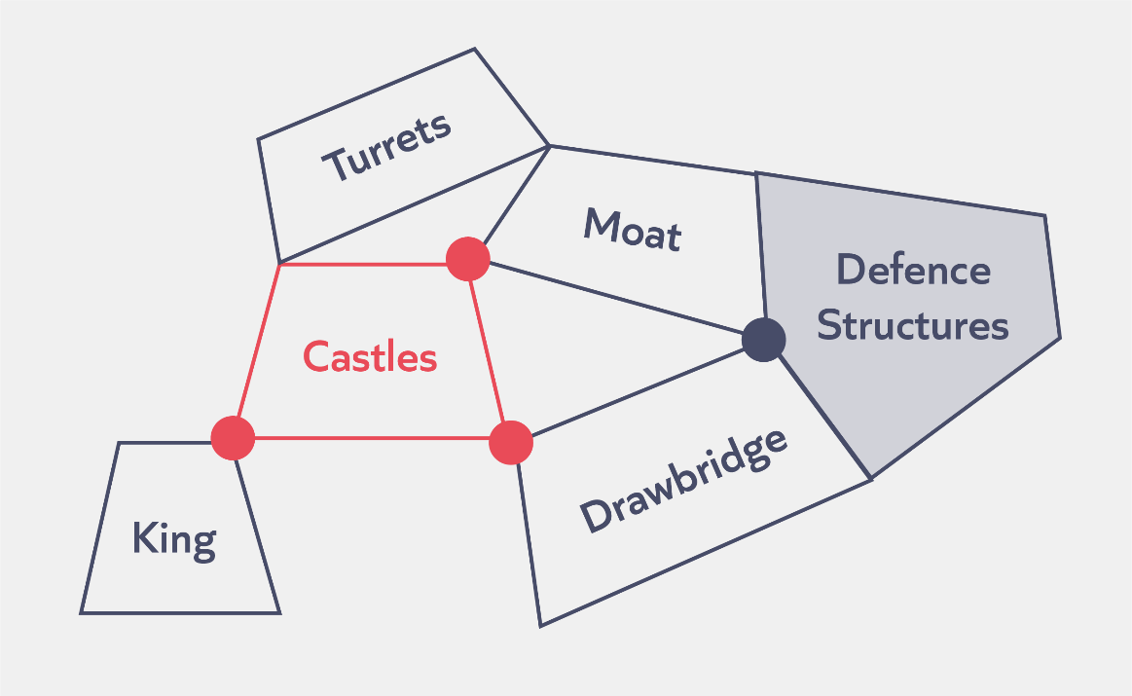
Mental models: The knowledge you have about a particular topic and how that knowledge is organised.

Check for understanding
Task: Which of these statements are TRUE?
- A leader’s mental model is all they know about school leadership.
- The more knowledge we have already learnt, the more successfully we can learn new knowledge in the future.
- Retrieval and practice helps to prevent knowledge being forgotten from our working memory.
Notes

Reflection
Scenario:
Kristy is a new English lead. She has been approached by two teachers wanting to use professional development time to share strategies for teaching vocabulary. Last month the school introduced a new marking policy.

- How does understanding the science of learning help Kristy make a decision about whether/how she use professional development time for sharing strategies to teach vocabulary?

Notes

Experiencing a module pair
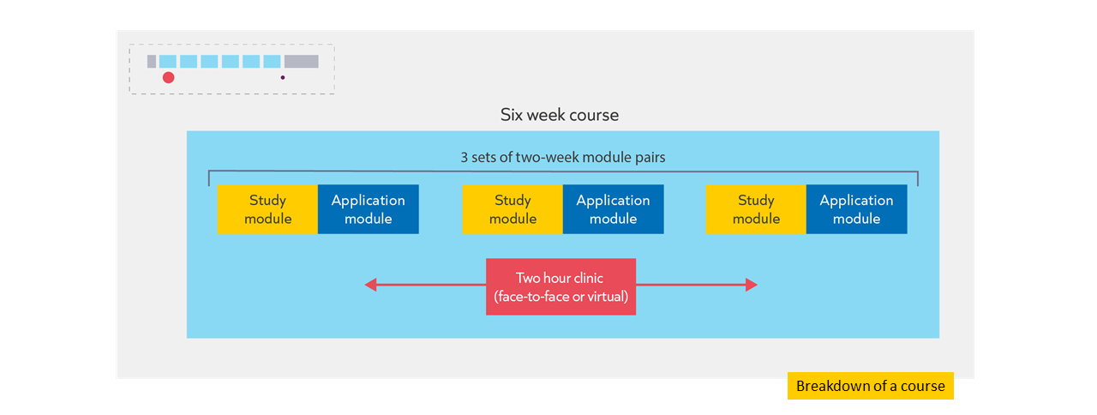
Study module
Introduction
Effective teaching is likely to involve a lasting change in pupils’ capabilities or understanding. The more we know about learning and how it works, the more likely we will be able to make it happen (Willingham, 2018). Our understanding of how learning works will underpin many of the decisions we make about curriculum design, assessment and teaching. It may also influence the decision that we make about professional development since we learn in the same way as our pupils.
As such, it is critically important that we have clarity over what learning is and how it happens. This will help us to make better informed decisions in our leadership work. To do this, in this module we will explore:
- Principles of learning and cognition utilising a simple model of memory
- Some applications of the simple model of memory to teaching, curriculum and professional development

Guiding questions
Before you continue, consider:
- What do you already know about how we learn?
- In what ways have you applied this to your leadership work?

Optional pre-reading
This module assumes you understand the following ideas. If you wish to understand these in more depth before jumping in, then we recommend you read the following:

- Early Career Framework module ECF Module I1

References

Willingham, D. T. (2017). A mental model of the learner: Teaching the basic science of educational psychology to future teachers. Mind, Brain, and Education, 11(4), 166-175.

Evidence summary
Problem
Khalid is a Key Stage 2 leader at a two-form entry primary school in Hull. He has recently worked with the school’s mathematics lead to refine mathematics teaching in Key Stage 2. Drawing on what they know about how learning works, they were keen to ensure that knowledge was consistently broken down into small steps in lessons. Together, they’ve delivered professional development to all teachers in Key Stage 2 to help them ensure learning is always broken down sufficiently. This year, Khalid is mentor to two early career teachers (ECTs) in his phase and wants to ensure they are also able to implement these improvements to the teaching of mathematics. Khalid has reviewed the content and sequence of learning planned to support ECTs. He has reflected that it would be useful to introduce more about how pupils learn from cognitive science, first to support their understanding of why knowledge should be broken down into small steps in mathematics lessons but also to inform their understanding of other aspects of curriculum planning, assessment and teaching. Khalid is aware that ECTs are novices - they are just beginning to acquire and organise their own knowledge about effective teaching and learning. Khalid thinks that he will need to frame his explanation of the simple model of memory differently when working with ECTs than with the more experienced teachers in his phase.
What is learning?
Learning can be described as “a lasting change in pupils’ capabilities or understanding” (Department for Education, 2019, p.10). Learning is both a process involving thinking, as well as a product involving the acquisition and organisation of new knowledge (Mccrea, 2019). Both the process of learning and its product can be usefully explained through Willingham’s simple model of memory.
Simple model of memory
The work of Daniel Willingham (2009) explaining cognitive processes and memory is very useful for teachers. This is because it provides models explaining key mechanisms and principles of learning. These principles apply to all learners: pupils and teachers.
As the diagram above shows, his simple model of memory splits memory into two parts: working memory and long-term memory. Working memory can be thought of as the site of thinking and has a limited capacity for new knowledge and information. For us to learn something, it needs to be embedded in our long-term memory (‘be a lasting change’).
We take in new information from our environment, the world around us, using our working memory. This is where information that is actively being processed is held. Working memory is very limited. This means we can only pay attention to a small number of new things at once as working memory can easily become overloaded. If working memory is overloaded, new information is forgotten instead of leading to a lasting change in long-term memory.
Fortunately, our long-term memory appears to be essentially unlimited. Long-term memory consists of everything we know and know how to do (factual and procedural knowledge). We learn new information from our environment by combining and making sense of it in our working memory with knowledge already stored in our long-term memory (prior knowledge). The way we organise and store information in our long-term memory is called a 'mental model' or 'schema' (Sweller et al., 1998, Education Endowment Foundation, 2021). Recalling information from long-term memory can help strengthen memories and reduce the risk of things being forgotten; you will return to this idea in course 1.
Implications for teaching
The more we know, the easier it is to build on that prior knowledge. This means that where new content is introduced, to either pupils in the classroom or teachers in a professional development session, attention should be paid to both how that information is presented and how much information is presented at any one time.
- Reduce and remove distractions
We learn what we think about, and what we think about is determined by what we attend to (Schweppe & Rummer, 2013). There are lots of stimuli in our environment that compete for our attention, but because working memory is limited, we can only choose to think about a handful of these at a time.
This means that attention is the gatekeeper of learning. Khalid is familiar with this idea; a large part of his job as a teacher is to harness and direct attention. He knows that this involves motivating pupils and teachers as well as drawing their attention to the key concepts and ideas he wants them to learn.
Where possible, educators should aim to eliminate redundant information and reduce distractions in the environment. These distractions can be social (for example, peers or other adults), environmental (for example display boards or clocks), activity-based (for example irrelevant images or tasks), or internal (for example performance anxiety, mind wandering). This does not mean removing all displays, or always having pupils work silently; but might mean putting displays or clocks at the back of the class and thinking about whether pupil talk is likely to help or hinder the current task. Khalid is used to thinking about redundant information and distractions when working with pupils but is aware that he sometimes forgets this when working with adults. He is likely to need to take into consideration when he runs his mentor sessions.
- Utilise limited working memory wisely
Working memory is where information that is being actively processed is held, but its capacity is limited and can be overloaded. Educators must ensure learners focus on a few ideas, processes or pieces of information at a time. This is more difficult if brand new content is being introduced or where the learners are complete novices. This is because we use our existing knowledge, skills and understanding to make sense of new ideas. Thinking becomes more difficult if we have limited relevant knowledge held in long-term memory to think with. Thinking works best when we attend to no more than two or three interacting pieces of information at once (Sweller et al., 2011).
These ideas from the science of learning, including the simple model of memory, are familiar to Khalid from his work with pupils and he’s keen to ensure he embeds them into his mentoring work with ECTs.
Guiding yourself as a learner
Having considered the simple model of memory and some ideas about cognitive load from Khalid’s own perspective as a teacher and leader, let’s consider how you might use these ideas in your own learning.
The same principles applied above to the teaching of pupils and through teacher education also apply to you as a learner on this programme. Particularly if this content on cognition and memory is new to you, as you work through the rest of the module you will need to consider:
- How will you fully attend to the content without distraction?
- What strategies do you need to put in place to think hard about this content without succumbing to cognitive overload?
Pause. Reflect. Respond.
- Consider the questions above. What actions will you take as you move through the rest of this module? The rest of the programme?
- How might you support teachers you are working with to reflect on their learning in the same way?
The more you know about an idea or topic, the easier it is for you to learn yet more. One way to benefit from this is to seek out opportunities to add to your knowledge base, creating more optimal conditions for thinking as your mental models develop. The more information our knowledge networks contain, the more we are able to think about. The amount of information they contain is determined by the number of meaningful connections they possess. The ease with which we can access and think with these elements is determined by how consolidated these connections are in our mind. Connection and consolidation are the two fundamental levers of learning. The more meaningful connections we forge, the more comprehensive and refined our understanding becomes. The greater our variation of experience, the more abstract and transferrable our knowledge becomes, and the more flexibly we can apply it across a range of situations (Lo, 2012). Sense-making can be supported by our peers, especially those coming from a similar starting point (or just ahead of us in the process).
Summary
Fully guided and explicit instruction is an effective strategy for introducing new and complex information where there is little background knowledge in the long-term memory to support thinking.
- Learning requires thinking about new content introduced into our working memory and is enhanced when new knowledge can interact with knowledge already stored in our long-term memory. Learning can be thought of as a lasting change in pupils’ capabilities or understanding.
- Working memory has a limited capacity therefore you should focus your attention on the thing to be learnt avoiding distraction wherever possible to reduce cognitive overload.
- Learning new content where there is an underdeveloped mental model is more difficult as there is little to no prior knowledge to draw upon to help with thinking about the new knowledge
- Principles of cognition and learning can be applied to learning opportunities for both pupils and teachers and can impact resource design and delivery techniques
- Principles of cognition and learning can be applied to participants on this programme as learners, and considerations should be made about optimal learning conditions and self-regulation

Nuances and caveats
The simple model of memory is a model. Although the simple model of memory is effective at explaining some of the effects we see when studying learning, it is a model. It is not possible to identify the site of working or long-term memory in the brain. Consequently, it will not explain everything we observe about memory or learning. This is similar to how scientific models such as Bohr’s model of the atom work – they represent and help us think about content, they are not an exact replica. The simple model of memory does not provide a precise formula for exactly how to introduce and explain content; it does provide us with useful guidelines.
The role of motivation. Shell et al (2010) make an important point in their writing on motivation and cognition: the capacity of the “absolute” working memory does not always equate to the working memory an individual actually allocates to learning. In other words, just because there is the capacity to focus working memory on new learning, it doesn’t mean that focus and attention will materialise. Motivation is a key factor in determining how much of working memory is put to best use.
Further reading
Mccrea, P. (2019). Learning: What is it, and how might we catalyse it? Ambition Institute.
https://s3.eu-west-2.amazonaws.com/ambition-institute/documents/Learning_what_is_it_and_how_might_we_catalyse_it_v1.4.pdf
Willingham, D. T. (2017). A mental model of the learner: Teaching the basic science of educational psychology to future teachers. Mind, Brain, and Education, 11(4), 166-175.
Willingham, D. T. (2009). Why don't students like school?: A cognitive scientist answers questions about how the mind works and what it means for the classroom. John Wiley & Sons.
References
Ambrose, S. A., Bridges, M. W., DiPietro, M., Lovett, M. C., & Norman, M. K. (2010). How learning works: Seven research-based principles for smart teaching. John Wiley & Sons.
Clark, R. C., Nguyen, F., & Sweller, J. (2011). Efficiency in learning: Evidence-based guidelines to manage cognitive load. John Wiley & Sons.
Department for Education [DfE] (2019). Early Career Framework. https://www.gov.uk/government/publications/early-career-framework
Education Endowment Foundation [EEF] (2021). Cognitive science approaches in the classroom: a review of the evidence. [Online] Accessible from: https://educationendowmentfoundation.org.uk/public/files/Publications/Cognitive_science_approaches_in_the_classroom_-_A_review_of_the_evidence.pdf
Ling Lo, M. (2012). Variation theory and the improvement of teaching and learning. Göteborg: Acta Universitatis Gothoburgensis.
Mccrea, P. (2019). Learning: What is it, and how might we catalyse it? Ambition Institute. https://s3.eu-west-2.amazonaws.com/ambition-institute/documents/Learning_what_is_it_and_how_might_we_catalyse_it_v1.4.pdf
Schweppe, J., & Rummer, R. (2014). Attention, working memory, and long-term memory in multimedia learning: An integrated perspective based on process models of working memory. Educational Psychology Review, 26(2), 285-306.
Shell, D. F., Brooks, D. W., Trainin, G., Wilson, K. M., Kauffman, D. F., & Herr, L. M. (2010). The unified learning model. In The Unified Learning Model (pp. 1-4). Springer, Dordrecht.
Simonsmeier, B. A., Flaig, M., Deiglmayr, A., Schalk, L., & Well-being, S. (2018). Domain-Specific Prior Knowledge and Learning: A Meta-Analysis Prior Knowledge and Learning Domain-Specific Prior Knowledge and Learning : A Meta-Analysis Universität Trier, Germany PH Schwyz , Switzerland,
Sweller, J. (2011). Cognitive load theory. In Psychology of learning and motivation (Vol. 55, pp. 37-76). Academic Press.
Sweller, J., Van Merrienboer, J. J., & Paas, F. G. (1998). Cognitive architecture and instructional design. Educational psychology review, 10(3), 251-296.
Willingham, D. T. (2009). Why don't students like school?: A cognitive scientist answers questions about how the mind works and what it means for the classroom. John Wiley & Sons.
Reflection
- What is helpful about the Study section?
- How will the Study section help to build your mental models?
- Do you have any questions?
Notes

Check
Task: Answer the following questions
- When presenting new or complex information, we should ensure learners focus on a few ideas, processes or pieces of information at a time because:
  - Working memory has limited capacity
  - Long-term memory has limited capacity
  - Long-term memory is essentially unlimited

- Knowledge is organised:
- In the long-term memory as mental models
- In the working memory as mental models
- In the long-term memory but there is limited capacity

- The ideas about working memory and long-term memory apply to:
  - Only pupils
  - All learners including adults and children
  - Only pupils and inexperienced teachers
Reflection
- What do you need to do to make the most of the Quiz section?
- How will the Quiz section help to build your mental models?
- Do you have any questions?

Notes

Quiz
Task: Read Example 1 and answer the analysis questions.
Example 1
Scenario
I am a teaching and learning lead in a large, urban primary school. I coach three teachers, one of whom is Nancy, an experienced teacher in Year 5 who is new to the school. It is the autumn term of the academic year, and we have been focussing on developing routines to support high expectations. There has been a whole school focus on incorporating methods influenced by cognitive science, so even staff new to the school have some familiarity with the simple model of memory and some of its implications for teaching.
This example is part of an instructional coaching conversation between myself and Nancy. The example will focus on the following module principles:
- Learners are learners: the implications of science of learning apply to pupils, teachers, leaders and self.
- Guide attention: limit distractions, direct attention and carefully consider the design of activities.
- Consider prior knowledge: teaching should start from what learners know and can do.
- Break it down: Working memory is limited. Break knowledge down and plan for it to be introduced and practised in small steps.
Narrative
In the lesson I’ve noticed that some of the pupils in Nancy’s class are finishing off their work when she is talking. I know that this is likely to be a distraction. I could launch straight into setting an action step, but if I do this without helping Nancy build her mental model for behaviour first then the new step is less likely to stick, and Nancy is less likely to be able to apply it appropriately to other situations.
During the coaching conversation below you will see that I:
- Ask Nancy what she thinks about pupils working while she is talking. This is because I need to figure out how well she is able to link what she knows about the simple model of memory and pupils’ behaviour.
- Ask her specifically about the simple model of memory, both to activate her prior knowledge, and also to judge where to start my explanation. Like when working with pupils, I want to break down the ideas so that they are easy to grasp but I don’t want to overload Nancy with detail.
- Talk Nancy through the importance of attention, and therefore behaviour, in terms of its impact on learning.
- Once I’m convinced that Nancy has made the connections and is bought into the idea, I share the action step that we are going to work on and provide a live model of what it looks like.
- Finally, I support Nancy to practise the step until she is ready to implement it into her classroom practice.
Artefact
We join the coaching session part-way through. The coach and teacher have already discussed and praised the teacher’s progress and reviewed the previous action step.
Mentor: “In the lesson I noticed that some pupils were finishing off their work when you were speaking. What can you tell me about that?”
Nancy: “Yeah, that happens sometimes. I find it hard to get them to stop, and most of them seem to be listening when I ask them questions afterwards, so I don’t think it is that big a deal.”
Mentor: “How do you think pupils working when you’re speaking will affect their learning?”
Nancy: “I don’t think it affects their learning much, as I said they still seem to be able to concentrate.”
Mentor: “I’m not sure I agree with you there, but before I explain why tell me what you can remember about the simple model of memory.”
Nancy: “Erm, well I remember that memory can be thought of as being split into working memory and long-term memory, and that working memory is limited. And that long-term memory is where all your knowledge and skills are stored. If you have too many things in working memory, then it gets overloaded and you won’t remember. That’s why we have to break things down to teach them.”
Mentor: “Great explanation, you’ve remembered loads. There’s another thing that is important: it is our attention that controls what information goes into working memory. Because working memory is limited, we can’t pay attention to everything going on in the environment around us. Our attention decides what gets into working memory in the first place, and therefore what has a chance of getting into long-term memory.
Pupils finishing off their work is likely to be taking up some of their working memory. They might cope with this if what you are talking about is familiar and simple, but as soon as it gets a little bit harder, working memory can get overloaded. Remind me why that matters again?”
Nancy: “If information doesn’t get into working memory then we can’t think about it so it can’t become part of long-term memory.”
Mentor: “Excellent, now let’s have a look at an action step linked to this that we can practise.”
Conclusion
Throughout this scenario, I was able to structure my explanation by focusing on the following module principles:
- Learners are learners: the implications of the science of learning apply to pupils, teachers, leaders and self.
- Guide attention: limit distractions, direct attention and carefully consider the design of activities.
- Consider prior knowledge: teaching should start from what learners know and can do.
- Break it down: Working memory is limited. Break knowledge down and plan for it to be introduced and practised in small steps
Reflection
- How does the leader consider prior knowledge?
- How does the leader guide the teacher’s attention?

Reflection
- What is helpful about the Reflection section?
- How will the Reflection section help to build your mental models?
- Do you have any questions?

Notes

Reflection
- How does the Study Module help to build your mental model?
- Do you have any questions about the Study Module?
- How can you make the most of the Study Module?

Notes

Application Module
Re-analyse
Task: Discuss the Reflection questions from the Study Module with your partner. Strive to:
- Be brave: ask questions, share insights and experiences
- Be kind: respectful, supportive, active listening
- Be present: be fully engaged, keep to time

Reflection
- What is helpful about the Re-analyse section?
- How will the Re-analyse section help to build your mental models?
- Do you have any questions?

Notes

Select
Task: Select the most appropriate and useful application task for you and your context.
Module principle | Application task
Break it down: Working memory is limited. Break knowledge down and plan for it to be introduced and practised in small steps | Read principle 2 from: Rosenshine, B. (2012). Principles of Instruction.  - Why might teaching new material overwhelm learners?  - How might you mitigate for this?
 | Review: Review a selection of medium-term plans for a curriculum area you’re responsible for. Is knowledge broken down and planned to be introduced and practised in small steps?
 | Do: Script an explanation of how you would explain the importance of breaking down knowledge and introducing and practising it in small steps in a lesson for a professional development session targeted at a group of teachers you work with.
Consider prior knowledge: teaching should start from what learners know and can do. | Read: Review this section on prior knowledge the Early Career Framework.  - How does prior knowledge help us make sense of new material?
 | Review: Consider one objective from a subject you’re responsible for which you intend pupils to have learnt by the end of the curriculum. Track back across the curriculum and consider how this objective builds on previous content.
 | Do: Prepare an explanation of how knowledge in the curriculum builds for a mentor meeting with an Early Career Teacher.

Discuss
- Which of these principles are most relevant to your context/role? Which did you choose and why?
- What do you plan to do next? How do you hope this will enhance your expertise and impact?

Plan

Example | Non-example
- To review three medium-term plans for English to see how knowledge is broken-down (Wednesday period 4)  - To script an explanation about the importance of breaking down prior knowledge (Tuesday, period 5)  - To read principle 2 from Rosenshine’s Principles of Instruction (next Thursday before school) | - Make sure I always break down knowledge in my lesson planning and talk to teachers about this.

Task: Plan your next steps.
Notes

Reflection
- How does the Application Module help to build your mental model?
- Do you have any questions about the Application Module?
- How can you make the most of the Application Module?

Notes

Experiencing a clinic
Study consolidation
Module | Module principles
Simple model of memory | Guide attention: limit distractions, direct attention and carefully consider the design of activities.
 | Consider prior knowledge: teaching should start from what learners know and can do.
 | Break it down: Working memory is limited. Break knowledge down and plan for it to be introduced and practised in small steps.

I do
Task: Read the scenario.

Scenario 1
A secondary English head of department recently decided to focus on the quality of teacher modelling across her team. She was concerned that in some lessons the learning was not clearly modelled by the teachers, which left pupils confused about what they needed to do during independent practice time. Consequently, in department meeting time, she has focussed on modelling by sharing good practice from her own classroom as well as that of other teachers in the department. Colleagues have discussed the strengths and weaknesses of the examples they’ve seen and together the department has constructed a success criteria for modelling:
- model should show what success looks like
- ‘talk aloud’ your thinking process to make it explicit
- make links to content previously taught
- remove distractors so pupils can focus on the key content
Teachers have then used this criteria to jointly plan how to use models effectively in their own lessons.
The head of department is now conducting a learning walk to review the quality of teacher modelling in her team. She sees modelling in two classrooms and makes the following observations:
Classroom 1: Pupils are attentive and focussed on the teacher’s instruction while she models. There is a noisy PE lesson outside the classroom but the teacher has drawn the blinds to limit distraction. The teacher is modelling a written passage. When she uses a semi-colon she refers to the success criteria on her writing wall to remind pupils of how to use these appropriately and effectively. She has given the pupils eight points to consider when doing their own writing and models how she considers these when writing her model passage. However, when pupils write their own passage, very few of them seem to be referring to the criteria which she gave when she modelled.
Classroom 2: Pupils are focussed during modelling. The lesson involves annotating an extract from the class novel to show where figurative language has been used and suggest its effect on the reader. A class display shows just the technical language that pupils are focussing on in this unit of work, with examples of each key term from a text pupils read earlier in the year. The teacher has given a success criteria for the task with 3 points which she refers to as she models, clearly articulating her thinking process. She is ambitious for her pupils, so her modelling goes beyond the 3 points on the success criteria. Although it’s a Year 7 lesson, she refers to concepts that will not be taught until Key Stage 4. Pupils are confused when they come to complete the task and become restless.
Question:
Taking into account what you have learned on this course:
- What might be effective about this leader’s decision making?
- What suggestions do you have that might enable them to make more effective decisions next time?

Task: Make notes while the facilitator models how to respond to the question.

Module principle | Response/suggestion
Guide attention
Consider prior knowledge
Break it down
Other notes:

Reflection
- How will the ‘I do’ section help to build your mental models?
- What do you need to do to make the most of the ‘I do’ section?
- Do you have any questions?

Notes

We do
Task: Read the scenario.

Scenario 2
The primary mathematics lead at a one-form entry primary school is concerned with the quality of teaching of her subject in year 2. She’s been given time out of class to support the year 2 teacher with his planning. The unit of work that they begin by looking at is on geometry. In the unit, there is some mathematical vocabulary which the mathematics lead knows pupils can get confused by, so she’s keen to talk about this. Here is a snapshot of their conversation:
Mathematics lead: next week is geometry – there’s a lot of vocabulary in this unit and pupils often get confused by it. Have you considered how you’ll support them to learn the words around 2d and 3d shapes?
Y2 teacher: maybe we could put the words up on the walls – I’ve seen other teachers do that around the school.
Mathematics lead: it’s helpful to have the most relevant vocabulary on display when the pupils need it – but be careful not to overwhelm your pupils. Displays left up all year with irrelevant content can just be a distraction from their learning. Maybe just put the most important vocabulary up on the working wall, with images where helpful. What vocabulary do you think it will be helpful to focus on?
Y2 teacher: whatever’s new in year 2 sounds like the best thing to me. Looking back at what was covered in year 1, I reckon the new terms are: octagon, hexagon, vertex/vertices….
Mathematics lead: yes, those weren’t taught last year. I think we can assume all the other key vocabulary will be pretty secure since they’ve been learning about shapes since reception and we talk about them all the time. So let’s focus on hexagon, octagon and vertex/vertices on our maths working wall. When will you introduce those words in your unit?
Y2 teacher: not all at once! Hexagon and octagon will come earlier in the unit then I’ll introduce vertex/vertices when we move onto 3d shapes.
Mathematics lead: great. You wouldn’t want to introduce all those new words at once – it would definitely lead to cognitive overload! Let’s start looking by the objectives for the unit then we can think about where the vocabulary is best introduced and how we can stagger its introduction. We can talk specifically about how best to introduce and revisit that new key vocabulary today too.

Task: Respond to the following question independently, then discuss with your partner.

Questions:
- Taking into account what you have learned on this course:
  - What might be effective about this leader’s decision making?
  - What suggestions do you have that might enable them to make more effective decisions next time?
- How have you used, or how do you anticipate using, one or more module principles in your decision making?
Module principle | Response/suggestion
Guide attention
Consider prior knowledge
Break it down
Other

Reflection
- How will the ‘We do’ section help to build your mental models?
- What do you need to do to make the most of the ‘We do’ section?
- Do you have any questions?
Notes

Reflection

- How does the clinic help to build your mental model?
- Do you have any questions about the clinic?
- How can you make the most of the clinic?

Notes

References
Bereiter, C., & Scardamalia, M. (1993). Surpassing ourselves: An inquiry into the nature and implications of expertise. Chicago, IL: Open Court.
Cordingley, P., Higgins, S., Greany, T., Buckler, N., Coles-Jordan, D., Crisp, B., Saunders, L., Coe, R. (2015) Developing Great Teaching: Lessons from the international reviews into effective professional development. Teacher Development Trust.
Education Policy Institute [EPI], 2020, Education in England: Annual Report 2020. https://epi.org.uk/publications-and-research/education-in-england-annual-report-2020

Furst, E., 2018. Learning in the brain. https://sites.google.com/view/efratfurst/learning-in-the-brain
McCrae, P. (2018). Expert teaching: What is it, and how might we develop it. Institute for Teaching.
https://www.ambition.org.uk/research-and-insight/what-is-expert-teaching/
Robinson, V. (2017). Capabilities required for leading improvement: Challenges for researchers and developers. ACERsSearch https://research.acer.edu.au/cgi/viewcontent.cgi?article=1306&context=research_conference.
Rose, N, (2018) The role of forgetting as we learn. Ambition Institute. https://www.ambition.org.uk/blog/why-forget/
Sutton Trust (2011) Improving the impact of teachers on pupil achievement in the UK – interim findings. https://www.suttontrust.com/wp-content/uploads/2019/12/2teachers-impact-report-final-1.pdf
Wiliam, D., 2014. Spoken Presentation. Research ED: http://www.dylanwiliam.org/Dylan_Wiliams_website/Presentations_files/2014-09-06%20ResearchED.pptx
Willingham, D., 2009. Why Don’t Students Like School? A Cognitive Scientist Answers Questions About How the Mind Works and What It Means for the Classroom. Jossey-Bas 2nd edition.

